GENDER PERSPECTIVE IN THE ALLOCATION, USE OF SPACE AND USE OF TIME IN A PERIODIC MARKET. A CASE STUDY OF KIBUYE MARKET IN KISUMU CITY.

BY

ONYANGO LOICE LOO

A THESIS SUBMITTED IN PARTIAL FULFILMENT OF THE REQUIREMENTS FOR
THE DEGREE OF MASTER OF ARTS IN PROJECT PLANNING AND
MANAGEMENT

DEPARTMENT OF URBAN AND REGIONAL PLANNING

MASENO UNIVERSITY

© 2015

DECLARATION

This thesis is my original work and has not been submitted or presented for a degree in any other university

…………………………………. …………………………….
Onyango Loice Loo Date
PG/PA/0010/2012

This thesis has been submitted for examination with our approval.

Supervisor

………………………………. ………………………………..
Dr. George. G. Wagah Date
School of Planning and Architecture, Maseno University
Maseno, Kenya

Supervisor

………………………………… ………………………………..
Prof. Raphael Kapiyo Date
School of Environment and Earth Sciences, Maseno University
Private Bag
Maseno, Kenya

ACKNOWLEDGEMENT
Compilation of this thesis has been possible through the assistance of various people to whom a lot of gratitude is owed. First and foremost I wish to thank my precious husband - Kevin Odhiambo for giving me the support and room to pursue this project. The constant guidance from my supervisors; Dr. George Wagah and Prof. Raphael Kapiyo is also highly appreciated. Their valuable insight has helped shape this study. The market superintendent of Kibuye Mr. Gordon Omulo is also appreciated for his unfailing support and timely response during field studies at the market. Finally gratitude is owed to those who helped with data collection; Anne Dwelle, Grace Ng'wono, Elijah Loo, Elisha Gweth, Miriam Kema, Nora Dwelle and Paula Anyango. Truly without your cooperation, the study would not have been a success.

DEDICATION
A tribute to my parents who have been my mentors and source of encouragement; Mr. Peter Onyango Loo and Dr. Leah Onyango.

ABSTRACT
Periodic marketing systems engage 84% of women working in the informal sector and are characterised by inadequate infrastructure and poor organisation. Allocation of space is on first come first served basis, disadvantaging women, who have less time than men due to reproductive gender roles ascribed to them. This creates room for inequitable distribution of resources considering that periodic markets tend to be self regulating. The purpose of this study is to understand the gender dynamics within a periodic market and their effect on allocation and use of space to provide a basis for improving equity and efficiency. This was conducted in Kibuye market of Kisumu, Kenya. Specific objectives of the study were; to establish the relationship between gender and use of space in a periodic market, to examine the relationship between gender and allocation of space in a periodic market, to determine the link between gender and use of time in a periodic market and to evaluate gender responsiveness of the institutions managing a periodic market. A case study research design was adopted for the market with a population of 6,674 traders, from which a sample size of 392 was drawn. Key informants included the local authority, self help groups and non-governmental organizations. Primary data was collected using structured questionnaires, interview schedules and focus group discussions. Key informants were selected using purposive sampling and traders through simple random sampling. Findings indicated sale of food as the dominant trade at 41%; a trade dominated by women at 68%. Chi square analysis (p-value 7.9 ˃7.815) indicated that male traders had better access to larger spaces indicating inequitable distribution of space. Allocation was male dominated at 83%. An Odds Ratio calculation indicated that men were 6.43% times more likely to occupy spaces allocated to them for longer durations than female traders; signifying inequity in allocation of resources. Further, men arrived in the market earlier than women-as early as 4.00 a.m. taking up the best positions and making better sales. Through cross tabulation the study found that management was male dominated (60.5% males and 39.5%); indicating gender inequality. The study concludes that access to resources is inequitable between male and female traders reducing efficiency in market operations. The study recommends; reorganization of the market through zoning, introduction of a new system of allocation, and better representation of both genders in management for the realization of equity and efficiency in resource allocation and utilization.

TABLE OF CONTENTS
DECLARATION ii
ACKNOWLEDGEMENT iii
DEDICATION iv
ABSTRACT v
TABLE OF CONTENTS vi
ACRONYMS ix
OPERATIONAL DEFINITIONS x
LIST OF TABLES xii
LIST OF FIGURES xiii
LIST OF PLATES xiv
CHAPTER ONE: INTRODUCTION 1
1.1 Background 1
1.2 Problem Statement. 4
1.3 Objectives 5
1.4 Research Questions 6
1.5 Significance of the study 6
1.6 Scope of the Study 6
1.7 Limitations 7
CHAPTER TWO: LITERATURE REVIEW 8
2.1 Overview 8
2.2 Market places 8
2.3 Spatial organization in a periodic market 12
2.4 Allocation of space in a periodic market 15
2.5 Temporal dimensions of periodic market places 17
2.6 Management of Periodic Markets 18
2.7 Conceptual framework 23
CHAPTER THREE: METHODOLOGY 25
3.1 Overview 25
3.2 Study area 25
3.2.1 Physical features 27
3.2.2 Population and demography 28
3.2.3 Transportation 28
3.2.4 Socio-cultural and economic factors 29
3.2.5 Kibuye market 31
3.3 Research design 31
3.4 Study population 32
3.5 Sample size 33
3.6 Data Collection Methods 34
3.6.1 Secondary data 34
3.6.2 Observation 35
3.6.3 Interview of traders 35
3.6.4 Pre-test 35
3.6.5 Focus group discussion 35
3.6.6 Key informant interviews 36
3.7 Data Analysis Techniques 36
CHAPTER FOUR: RESULTS AND DISCUSSIONS 38
4.1 Introduction 38
4.2 Relationship between Gender and Use of Space 38
4.2.1 Gender Compositions of Traders in Terms of Sex and Age 38
4.2.2 The Use of Space by Different Categories of Traders 40
4.2.3 Zoning of the Market for the Sale of Different Trade Items 50
4.2.4 Sanitation and Hygiene in the Use of Space within the Market 56
4.3 The Relationship between Gender and Allocation of Space in Kibuye Market 62
4.3.1 Persons and Institutions Involved in Allocation of Space 63
4.3.2 Allocation Procedures 64
4.3.3 Land Ownership and Security of Tenure on Allocated Spaces 67
4.4The Link between Gender and Use of Time in Kibuye Market 71
4.4.1 Time of Arrival in the Market 72
4.4.2 Time Spent in the Market 73
4.4.3 Late arrival in the market 75
4.5 Gender Responsiveness of Institutions Managing Kibuye Market 77
4.5.1 Institutions Involved in Management 77
4.5.2 Gender Considerations in Institutions that are Involved in Management 78
4.5.2.1 Jamii Bora 79
4.5.2.2 Market Union 80
4.5.2.3 Kibuye Jua Kali Association 80
4.5.2.4 Self Help Groups 80
4.5.2.5 UN-HABITAT 80
4.5.2.6 City Council of Kisumu 81
CHAPTER FIVE: SUMMARY OF RESULTS, CONCLUSIONS AND RECOMMENDATIONS 90
5.1 Summary 90
5.2 Conclusion 92
5.3 Recommendations 93
5.4Areas for further Research 95
REFERENCES 96
APPENDICES 103
Appendix 1; Questionnaires designed for the traders at the market. 103
Appendix 2; Key informant questionnaires 108
Appendix 3; Research Permit from the Local Authority 111
Appendix 4; Mapping of Activities in Relation to Time 112

ACRONYMS
DF Degree of Freedom

CDF Community Development Fund

CCK City Council of Kisumu

OR Odds Ratios

TOL Temporary Operational Lease

USAID United States Agency for International Development

FAO Food and Agriculture Organization

MDGs Millennium Development Goals

OPERATIONAL DEFINITIONS
Allocation of space The procedure through which trading spaces are issued to traders or the procedure through which traders get access to trading spaces

Compatibility Capability of existing in harmony.

Core Central most part of the markets; The central or innermost part of the market

Equity Fairness in distribution of resources within social and professional situations.

Gender Cultural interpretation of differences between men and women. It entails both men’s and women’s active roles in society and their ideas about maleness and femaleness

Gender perspective Looking at an issue from gender's point of view; the implication of one's maleness or femaleness in their active participation

Gender responsive Creating an environment through site selection, staff selection, program
Development, content, and material that reflects an understanding of the realities of the lives of women and men and that addresses and responds to their strengths and challenges.

Mainstreaming gender A strategy for making women's as well as men's concerns and experiences an integral dimension of the design, implementation, monitoring and evaluation of policies and programs in all political, economic and societal spheres so that women and men benefit equally hence gender equality.
Use of space The activities carried out in trading spaces and characteristics of the spaces

Use of time The duration spent by traders in the market in terms of hours per day as well as the number of years or months within which they have been operating in the market. It also encompasses the spread of trading activities throughout the entire market day

LIST OF TABLES
Table 3.1; Sampling frame 33
Table 4.1; Upper and lower limits of dominant age bracket. 39
Table 4.2; Goods sold by male and female traders 41
Table 4.3; Categories of traders in relation to gender 42
Table 4.4; Chi-Square Test 43
Table 4.5; Distribution of space amongst different categories of traders 44
Table 4.6; Sizes of spaces occupied by traders 45
Table 4.7; Sizes of spaces occupied by traders selling food 47
Table 4.8; Distribution of goods in the market 52
Table 4.9; Percentages of traders with stands for display 59
Table 4.10; Persons involved in allocation of space 64
Table 4.11; Security of tenure in markets 68
Table 4.12; Calculation of Odds Ratios 68
Table 4.13; Traders operating in shifts 73
Table 4.14; Goods sold by traders who change shifts 74
Table 4.15; Institutions in operation within the market 78
Table 4.16; Toilets within Kibuye market 82
Table 4.17; Gender and education qualifications of persons in management 87
Table 4.18; Education qualifications of persons in management 87

LIST OF FIGURES
Figure 2.1; Conceptual Framework 23
Figure 3.1; Kisumu County in the regional context 26
Figure 3.2; Kisumu City in the local context 26
Figure 3.3; Periodic markets in Kisumu county 30
Figure 3.4; Aerial View of Kisumu 31
Figure 4.1; Population pyramid showing the distribution in age of traders by count 39
Figure 4.2; Types of goods in Kibuye market 41
Figure 4.3; Distribution of traders by gender in Kibuye market 51
Figure 4.4; Distribution of space use in Kibuye market 53
Figure 4.5; Use of space at the core of the market 54
Figure 4.6; Proposed plan for Kibuye market 55
Figure 4.7; An extrapolation of Zone 'A' 56
Figure 4.8; Traders encroaching on the road reserve to trade 61
Figure 4.9; Proposed floor plan for the new stall designs 62
Figure 4.10; Gender of persons involved in allocation of space 63
Figure 4.11; Proposed system of allocation 71
Figure 4.12; Arrival time of traders in the market 72
Figure 4.13; Gender of traders dealing in more than one good 75
Figure 4.14; Linkages betweeninstitutions working in Kibuye market 77
Figure 4.15; Key participants in waste management 83
Figure 4.16; Sources of water for Kibuye market 84
Figure 4.17; Parties involved in road maintenance 85

LIST OF PLATES
Plate 4.1; Gakomore market of Meru County-Kenya 49
Plate 4.2; Traders selling vegetable next to charcoal 57
Plate 4.3; Innovative ways used by traders to raise displays form the ground 58
Plate 4.4; Vegetables displayed directly on the ground 58
Plate 4.5; Furniture displayed outside workshops in Kibuye market 59
Plate 4.6; Wooden structure acting as a stall 79
Plate 4.7; Bio digester toilets in Kibuye market 81
Plate 4.8; Condition of access road in Kibuye market during rainy season 86

CHAPTER ONE: INTRODUCTION

Background
A gender perspective in development is becoming a necessity for most studies targeting the economy as the number of women participating in the labour market is steadily increasing. UN-HABITAT (2009 c) links this to informality of economies that have reduced manufacturing jobs (men-jobs) and increased informal economy jobs (service and care) where women tend to outperform and out-compete men. Periodic markets offer informal employment which is an important part of the economy and is vital for a sustainable economy engaging 84% of women in non agricultural employment(UN-HABITAT, 2009 c). However, the marketing systems of periodic markets in most developing countries is characterised by inadequate storage, transport, infrastructure and poor organisation of markets both physically and institutionally.

USAID (2006) notes that economic growth and trade, can be powerful forces of poverty reduction and can provide greater income-generating opportunities, for skilled and unskilled workers, entrepreneurs, poor and working families, men and women. As increasing numbers of women have been drawn into the labour force, they have increasingly contributed to the household, local, and national economies. Understanding how women’s contributions and challenges to participation in the global economy, may differ from men’s, is crucial to identifying opportunities to create sustainable jobs for them that will improve their lives and the lives of their families, and help reduce poverty. Yet much work remains to ensure that the benefits of trade-led growth extend to the poor, particularly vulnerable groups including indigenous communities and women (USAID 2006).

USAID (2006) and UN-HABITAT (2009 c) have highlighted the significance of periodic markets as livelihood sources recommending a gender perspective for development that will be sustainable to them. The importance of conducting a gender study is also highlighted in studies by Raji (2005), Anthon (2007) and Rozelle (2002) who bring out the gender dynamics in periodic markets.

Both Raji (2005) and Anthon (2007) state that a majority of traders in markets are women. Vaa, (2002) who also supports this, states that most men are also venturing into markets as traders thus increasing the contest for space. Raji, (2005) explains that use of space within markets can be gender specific. With the increase in demand for space and the fact that men dominate in positions of governance (Anthon, 2007), the dynamics could play out differently for male and female traders in the market place. Although critical to efficiency and equity in the market, the dynamics have not been brought out clearly for male and female traders.

Raji (2005) illustrates that the use of space in markets as in the case of Yoruba could be gender specific. The Yoruba had associations called guilds which engaged in proper coordination of economic activities. There were specialized guilds for women traders named after their profession like pepper traders. Some guilds were dominated by men like the guild of blacksmiths and carvers. In terms of space use in the market, the spaces occupied by carvers and blacksmiths were mostly male dominated. This is a pattern that is consistent in all markets as male traders tend to dominate the more labour demanding crafts like carpentry while women favour less labour intensive ones like weaving and pottery. This has an effect on the demand for space in the market. Access to designated spaces in the market can serve as an incentive for more women to participate. Unregulated contest for space can on the other hand serve as a disincentive for women who want to be part of the periodic market.

Rozelle (2002) asserts that in periodic markets, the mode of operation is characterised by conflicts over trading rights, prime locations and incompatible use of space hampering efficiency. Recommendations have been made for detailed market surveys to determine the needs to no avail. As has been highlighted by USAID (2006), traders could be affected differently by the current management systems of markets based on their gender. Given the dynamic nature of space use in periodic markets, it is however not clear how male and female traders fare in the contest for space.

Walker (2011) states that processes of space allocation in periodic markets have seemed to work well in places like Bolton, United Kingdom; where traders are categorized as regular and casual. However, gender considerations have not been made and the system could disadvantage female traders for example; by requiring payment for the stalls while on leave to maintain them, without special arrangement for maternity leave. The implications of allocation processes on both male and female traders have therefore not been addressed though of importance, as they could hinder equity and efficiency in the market.

Time is of importance to the operations of periodic markets. Rozelle (2002) highlights that periodic markets start before dawn. This could affect participation due to insecurity at early hours as cited by USAID (2006). It is of importance whether the participation of male and female traders is affected by the early starting hours of the market. Mary (1993) highlights the fluctuating nature of prices in periodic markets with time. The implication of price fluctuations as highlighted could also differ for male and female traders based on their commodities of sale and thus of interest to the study.

In most African cities the retail distribution system of markets and street vending is female dominated, while governments and bureaucracies are overwhelmingly male. Anthon (2007) states that urban governance and urban markets and the relationship between the two have important gender dimensions. This bias in the urban economic relations could have an impact on patterns of cooperation and conflict between city authorities and traders (Vaa, 2002). Rozelle (2002) illustrates the operations of a periodic market in which a clear structure of management is lacking. Resources are therefore not equally distributed with the oldest traders having the upper hand in most issues.

This implies that there are more men in management than women which could promote bias in favour of men though the study by Vaa, (2002) does not clarify. With the increase in demand for space and the fact that men dominate in positions of governance, it is important to investigate whether skewed distribution of resources is experienced at the market place and how it affects the performance of male and female traders in the market.

Karl (2011) notes that markets like Caribbean Gardens Market have managed to provide infrastructure for traders regardless of the fact that management of periodic markets is not clearly outlined. Nevertheless the effect of this on traders based on gender is not evident. Gender responsiveness has been advocated for by UN-HABITAT (2009 a) and the Government of Kenya but trends continue to indicate male dominance in management positions. The dynamics brought into play by management that is not gender responsive are therefore of interest to this study as they consequently affect equity and efficiency in periodic market places.

In Kenya, significance of periodic markets is emphasized by the volume of traders it engages, playing a fundamental role in economic growth (Wambugu, 2005). In example, Nairobi City Council estimates that about 65,000 people work in Gikomba, Kenya's largest second hand cloth market. The periodic market is a critical source of livelihood as it enables traders to start up businesses with as low as 1000 shillings capital, enough to buy a clothes bundle that will earn a small profit (Reuters, 2014). However other markets like Kibuye market located in Kisumu City engage traders dealing in a variety of goods forming a more complex system. The setting in Kibuye market is thus ideal for evaluation of gender perspectives in allocation of space, use of space and use of time. This is because, the market is located in Kisumu city which has a growing population of 2.6% against the country's 4.3% per annum with no approved densification and extension plan, despite the fact that it is centrally situated in the East Africa region. Further, Kisumu City's poverty incidence is high compared to other major towns in Kenya with 52% of the working population (70%) employed in the informal sector (UN-HABITAT, 2012 b).

The projected urban growth translates to increasing demand for infrastructure and urban service which will be felt in Kibuye market. Considering the importance of periodic markets to the informal sector of Kenya with regard to economic growth; it's important to evaluate their use of space, allocation of space and use of time to create a basis for enhancing their operations towards equity and efficiency for sustained economic growth.

Problem Statement.
Periodic markets which offer informal employment and are an important part of the economy engaging 84% of women in non agricultural employment (UN-HABITAT, 2009 c); are characterised by inadequate storage, transport, infrastructure and poor organisation of markets both physically and institutionally. This is attributed to the fact that periodic markets occur in open spaces where spaces are not designated for specific uses creating a haphazard land use pattern. The markets tend to control and regulate themselves with oldest market users having the upper hand in most issues. There is no restriction on the number of traders who bring their goods to the periodic markets. This creates competition for space which needs to be regulated to reduce overcrowding and ensure efficient use of space. Lack of regulation creates room for inefficiency and inequity in market operations.

Debatably, retail distribution systems and street vending are female dominated, while governments and bureaucracies are overwhelmingly male (Vaa, 2002). This indicates a bias in the urban economic relations which result in inequalities that favour men in resource allocation. Coupled with lack of a clear regulation system, male dominance in resource allocation further creates room for inequitable distribution of resources. The dynamics can adversely affect equity and efficiency in resource allocation within the market in a manner that differs for male and female traders necessitating a gender perspective in planning, as has been highlighted by (USAID 2006). USAID (2006) states that traders could be affected differently by the current management systems of markets based on their gender.

However the implications of the self regulating nature of periodic markets have not been highlighted by Rozelle (2002) and Mary 1993 for male and female traders. The study uses Kibuye market as an example to highlight the gender dynamics in a periodic market as its setting relates to that of many periodic markets in developing countries. Consequently, the study sets out to establish the allocation of space, use of space and use of time in a periodic market and how this reflects on equity and efficiency.

Objectives
The study's main objective is to establish the gender perspective in allocation, use of space and use of time in a periodic market.
Specific objectives
- To establish the relationship between gender and use of space in a periodic market.
- To examine the relationship between gender and allocation of space in a periodic market.
- To determine the link between gender and use of time in a periodic market.
- To evaluate gender responsiveness of the institutions managing a periodic market.

1.4 Research Questions
The study seeks to answer the following questions;
- What is the relationship between gender and use of space in a periodic market?
- What is the relationship between gender and allocation of space in a periodic market?
- How does gender define the use of time in a periodic market?
- How gender responsive are the institutions managing a periodic market?

1.5 Significance of the study
Periodic markets are of economic significance. It is important to understand the gender dynamics within the markets to provide a basis for improving equity and efficiency in the use of space and time. Local authorities who are administrators of local markets can use information generated from this study to improve the allocation and use of space in periodic markets in such a manner that gender biases are eliminated. Improving management of periodic markets can lead to better revenue collection for the local authority and higher returns for the traders. With improved revenue collection, finances can be gathered to renovate and upgrade the markets. Periodic markets are important outlets for items produced in the informal sector and also for traditional crafts and artefacts. The efficient operation of such markets has potential to boost income generation and employment at community level. In view of the increasing expansion of the informal sector it is important to improve the efficiency of the periodic market as an outlet for the informal sector.

1.6 Scope of the Study
The study was carried out in Kibuye market in Kisumu City. Kibuye market is the largest periodic market in western Kenya hence its choice. The study focused on the use of space in Kibuye market and the gender considerations included in its operations. Information was collected from the traders in the Kibuye market as well as the institutions involved in management. Use of space was examined in relation to size of space occupied, positioning in the market, items sold, security of tenure, and how all these impact on efficiency and equity. In analyzing allocation of space, the study focused on highlighting the processes of space allocation, persons involved in allocation with regard to gender, security of tenure and how this relates to equity and efficiency.

The study also analyzed the temporal dimension of activities in the market and how they relate to gender. This included observing time of arrival of traders and time spent in the market. Gender responsiveness was analyzed by examining institutions that are involved in the management of Kibuye market and their roles as well as the extent of gender considerations in provision of services.

1.7 Limitations
In undertaking this study there were constraints that attributed to the temporal dimensions in periodic markets. The inconsistency in participation of traders has resulted in a shortage of information for the compilation of a database for Kibuye market. As such, the study relied on secondary data from previous studies of the market in establishing population and sample size. During field studies, it was challenging to capture activities from the opening hours of the market due to the early hours (4.00 a.m.). The study therefore relied upon interviews in order to capture the information. Additionally, the traders were suspicious so much that some pictures taken at the market had to be deleted for those who did not want to appear in the them. In order to overcome this, field studies were conducted in the accompaniment of the market superintendent whom the traders trusted as was observed during the study.

CHAPTER TWO: LITERATURE REVIEW

2.1 Overview
This section provides a review of relevant literature on gender, the use of space, allocation of space, use of time and management in periodic markets. It begins by defining and describing market places and their dynamics in space use. It follows this with a discussion on allocation of space, the temporal dimensions of market places and the management of periodic market places. At the end of the chapter is a conceptual framework which explains the interactions between the variables in periodic markets and the expected outcome.

2.2 Market places
A market refers to a platform where goods and services exchange hands from traders to consumers or a place where the distribution of goods and services (tertiary activities) take place. Alao (1988) views markets as meeting places of consumers, producers, sellers and collectors implying that market operators consists of both local people and outsiders. Hodder’s (1969) definition introduces the element of time in a market as he defines it as an authorized public gathering of buyers and sellers of commodities meeting at an appointed place at regular intervals.

Markets can be of various types like periodic ones which the study seeks to examine. A periodic market is a type of market where meetings are separated by market-less days. They exist due to low density of demand for goods. For this reason their periodicity concentrates sales into a short time period. Periodic markets favour areas in the hinterland with low population density and low per-capita income (Emily, 1998).

Yavuz (2014) reports that periodic markets date as far back as 4000 B.C. in the early civilizations of the river valleys e.g. Mesopotamia and Egypt. The civilizations were characterized by: food production in permanent habitations, processing metals and other natural sources, a division of labor in terms of occupational specialization and the development of writing. This led to surplus in production as a result of technological advancements. As such periodic markets emerged and served as outlets for surplus and inlets for external goods.

Corbett and Rebich (2011) review William Skinners study in rural China, 1964-1965 and conclude that, with advancement into the industrial revolution, settlements grew into modernized systems in which some of the high level cities and central market towns were linked by efficient transportation. This enabled villagers to leapfrog up the hierarchical ladder to central markets to do their business rendering period markets redundant. Economies like China in the 19th century and early 20th century used the trend while under communistic rule and attempted to replace the traditional marketing systems with government run markets which did not do well. Rural areas failed to get their surplus to the central markets resulting in wasted food hence the periodicity was reverted.

The significance of periodic markets in bridging the gap of social economic isolation associated with rural areas as well as integrating peasant traditional societies into regional and national socio-economic is thus emphasized. They serve as points for bulking produce into larger sacks for sale in larger markets. Their significance is thus emphasized more so for developing countries where rural areas are still vast (Yusuf, 2007). Notably, periodic markets engage 84% of women in non agricultural employment providing informal employment which is vital for a sustainable economy (UN-HABITAT, 2009 c).

Having highlight the importance of periodic markets to sustainable economic growth, the study seeks to examine the operations of these markets from a gender perspective. According to (USAID, 2006) gender refers to the cultural interpretation of differences between men and women. It entails both men’s and women’s active roles in society and their idea about maleness and femaleness. UN-HABITAT (2009 a) states that gender roles e.g. child bearing and housekeeping ascribed to women could limit the opportunity for women to look for jobs away from home, affecting their participation in the economy.

Vaa (2002) affirms that the number of women participating in the labour market has been increasing over time but despite the benefits of increasing women’s access to markets, women still lag far behind men in wages, earnings, assets, and employment. In Peru for example, between 1980 to 2000 women’s participation in the labour force rose from 24 percent to 31 percent (USAID, 2006). Unfortunately Raji (2005) states that several factors interact and overlap to impede women’s ability to enter markets to the same extent as men are able. As such UN-HABITAT (2012 a) notes that the impact of gender roles on economic participation needs to be understood in the context of different places. This would create a basis for governments and policy makers to improve conditions of work in the informal sector for example through ensuring equal access to basic services and physical space to do business UN-HABITAT (2009 b). When provision of services address gender inequalities and promote equal opportunities, greater economic benefits can be achieved.

UN-HABITAT (2009 b) emphasizes that informal sector is an important part of the economies of developing countries in sub-Saharan Africa. In Africa, periodic markets which form part of the informal sector are popular because of the low capital required to participate in them. Out of 258 market centres in Osun State, Nigeria, 182 (72%) are periodic markets. Other examples of periodic markets in Africa include Ibaka market, Oka market and Oba market in Western Nigeria (Ehinmowo, 2010). The MDG Report 2012 records that women tend to engage in informal jobs more than men given the challenges of securing formal jobs; stressing that over 80% of women in countries like Uganda hold informal jobs (United Nations, 2012). The facts outlined by UN-HABITAT (2009 b), Ehinmowo (2010) and The MDG Report 2012 emphasize the significance of periodic markets in Africa as a source of livelihood for vulnerable groups like women. The need to establish the impact of gender roles on participation would therefore be significant in creating a basis for improving equity and efficiency in market operations as recommended by UN-HABITAT (2009 b).

The Central Bureau of Statistics (2003) states that in Kenya, marketplaces form a large part of the informal economy, making up a third of the country’s economy. This reflects findings by UN-HABITAT (2006) which note that small scale trading forms 60% of the urban jobs in developing countries. Examples of periodic markets in Kenya include the Maasai market and Gikomba market in Nairobi. In Kisumu which is the regional hub for Eastern Africa, the largest periodic market is Kibuye market which has an assortment of goods as opposed to Gikomba and Maasai market in Nairobi which deal is specific goods i.e. second hand clothes and ornaments respectively.
According to UN-HABITAT (2006) 60% of the food brought to marketplaces is thrown away due to lack of adequate storage facilities. This becomes a delicate issue on the local level in Kisumu, which has the highest food poverty. The population of Kisumu who lived in food poverty in 2006 was 53 % and is said to have increased(UN-HABITAT 2006). In order to make -these markets well-functioning and sustainable, planners and architects need knowledge and understanding of how markets are used and which factors make them good. With a focus in Kibuye market, this study will investigate the interactions in the periodic market to see if there are any factors that compromise participation with regard to gender.

Significance of the informal sector in improving livelihood has been noted globally and provided for in the Agenda 21. In order to improve the standard of living through sustained economic development; the Agenda 21 seeks to promote an open, non-discriminatory and equitable trading system that will enable all countries - in particular, the developing countries - to improve their economic structures. This is aimed at providing all persons with the opportunity to earn a sustainable livelihood (United Nations Conference on Environment & Development, 1992).

The Kenya government estimates that 76.5% (5.9 million people) of Kenya’s labour force works in the informal sector, and that this labour force continues to grow each year; employment in the informal sector is estimated to have grown from 7.5 million to 7.9 million in 2008 (The Central Bureau of Statistics, 2003). Thus, the majority of Kenya's urban population survives on the informal sector. Based on this, the vision 2030 has made provision for improvement of the informal sector aiming for a society that guarantees equality of opportunity in accessing public services. This is partly to be done through a better and more inclusive wholesale and retail trade sector, by moving towards greater efficiency in the country’s marketing system (Kenya. Republic of, 2007 b). Additionally it involves strengthening informal trade through investment in infrastructure. The vision plans “to enumerate informal sector operators, to provide them with permanent and services facilities, simplification of business registration and trade licensing in order to create a more enabling business environment for all trading activity. (Kenya. Republic of, 2007 b).

In line with the Agenda 21 and Vision 2030, the local vision by the Regional office of Ministry of Lands states that Kisumu should be “a diverse and vibrant local economy” through, among other things, promotion of an investment culture. It sees the unplanned and undeveloped alternative commercial nodes in the town as opportunities to increase accessibility to as well as provide adequate basic infrastructure in these nodes (Kenya. Republic of, 2010). In line with these, the study in Kibuye market will highlight disparities among male and female traders providing a basis for implementation of the policies highlighted in a gender sensitive manner; promoting equity and efficiency.

2.3 Spatial organization in a periodic market
Rozelle (2002) states that in many periodic markets, especially primary ones in more remote areas, the most common response to questions about who runs or manages them is “no one!” Just watching the arriving sellers reveals the predominance of self-organization. Hawkers try to move in on the best locations. Arguments and minor scuffles sometimes break out between old established sellers and newcomers over trading rights and prime locations. Rozelle (2002) quotes one old Hubei trader of rat poison, cockroach spray, and mosquito coils, a non-local who has attended the circuit through far-flung markets of northern Shaanxi for the past ten years, explaining his relationship with the authorities most concisely: “Get there early, dig your table in, light your breakfast fire, pay your fee, sell your goods, pick up your trash, and get ready for a quick getaway.

Rozelle (2002) clearly depicts a scenario that is replayed over in periodic markets. There appears to be a constant contest for the best locations. The arguments and minor scuffles which sometimes break out between old established sellers and newcomers over trading rights and prime locations are an indication of poorly established tenure of space. This also indicates lack of clear order in terms of space use. Any trader can set his wares on available space regardless of compatibility. This is phenomena is reiterated by Barrett et al. (2005) and Goodwin (1994) who note that the food marketing system in most developing countries is characterised by inadequate infrastructure and poor organisation both physically and institutionally.

Research by Raji (2005) implies that efficiency is compromised by market systems that lack order in the manner in which goods and services are displayed. Though some markets are zoned in terms of commodities, a majority have not in-cooperated this aspect in a manner to induce efficiency. Bearing in mind that 84% of women are engaged in periodic markets, the implications of these dynamics on their participation is key to sustainable development (UN-HABITAT, 2009 c). Poor labour conditions whether for men or women, reduce productivity through negative social effects, such as fear of harassment. The study endeavours to highlight the link between gender and the use of space with the view of improving equity and efficiency in periodic markets.

Hay (1971) states that in periodic markets, consumers often know vendors by their location and changing of this position causes annoyance for the consumer. Geographic location therefore contributes to relational stability as well as directional orientation. Since vendors maintain the same location for the duration of the market, after the first few weeks regular customers acclimate themselves to the site. Unfortunately due to the nature of the contest for space in periodic markets, a trader may be unable to secure his usual position due to lateness or other factors; resulting in customer annoyance and inconvenience as well as loss of trade.

Rozelle (2002) asserts that in periodic markets, allocation of space is on first come first served basis. The time of arrival is therefore crucial in securing a desired spot. Since women have more responsibilities at home, it would be difficult for them to get to the market as early as the men. The report compiled by (USAID, 2006) reiterates this gender imbalance. It stresses that women still do the bulk of “reproductive” work for their households. This includes unpaid household and family maintenance work such as caring for their children, preparing meals, and keeping the household clean and functioning. Because of the labour that women devote to these tasks, they generally have less time than men. This disadvantages them in the contest for space in periodic markets. The study is however interested in finding out if the mode of operation on first come first served basis has any implications on the participation of traders in the market given the gender dynamics highlighted.

USAID (2006) states that some forms of trade are dominated by men or women. Prevailing evidence on labour market segregation indicates that women tend to concentrate in certain jobs and occupations that are distinct from those where men concentrate. The result is a marked sex segregation of the labour market worldwide. This can shape the order of markets along gender lines. Women dealing in pottery and men in carpentry may have distinct spaces in which they occupy like the case of Kibuye market where metal workers and carpenters have clearly demarcated spaces that they occupy (Yusuf, 2007). Malaza (2009) notes that there is increasing evidence that women and men experience built environment differently necessitating gender sensitive planning, which the planning profession has been blind to. In response to this, the study will highlight the characteristics of spaces in periodic markets and their consequent effect on equity and efficiency for male and female traders.

According to the Physical Planning Department in Kisumu-Kenya, lack of designated sites for activities and inadequate infrastructure are some of the challenges of markets (Kenya. Republic of, 2010). The problems identified by Rozelle (2002) would therefore be experienced in Kibuye market. As such, existence of equity in the markets is questionable bearing in mind that actions like fighting over trading locations take place. Kenya Market Trust (2012) has made several recommendations over time in which Governments, particularly the Local Government Councils should carry out a detailed market survey to determine the shop-needs, so that, on regular basis, they can provide more shops/stalls/stores and allocate them on the basis of need. Unfortunately this has not been realized in the case of Kibuye market where traders make do with what is available. A majority display their wares on the ground which could be unhygienic depending on the product of sale (Tracey-White, 2003).

Apparently the manner in which space is used in periodic markets depicts lack of order. The mode of operation is thus characterised by conflicts over trading rights, prime locations and incompatible use of space hampering efficiency. Recommendations have been made for detailed market surveys to determine the needs to no avail. As has been highlighted by USAID (2006), traders could be affected differently by the current management systems of markets based on their gender. Considering the fact that the planning profession has traditionally been 'gender blind', the study endeavours to highlight the link between gender and use of space; to provide a basis for improving equity and efficiency in market operations, from a gender perspective.

2.4 Allocation of space in a periodic market
Tracey-white (2003) states that most of the land on which periodic markets are located are state owned. However, the extent to which the public sector and local communities are involved depends on who pays for the development and who maintains it. List (2009) reiterates this thought by noting that temporal assignment of the physical marketplace is typically done by a professional association or local seller who rents a large space, such as a coliseum, stadium, large parking area, or a fairground, and allocates tables to dealers for a nominal fee. Tracey-white (2003) notes that the involvement of central government in small marketing infrastructure is usually limited to capital expenditure, the maintenance being undertaken by local government or the community itself using locally generated funds such as the market fees. As such, trading spaces are allocated by the mangers be it the community or local authority.

Walker (2011) states that for most periodic markets, regular traders are allocated the right to occupy the same stall on market days. In Bolton, United Kingdom, a trader has a period of twelve months to qualify as a regular trader. This period however varies from market to market. Regular traders are granted a holiday entitlement of three weeks per year though they pay reservation fee equal to half the normal stall charge. This is to ensure they maintain their permanent allocation. Since women are prone to maternity leaves, they undergo losses during such seasons. This is because they pay to retain their stalls even when out of business putting a double strain on their resources as opposed to their male counterparts. However, this bias is yet to be verified hence the importance of this study.

Tracey-White (2003) elaborates that such types of markets have two kinds of traders; regular and casual. Casual traders are allocated stalls only on the days when they attend markets. They pay no charges on the days in which they do not attend. Walker (2011) states that stall charges cost up to ten USD (United States Dollar) the equivalent of eight hundred Kenya shillings per market day. He further states that for most markets, the letting procedure for casual traders occurs between 7am and 9am on the market ground. The market inspector issues a registration form to be filled by first time casual traders. The traders produce legal identification like drivers license after which they are issued with a list of rules and regulations (Walker, 2011). Most women lack legal identification especially from rural areas. This is a major setback because allocation of stalls to such persons may not be possible.

In some periodic markets, attendance to the market gains the trader "attendance points" which are recorded by the Market Inspector. During the letting process, stalls are first offered to traders with the most "attendance points", proceeding until all the stalls have been allocated. Casual traders who are absent from the market for three consecutive weeks are removed from the ‘Casual List’. After approximately five weeks the top Casual Trader will be offered a vacant stall as a Regular Trader, depending on the position of that stall and goods sold (United Kingdom Gov, 2011). This sets a fair environment for the contest of space as one’s consistency guarantees allocation of space without any bias. Unfortunately most markets in developing countries like Kenya have not yet reached such levels of management and lack an appropriate framework to guide the sector (Kenya. Republic of, 2010).

Tracey-White (2003) tentatively agrees with the letting process described by Walker (2011). He states that though it is an important consideration that those wishing to trade in a retail market should be given the opportunity to do so, it is not possible. He notes that the needs of existing traders should first be prioritized with allocation for growth. Thus allocating space to all those who request it may limit the amount of space that can be given to experienced and genuine traders. The main difference between the two processes is that (Tracey-White, 2003) gives room for growth by projecting future needs while (Walker, 2011) doesn't. However, the study focuses on the gender implications of the allocation processes described by Walker and Tracey-White.

The MDG Report 2012 highlights the significance of a gender perspective in development and aims to promote gender equality and empower women. The Report highlights gender disparities reporting that equal access to job opportunities remains a distant target for women with only 33% female employees in non agricultural wage employment as of 2010 (United Nations, 2012). The trend highlighted in the MDG Report could be as a result of barriers to entry in periodic markets, as described by Tracey-White (2003) and Walker (2011) where legal documentation is required during allocation of space potentially barring traders without legal identification from participation.
Overall, processes of space allocation have seemed to work well with traders being categorised as regular and casual in well organized markets. However, gender considerations need to be made in order to eliminate any room for discrimination. In example, the system of space allocation described by Walker (2011) could disadvantage female traders by requiring payment for the stalls while on leave without special arrangement for maternity leave. The implications of allocation processes on both male and female traders are therefore critical to this study as they could have an effect on equity and efficiency in periodic markets.

2.5 Temporal dimensions of periodic market places
Rozelle (2002) states that traders and sellers attending periodic markets start streaming in at predawn. Goods are displayed and transactions begin before sunrise. The goods are often transported by Lories, trailers and carts. Unfortunately for the case of Yoruba women who were established traders since pre colonial era; several setbacks hindered their participation (USAID, 2006). Kidnappings and cases of rape prevented them from getting to the market at very early hours in the morning. Considering that most periodic markets lack basic utilities like electricity, it would be insecure for traders to start selling very early in the morning. Since in a periodic market the time of arrival is crucial to a trader’s location, it is of importance whether the participation of male and female traders is affected by the early starting hours of the market.

Yusuf (2007) states that most of the goods found in periodic markets are perishable in nature. He explains that the low proportion of industrial durable goods could be a consequence of the low purchasing power for the goods. In periodic markets like Kibuye, perishable goods also form the majority of the goods and can be found in all corners of the market. Since they are perishable in nature, their prices quickly fluctuate as traders never want to go back with stock. Mary (1993) illustrates a scenario in which traders come in early, set up their stands and walk round the market in the disguise of greeting acquaintances, or taking coffee, while in the real sense they are taking note of competitors and new trends of development, assortments and displays so as to make adjustments on their own prices. This influences the fluctuation of prices from time to time. The prices may be very low in the morning before customers arrive. By midday when the market is packed, prices tend to escalate with increase of customers. If a certain trader is making more by lowering prices or giving certain packages as incentives, soon other traders dealing in the same commodity follow. The implication of price fluctuations could differ for male and female traders based on their commodities of sale and thus of interest to the study.

Regardless of the price fluctuations tax is paid at a fixed rate. (Mary, 1993). Traders of perishables evidently face a great risk of incurring losses as their produce cannot wait till the next market day. This is aggravated by the fact that most periodic markets lack proper storage facilities with cooling systems to cater for perishable goods. Evidently, the element of time is critical to sustainability of businesses with the possibility of female traders being worst hit due to their tendency of selling perishable goods Colin (2005). The study is thus focused on highlighting the impact of temporal dimensions in equity and efficiency for traders based on gender.

Baron (2001) measures the differences between male and female attitudes towards competition in an attempt to explain the reaction of males and female to competition. The emerging view is that women who choose competitive environments perform similarly to men, but that women, on average, are less likely to choose those environments. Their attitudes toward bargaining and negotiating exhibit a similar pattern. Women are far less likely to choose to engage in negotiations, far less likely to state that they are entitled to more money and far less likely to feel that it is up to them to make sure they get what they are worth. As such the periodic markets which are very competitive in nature would tend to favour men who will not shy away from constant bargains on prices and spaces occupied.

Evidently time is of importance to the operations of periodic markets and it is of importance whether the participation of male and female traders is affected by the early starting hours of the market. The implication of price fluctuations could also differ for male and female traders based on their commodities of sale and thus of interest to the study.

2.6 Management of Periodic Markets
Ehinmowo (2010) observes that earlier researchers had less to say about the origins and management of markets, most likely because most markets required little state intervention. Lower markets were mostly “self-regulating and self-taxed” exhibiting the laissez faire nature of traditional markets, pointing out that officials typically did not participate in the layout of the market, at most entrusting management to merchants, and were unable to tax most of the buyers and sellers (Rozelle, 2002). The management of periodic markets is crucial as it sets a fair environment for participation of both genders if run effectively. Although periodic markets have served an important purpose in linking remote areas to urban areas their management over time is not clearly outlined.

The lack of management could lead to inefficiency and inequity in market operations and resource allocation respectively. The implications of this on male and female traders would be of importance in establishing equity and efficiency. Caribbean Gardens Market is an example of a market in which traders are provided with a shed and a table for displaying goods. This is an example of a scenario in which taxes collected are used to improve efficiency in the market (Karl, 2011). However, the effect of this on traders based on gender is not evident.

FAO (2010) reports that until the 1970s traders were usually responsible for the construction of stalls and shops in central markets, with only about 30 percent of the work involved being undertaken by market management or local authorities. However he gives an exception of the Bobo-Dioulasso Central market, where the local authorities were responsible for about 68 percent of the market construction. In recent years, local authorities have played an increasing role in the construction and reconstruction of markets, particularly in order to ensure that basic modern design requirements are satisfied. Traders, however, often pre-finance construction carried out by the local authorities. This attempt though positive is not sufficient as is raised by other studies. Omole (2009) indicates inefficient provision of infrastructure to traders in Lome and Abidjan. Market authorities in their attempt to upgrade and modernise markets provided storied buildings for traders which were disregarded and traders remained on the streets. The needs of the traders are therefore key to realizing efficiency in service provision; an approach which has been missing more so with regard to gender differences.

Phillips (2005) further highlights imbalances in labour markets. He notes that women increasingly supply national and international markets with traditional and high-value produce, but compared to men, women farmers and entrepreneurs face a number of disadvantages, including lower mobility, less access to training, less access to market information, and less access to productive resources. Evidence suggests that Women also have a lower presence in the formal sector and in more urbanized and developed markets. In order for their participation to increase, Phillips (2005) emphasizes improvement in land ownership, access to formal financial and technical assistance, and higher level of education.

Emeagwali (1998) notes that informality of economies in Africa’s rapidly growing cities raises critical questions about urban governance, patterns of provisioning and gender dynamics. As such, local and national authorities often have ambitious policies for the control of urban space, but incidentally lack financial resources and staff for their implementation, and also for providing services to city enterprises and households. This reflects the view by FAO (2010) that lack of finances is a key challenge to the governance of periodic markets. As a result, municipal councils were formed as highlighted by Emeagwali (1998). She refers to the creation of decentralized elected municipal councils as a fairly recent phenomenon in most countries. Therefore their role in city governance and their relations to established structures of urban management and power constellations need to be studied. Another line of inquiry as she points out may be how decentralised, democratically elected city councils are perceived and used by urban women and men, who are used to seeing authorities as repressive and something to be avoided rather than institutions of public service. The study highlights the need for an evaluation of management institutions implying that males and females could be affected differently by the management systems. Since periodic markets like Kibuye market are under the authority of local authorities, the dynamics brought about by management would be of interest in examining efficiency and equity for male and female traders.

The UN-HABITAT (2009 a) promotes gender responsiveness in all aspects of local government programs and activities. This is backed by the presidential directive on 30% affirmative action for women in Kenya (Kiura 2014). Implementation of such initiatives in periodic markets and their effects are therefore of interest to this study. However, Anthon (2007) states that in most African cities the retail distribution system of markets and street vending is female dominated, while governments and bureaucracies are overwhelmingly male. The trend implies male dominance in management positions which could have varying results for male and female traders in periodic markets. This is because the needs of female traders and that of male traders vary. Patel (2008) also reiterates that in South Asia, the gender gap in governance in all spheres is very high. Women representation in management and political positions is extremely low with only 20% in local governance. The scenario depicted could result in an imbalance in resource allocation and service provision. This could affect efficient operations of periodic markets.

However, best practices with regard to gender responsiveness can be emulated from Peru in infrastructural development. USAID (2006) states that the lack of rural transportation in Peru’s highlands limits access to markets, employment, health services, and schooling for men and women in largely indigenous communities. Men’s and women’s transportation needs vary though large infrastructure projects tend to ignore the fact. Through the Peru Rural Roads Program (PRR), the World Bank and Inter-American Development Bank aimed to address the transportation needs of both men and women by consulting and including women in the project design and implementation. The participation of women was required in the Road Committees that oversaw the project’s activities as well as in the community-based road-maintenance micro-enterprises that helped maintain local roads and tracks. Given successful results of the project, the significance of gender considerations in development is thus highlighted. In the market scenario, the extent to which gender responsiveness is exercised in management is not clear.

Several approaches have to be considered in order to eliminate gender related biases in the allocation and use of space in periodic markets. Omole (2009) proposes that the choice of a suitable location as well as the layout of market units (shops/stalls/stores) furnished with adequate infrastructural facilities should constantly be the target of the planning process. This will create order in periodic markets. Proper planning in markets to ensure clearly defined ownership and rights on trading spaces within the market is evidently an activity that should be investigated with the aim of improving efficiency within the market.

Evidently, management of periodic markets is not clearly outlined. Nevertheless markets like Caribbean Gardens Market have managed to provide infrastructure but at the expense of traders. The effect of the current management systems on traders based on gender is not evident. Gender responsiveness has been advocated for by UN-HABITAT and the Government of Kenya but trends continue to indicate male dominance in management positions. The dynamics brought into play by management that is not gender responsive are therefore of interest to this study as they consequently affect equity and efficiency in the market place.
Summary of Study Gaps
Raji (2005) states that, the distribution of land use in periodic markets apparently lacks order and is thus characterised by conflicts over trading rights, prime locations and incompatible use of space hampering efficiency. However the literature reviewed is not clear on how male and female traders fare in the contest for space given the dynamic nature of space use highlighted. Considering the fact that the planning profession has traditionally been 'gender blind', the study endeavours to establish the relationship between gender and use of space; to provide a basis for improving equity and efficiency in market operations, from a gender perspective.

List (2009) and Tracey-white (2003) draw attention to various modes of space allocation including, allocation by Local Authority, allocation by community managers and allocation by individuals who hire coliseums and rent out tables to traders. However successful allocation processes require traders to have legal documentation such as described by (Walker, 2011). While on leave, the traders are given the chance to maintain their stalls by paying half the prize. Nevertheless, gender disparities could arise from the allocation process as provisions for incidences like maternity leaves have not be factored in. Consequently, the study seeks to establish the link between gender and allocation of space in a periodic market; highlighting gender biases in the process of allocation thereby creating a basis for improving equity and efficiency in market operations.

Mary (1993) has underlined time to be of essence to traders in the market as price fluctuations offer traders varying profit margins at different times of the day. Given the early starting hours of the market, it is of importance whether the participation of male and female traders is affected by the early hours as depicted by (Rozelle, 2002). In their studies, Mary (1993), Rozelle (2002) and USAID (2006) are not clear on the implication of time for male and female traders. Consequently, the study seeks to determine the influence of gender on use of time and how this affects equity and efficiency in a periodic market. Gender dynamics in the use of time will thus be highlighted creating a basis for improving efficiency in the use of time for both male and female traders in a periodic market.

Anthon (2007) and Emeagwali (1998) note that the African labour market displays dominance of men in management. They raise the need for further studies on relationship between elected City Council leaders and the population they serve due to the reverence given them. Further, Omole (2009) describes market management systems that provide services regardless of the traders' needs leading to wastage of resources. The studies however do not delve into the gender implications of male dominated management on equity and efficiency in market operations, leading to this studies fourth objective; to evaluate gender responsiveness of the institutions managing periodic markets. This will highlight the biases experienced in periodic markets with regard to management creating a basis for engendering management for efficient market operations.

2.7 Conceptual framework
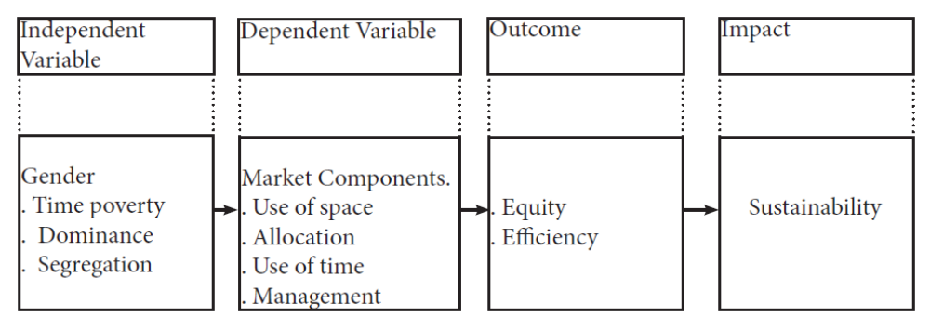
Figure 2.1; Conceptual Framework
Source; Author
The study envisages that Gender, which refers to the roles ascribed to men and women, influences the participation of traders in periodic markets. Gender implications in the study translate to; time poverty due to reproductive roles ascribed to women at home, male dominance in positions of governance and resource allocation and segregation in the market due to clustering of traders in particular forms of trade based on gender as indicated in Figure 2.1. The study has designated these as independent variables. The independent variables dictate the manner in which traders interact with market components in the periodic market. The market components are designated as dependent variables and include, the use of space, allocation of space, use of time and management. Interactions between the independent and dependent variables could result in efficiency and equity in market operations. This would in turn lead to sustainability in the periodic market as an impact. However, the roles ascribed to gender may cause imbalances for the male or female traders when it comes to participating in the market. Such are the perspectives that this study sought to highlight and mitigate in order to ensure market systems that are favourable to all.

CHAPTER THREE: METHODOLOGY

3.1 Overview
This chapter describes the methodology that was used in conducting the study. It describes the study area, research design, study population and sampling technique. The tools for data collection and analysis are also described.

3.2 Study area
Kibuye market which is the study area is located in Kisumu City. The market was chosen due to the fact that it is one of the largest open air markets in Kenya. Kisumu City where the market is located is the third largest city in Kenya and one of the fastest growing cities in the country. It serves as a principal city in the Western region of Kenya and has become one of the leading communication and trading confluences for East Africa (UNHABITAT, 2010). Kisumu City is located in Kisumu County as indicated in the Figure 3.1 below.

Figure 3.2 shows Kisumu City in its local context. It is bordered by major towns like Kakamega to the North, Kisii Town to the South, Kericho Town to the South East, and Siaya to the North West. The economies of these towns are mutually dependent with great transport, trade and commerce linkages (Kenya. Republic of, 2010). The Figure 3.2 also shows the location of Kibuye market.

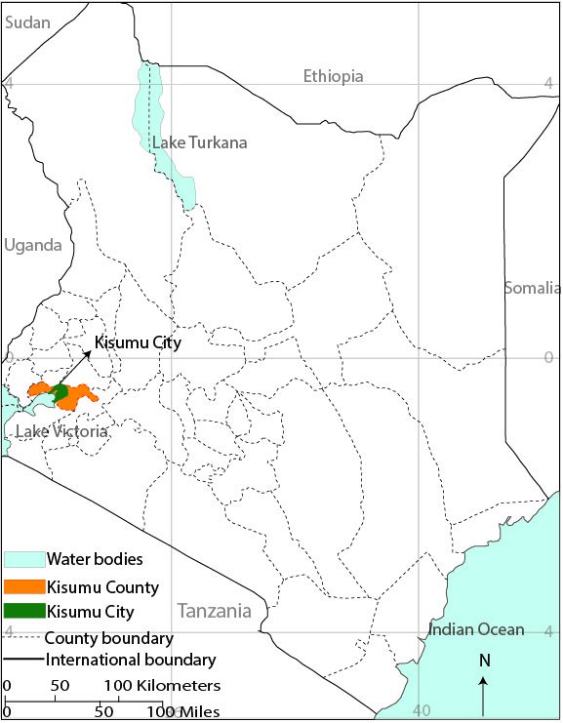

Figure 3.2; Kisumu County in the regional context
Source; Kenya, Republic of. (2010)

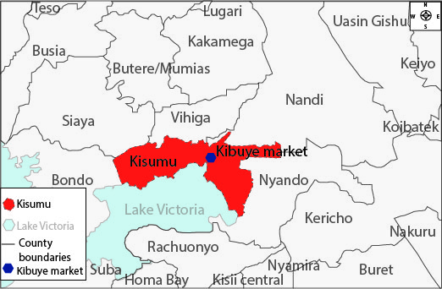

Figure 3.3; Kisumu City in the local context
Source; Kenya, Republic of. (2010)

3.2.1 Physical features
Location and Size
Kisumu City is situated between latitudes 34⁰ 35⁰ E and 34⁰55⁰E and longitudes 0⁰00⁰S and 12⁰S⁰and lies within the equator. It has a total area of 417 sq. km (157 sq. km. of water and 260 sq. km. of land (Municipal Council of Kisumu, 2004). The city is located in western region of Kenya, on the shores of Lake Victoria, Winam Gulf.

Topography
The city divides into two zones, the hilly North and the Southern Kano plains. The East of Kisumu town forms part of the southern zone which includes Chiga, Nyalunya and the slum areas of Nyalenda and Manyatta “B”. The hilly North namely Riat and Kajulu areas form the central parts of the city. The land then rises gently through Kanyakwar and merges with the steep escarpment of the Nandi Hills forming the Northern boundary and a physical barrier to the town’s expansion. Major outstanding physical features are overhanging huge granite rocks in Kisian and the Lake Victoria and its shoreline. (Municipal Council of Kisumu, 2004). The topography though varied is ideal for biking which constitutes 37% of transport in the area (Kola et al, 2013). Traders in Kibuye market take advantage of this by shipping their goods to and from the market by bicycles or hand drawn carts which require physical energy.

Climate
The city experiences an equatorial type of climate with 20⁰c - 30⁰c mean annual temperature and 1280mm mean annual rainfall. It receives bimodal rainfall with the long rainy season from August to September and short rainy season from October to February. Peak rainfalls are between March and May with the second peak in September and November. The heavy rains cause floods in poorly drained areas and rising lake levels. Areas vastly affected are Kolwa East and Central location and Kawino. It leads to damaged roads and bridges, collapsed schools, health facilities and residential buildings. The heavy rains also interfere with sanitation facilities, contamination of water and large masses of stagnant water contributing to spread of malaria and other water borne diseases (Municipal Council of Kisumu, 2004). Operations of the market during rainy seasons are thus hampered due to flooding and impassable roads.

Urban form and size
The first plan for Kisumu town was prepared in 1969 and covered an area of 19.8 km² and this was composed of the land within the Winam Gulf and the old airport. However in 1974, the Government acquired other land within Kanyakwar, Kibos and Nyalenda area about 1054.35Ha for town expansion. This was planned for oxidation ponds and Kasagam Secondary school (Nyalenda)and the Industrial area at Kibos. The 1983 plan covered an area of 76.9 km² however the plan was never implemented (UN-HABITAT, 2005 a). Kibuye market has been within the town boundaries positioning it for infrastructural development which is yet to be seen.

Currently, the built up and planned area of the town covers an area of 32.8km. The current built up area has adopted a concentric model of urban form however with a linear pattern along the major transportation corridors. There are three main roads which have defined the current growth; Kisumu-Nairobi Class A road, Kisumu-Kakamega Class A road and Kisumu-Busia Class B road. Kibuye market is located along the Kisumu-Kakamega road and therefore critical to the development of the town (Kenya. Republic of, 2010).

3.2.2 Population and demography
The census of 2009 (Kenya National Bureau of Statistics, 2010) sets the population of Kisumu at about 500,000 and it is estimated that the town has about 700,000 in its day population. The city experiences a net immigration flow from the surrounding districts of the Lake Basin; mainly
because of the variety of resources that continue to attract populations and investors within the region (UN-HABITAT, 2005 a). The catchment population for Kibuye market is therefore huge and varied more so by the day when it is in operation.

3.2.3 Transportation
Kisumu serves as a regional transportation node for the wider East African region. It has various means of transportation- road, rail, air and water. The region is well served by an elaborate road network with a total of 255 Kilometres of roads and streets(UN-HABITAT, 2005 a).This provides reliable transport for goods and people to and from Kibuye market.

However, the capacity of the railway line is underutilized as the Nairobi-Kisumu route is out of operation. The decline in railway as well as shipping services has increased the cost of trading limiting it to local goods, as road transport is relatively expensive. Initially, goods would be ferried to and from areas as far as Musoma, Mwanza and Bukoba in Tanzania and Jinja, Kampala and Entebbe in Uganda via the lake, bearing great economic benefit (UN-HABITAT, 2005 a). With the decline in railway and shipping services, transportation costs have increased for traders more so for bulky goods. Disconnection from Tanzania and Uganda has resulted in reduction of the variety of goods in Kibuye market.

The airport has been expanded to international standards with a runway over 3 Kilometres to accommodate larger and heavier aircrafts. This has great implications for Kisumu City and the region as a commercial and tourist centre due to its strategic location(Municipal Council of Kisumu, 2004). This creates the potential for the number of visitors coming to Kisumu to increase, consequently raising the catchment population for Kibuye market. However, air transport is too costly for the traders at Kibuye market to ferry their goods by.

3.2.4 Socio-cultural and economic factors
UN-HABITAT (2006) states that Kisumu City experiences high rate of food poverty with 53% of its population having insufficient food to sustain their families. Unemployment rate is about 30% and out of the working population 52% are engaged in informal activities (UN-HABITAT, 2006). The significance of Kibuye market as an informal source of income is thus evidenced. Its sustainability is critical to approximately 46% of the livelihoods in Kisumu.

The Economic activities that drive the economy of Kisumu include trade and commerce, manufacturing industry, informal sector, service sector, fisheries and tourism. The main economic activities in this sector are wholesaling and retailing, supermarkets, restaurants and hotels. The contribution of the sector to the local economy is 10%(Kenya. Republic of, 2010). About 46% of the local economy is supported by informal commercial activities such as hawking, selling of second hand clothes, food and vegetable kiosks, fruits and grains; operating mainly in stalls, mobile and stationary kiosks on the streets and in residential areas. All the forms of activities listed are found in Kibuye market as sources of livelihoods showing its significance.

The City Council of Kisumu has designated closed and open air markets i.e. Jubilee Market and Kibuye market for commercial activities. However, they are inadequate and cannot absorb the ever increasing informal trade activities (UN-HABITAT, 2005 b). This can be attributed to fact that Kisumu's population is growing at 2.6% against the national growth rate of 4.3% and the projection is that it will double from roughly one million to 2 million in 2039.Yet Kisumu has no approved densification and extension plans for addressing challenges of urban growth, wealth creation and land management (UN-HABITAT, 2012 b). As a result, informal commercial activities have increased in the town’s major streets. The Figure 3.3 below shows the periodic markets in the whole of Kisumu County.

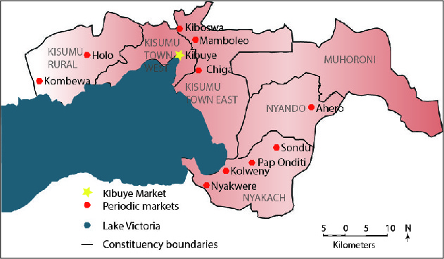

Figure 3.4; Periodic markets in Kisumu county
Source; (Folkesson & Skarp, 2012)

These markets have a main market day in which traders and consumers from different regions stream in to trade. Within Kisumu County, goods find their way from one market to another on the main market days. The largest flow of goods is usually to and from Kibuye market during the weekend in preparation for the Sunday market. Major periodic markets in Kisumu City are highlighted in the Figure 3.3 above. These include Kibuye, Kiboswa, Ahero and Sondu. Their main market days are on Sunday, Saturday and Thursday respectively. Altogether, Kisumu has a total of approximately 37 markets encompassing both daily and periodic markets (Folkesson, 2012).

3.2.5 Kibuye market
Kibuye market is located approximately 2km away from the Kisumu bus park. Based on a study conducted by KEMRI in 2013 the market has a total of 6,674 traders. Out of this number 4,206 (63%) are female while 2,468 (37%)are male (KEMRI, 2013).It is one of Kenya’s most animated, and certainly one of its largest markets, spilling out onto the surrounding roads. The Figure3.4 below shows the location of Kibuye market in relation to Kisumu City.

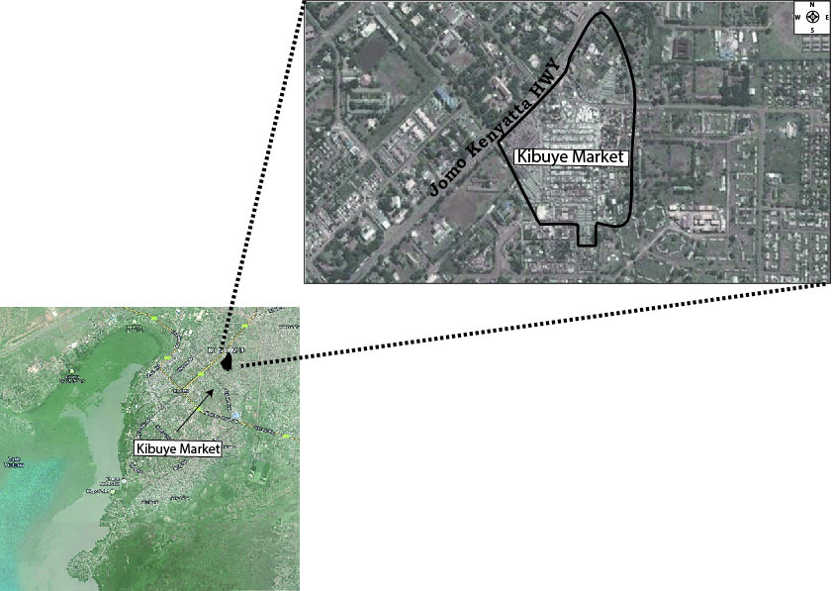

Figure 3.5; Aerial View of Kisumu
Source; http.imagery2012Ones/Spot Image. DigitalGlobe.GeoEye

The market occupies approximately of 8.92 ha of land (Kenya. Republic of,1994). Odidi (2014) states that over 50,000 people do their shopping in Kibuye market on a market day. Kibuye Market therefore serves as a source of livelihood for locals. It also serves as a centre for dissemination of information (Onyango et al, 2013).

3.3 Research design
The study employed a case study research design in its approach. Case study refers to an in-depth study of a particular problem rather than a sweeping statistical survey. The approach enabled the study to narrow down on the broad field of periodic markets and their dynamics. In light of this definition; the study selected Kibuye market to represent periodic markets which were of key interest to the study. Qualitative data was collected by use of interviews and focus group discussions (FGD). The interviews provided in-depth explanation on issues surrounding management of Kibuye market which was reinforced by discussions from the Focus group Discussions. Quantitative data was collected through questionnaires.

The study was conducted in two phases: the first phase involved administering of questionnaires and interview schedules to traders at Kibuye Market. This was done with the aid of enumerators. Pictures were also taken during the first phase to back up the information gathered. In order to evaluate the spatial distribution of uses in the market, the study used a base map from the physical planning department. The map indicated the boundary of Kibuye market to scale. Through the aid of Adobe Illustrator which is a computer software, the map was digitized to generate a softcopy without losing its dimensions. Uses of space in the market were then entered into the digitized map with the aid of GPS coordinates. The uses of space were zoned based on the dominant forms of trade. Phase two, was a purely qualitative inquiry in which key informant interviews and Focus group discussions were held. The information gathered was then entered into the computer and analyzed. The unit of analysis was the trader. The analysed results were discussed in the light of findings from previously concluded studies.

3.4 Study population
The target population consisted of all the 6,674 traders in Kibuye market (KEMRI, 2013). This is the population of traders on Sundays which is the main market day. In contrast to this population, Kibuye market receives approximately 2000 retailers and 200 wholesalers on weekdays as informed by the market superintendent. The Sunday population is the largest. The wholesale area is closed on this day and all traders operate in the retail area. Due to its large population of traders, Kibuye market is critical to the economy of Kenya and Kisumu City.
Sampling frame
The study drew its sample from a population of 6,674 traders. The figure 6,674 was obtained from a project conducted by KEMRI which sought to map out the location of traders in Kibuye market (KEMRI, 2013). Other studies have indicated existence of different categories of traders such as retailers, brokers, mobile vendors and wholesalers who are all important to the study (Poulton, 2005). The different categories could have varying needs for space which should be captured. Based on Watson's (2001) formulae, a sample size of 392 was obtained from 6,674 and placed in categories. The study used findings from Poulton (2005)to determine the population of the various categories as indicated in the Table 3.1 below. The findings show that the different categories of traders i.e. Mobile vendors, brokers, retailers and wholesalers form 9%, 7%, 46% and 38% of traders in Kibuye market respectively. The population for each category was therefore calculated from the population size given by KEMRI (2013) using the percentages highlighted by Poulton (2005).

Table 3.1; Sampling frame
Category of traders | Study population | Sample size
Mobile vendors | 601 | 36
Brokers | 467 | 28
Retailers | 3070 | 180
Wholesalers | 2536 | 148
Total | 6674 | 392
Once the sample size was determined, the traders were selected randomly according to the frame above.

3.5 Sample size
According to Watson (2001), sample size can be calculated using the formulae below. The formula is recommended when the population size is less than 10,000.
n = P (1 - P)
A² + P (1 - P)
Z² N
N Number of people in the population (6,674)
n Sample size required
P estimated variance in population as a decimal (0.5 for 50-50)
A precision desired expressed as a decimal (0.05 for 5%)
Z Based on confidence level (1.96 for 95%) confidence level
n = 0.5 (1 – 0.5)
0.05² + 0.5 (1 – 0.5) = 392
1.96²6,674
Key informant interviews were also conducted. The key informants included the local authority, self help groups and non-governmental organizations in operation within Kibuye market.
Sampling techniques
The study employed multi-stage sampling. This included; stratified sampling, quota sampling and purposive sampling. The overall sample of 392 was first divided into groups of specialization/strata; wholesalers, vendors, brokers and retailers hence stratified sampling. This was done to ensure the sample which is heterogeneous is well represented. Quota sampling which enables research to find and interview a prescribed number of people for each category defined (Oso, 2008), was then applied to the different strata/categories.

In purposive sampling, knowledge, experience and judgment are used to select the most desirable elements for a study. The method was employed in selecting the key informants for the study. The key informants selected were thus people with in-depth knowledge and understanding on matters of management in the market.

The number of respondents for each category was calculated from the sample size of 392 using the percentages highlighted by Poulton (2005). The numbers prescribed for each category are displayed in Table 3.1 as indicated above. In the administration of questionnaires to the retailers, vendors, brokers and wholesalers, simple random sampling was used for each category. Simple random sampling gives every sample an equal opportunity of being picked (Kerlinger, 1983).

3.6 Data Collection Methods

3.6.1 Secondary data
Secondary data was collected from e-journals, books and thesis -on market places and gender issues - to aid in literature review. The data helped focus the study based on previous researches that had been done. Photos and maps were also collected as secondary data.

3.6.2 Observation
Observation method was used for data collection. This was backed by taking of pictures to aid in depicting the actual scenario in Kibuye market.

3.6.3 Interview of traders
Interviews were conducted with the aid of questionnaires. The element of gender was very critical therefore the questionnaires were used to collect data on gender of traders. Of importance was also the diverse use of space in the market. This was identified by the trade in which a respondent engaged in and was captured by the questionnaires. The questionnaires further captured the parties involved in allocation of space within the market as well as the cost and size of the space for each trader. They had open ended and closed questions to aid in the collection of data.

3.6.4 Pre-test
A pre-test was conducted to test the validity of the questionnaires and the method of administration before actual data collection. Five respondents from each category were represented in the pre-test; mobile vendors, brokers, retailers and wholesalers; totalling to twenty respondents. In order to ensure pre-test respondents were not included in the main survey, respondents were asked to state whether they had participated in the research before; if they had- they were not included in the main survey. A letter authorizing administration of questionnaires was obtained from the local authority. The market superintendent was also notified on the intended activity of questionnaire administration. Traders were then approached randomly and interviews conducted face to face based on the category of trade that they belonged to.

3.6.5 Focus group discussion
A Focus group discussion was conducted for one hour as this was the maximum time traders were willing to spend away from their goods. Participants included; two brokers, two wholesalers, two retailers, two mobile vendors, the market superintendent and one security personnel from the local authority. Each category of trade had a male and female representative. The participants were selected with the assistance of the market superintendent. One of the traders availed his vacant stall as a venue for the meeting. Activities carried out by the participants included writing and drawing on charts as well as discussions.

The Focus group discussion aided the study in identifying the institutions operating within the market as well as the services that they offer. This was captured by mapping institutions and their linkages during the focus group discussion. The discussions were also used to identify existing resources within the market and their distribution. Participants gave recommendations on the issues they would like to be addressed for efficiency to be realized in the market.

3.6.6 Key informant interviews
Key informant interviews targeted local authority representatives working in the market; market superintendent and the head of market security. Chair persons of self help groups and nongovernmental organizations were also interviewed. Appointments were booked over the phone and interviews conducted face to face.

Interview schedules were used in conducting key informant interviews. The study mainly focused in identifying the different services provided by the institutions and gender balance of their employees. The interviews took approximately one hour as most of the questions in the schedule were intended to probe for information.

3.7 Data Analysis Techniques
The data collected in this study was analyzed both quantitatively and qualitatively. Quantitative analysis involves deriving statistical description and interpretation of data by use of descriptive statistics. In this case central tendencies like the mean and mode were used in establishing; the most common category of trade, the location of traders in the market based on gender, and different means of space allocation within Kibuye market. The mean also helped the study in determining the general size of space likely for a trader to occupy in the market. Pie charts and graphs were used to identify existing uses of space and how they compete, as well as the duration within which spaces can be owned.

Cross tabulation enabled the study to identify the relationship between ; gender and the size of spaces occupied; gender and the trade one deals in; size of space occupied in relation to trade. The data was displayed in contingency tables (cross tabs) and relationships between the variables established then measured through chi square tests. The relationship between gender and use of time was evaluated by cross tabulating; gender against traders operating in shifts. Further cross tabulation of gender against duration of space ownership was also conducted to evaluate the relationship between gender and use of time through Odds Ratios.

Gender balance in management was analysed through cross tabulation. Data on the gender of different market managers was cross tabulated. Venn diagrams were also used to show the institutions operating within Kibuye market and the linkages between them.

Findings from open ended questions were analyzed qualitatively. This involved looking for themes and contents in the qualitative data generated from the questionnaires and Key Informant Interviews. The results of the qualitative analysis were used to explain patterns emerging from the descriptive statistics.

CHAPTER FOUR: RESULTS AND DISCUSSIONS

4.1 Introduction
This chapter outlines the gender implications in market operations. The various uses of space are analyzed in relation to gender. The various modes of space allocation are also examined to determine their effect on equitable access to trading spaces for male and female traders. In evaluating the element of time, temporal dimensions of periodic markets are analyzed against gender. Accessibility of services by traders based on gender is also analyzed in the discussion of gender responsive management. The findings for every objective are compared to and contrasted against findings from other reports creating a basis for discussion in this study.Findings and discussions are organized in accordance with study objectives.

4.2 Relationship between Gender and Use of Space
This section addresses the first objective of the study and therefore seeks to answer the following research question; “What are the relationships between gender and use of space in a periodic market” in order to establish therelationships, the study examined the following parameters;
- Gender compositions of traders in Kibuye market in terms of sex and age
- The different categories of traders, how they use space and how this relates to gender
- Zoning of the market for the sale of different trade items and how this relates to gender.
- Sanitation and Hygiene in the use of space within the market in relation to gender

4.2.1 Gender Compositions of Traders in Terms of Sex and Age
Based on analysis of the data collected, the study found that (47%) of the 392 respondents contacted were male and (53%) female. The percentage of female respondents in the market supersedes the proportion proposed in the gender representation policies of Kenya recommending 30% representation of women in participation (Kiura, 2014). The findings therefore indicate a strong presence of both male and female respondents with female traders dominating at 53%. This finding is in line with UN-HABITAT (2009 c) which states that 84% of engaged in periodic markets are women. However, the findings in Kibuye indicate a stronger presence of men in the market at 47% in comparisons to 16% as stated by UN-HABITAT (2009 c).

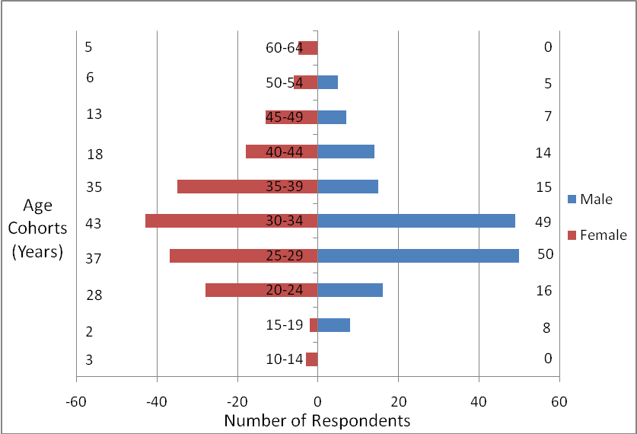

Figure 4.6; Population pyramid showing the distribution in age of traders by count
Source; Author

The Figure 4.1 shows the distribution of respondents across different age cohorts. The values in the pyramid along the y- axes show the number of respondents in the specified age cohorts. For male respondents, the highest count was falling between age 25-29 and 30-34 for women. In general, 179 of the 392traders i.e. (46%)were between ages 25 and 34. The study calculated the upper and lower limits of males and female in the age bracket to determine whether the difference was significant as shown in the Table 4.1below.

Table 4.2; Upper and lower limits of dominant age bracket.
Gender | Traders between ages 25 and 34 | Lower limit | Upper limit
Male | 55% | 38.9 | 70.9
Female | 45% | 27.8 | 65.8

The higher figure 55% was significantly higher as its upper limit was more than the lower figures lower limit and the lower figure 45% was significantly lower as its lower limit was less than the higher figures upper limit. The study thus found that Male traders dominated the age bracket at 55% which was significantly higher than the percentage of female traders at 45%. The implication of this to participation in the market is highlighted by studies in Peru stating that both gender and age affect participation of men and women in the labour market. Men being viewed as bread winners have more time to seek and engage in employment while women mostly aged 33 years, are hindered from optimal participation due to the responsibility of caring for young dependent children USAID (2006). This coupled with unpaid household and family maintenance work such as preparing meals, and keeping the household clean implies that women generally have less time to pursue economic activities than men (Raji, 2005).

Given the gender roles ascribed to males and females, the female traders are most likely to bear more responsibilities at home than their male counterparts (USAID, 2006) and (Raji, 2005). This results in time poverty for female traders thus disadvantaging them in the contest for space. Male traders thus have more opportunity to carry out activities in the market place. Their productive roles thus hinder the optimum participation of female traders in competing for market resources as opposed to the male traders; who are more than female traders in this age bracket. Access to resources would therefore be unequal for the male and female traders in the market.

4.2.2 The Use of Space by Different Categories of Traders
The study defines use of space as the activities carried out in trading spaces as well as the characteristics of the spaces. The space in Kibuye market covers an area of 8.92 ha as indicated in a Part Development Plan by the Ministry of Lands (Kenya. Republic of, 1994). The space is used by approximately 6,674 traders (KEMRI, 2013). The traders sell a variety of goods as displayed in Figure4.2. A majority of the traders (41%) sell food. This is closely followed by traders selling fabric (35%).The fabric seller’s trade in clothes, curtains, bedding and bags. A separate category “other” represents goods that are sold in small scale compared to; food, fabric and furniture. They include; hardware (2.3%), charcoal selling (1.9%), cobbler (1.4%) and art work (0.6%).

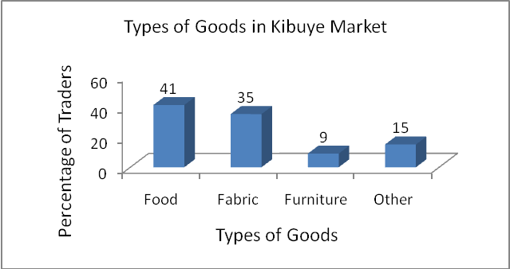
Figure 4.7; Types of goods in Kibuye market
Source; Author
As is displayed in the Table4.2 the study finds that of the 41% food traders;68% are female and 32% are male. Furniture on the other hand has 100% male traders and no female traders. This shows gender segregation in relation to goods sold as reported by (Raji, 2005) and could hinder efficient operation of traders in the market due to clustering of either male or female traders in specific locations.

Table 4.3; Goods sold by male and female traders
 | Respondents gender |  |  |  | Total
Commodities of trade | Male |  | Female |  | Percentage (%) | Count
Commodities of trade | Count | Percentage (%) | Count | Percentage (%) | Percentage (%) | Count
Food | 51 | 13 | 109 | 28 | 41 | 160
Fabric | 63 | 16 | 74 | 19 | 35 | 137
Furniture | 36 | 9 | 0 | 0 | 9 | 36
Others | 35 | 9 | 24 | 6 | 15 | 59
Total | 185 | 47 | 207 | 53 | 100 | 392

This study categorizes traders as wholesalers, retailers, vendors and brokers. Wholesalers buy goods in large quantities and sell to retailers and consumers. Goods are produced outside the market e.g. farms. Suppliers then get goods from producers intending to sell to wholesalers and retailers. Brokers often act as a bridge linking suppliers to wholesalers and retailers. The goods are then sold to consumers. The study focused on the players operating within the market and their presence indicated by the percentages in the Table 4.3 below.
From the Table4.3,(76%) of the traders interviewed operate as retailers registering the highest in comparison to other categories. Out of the 76% retailers, 34% are male and 42% are female. The category of brokers registers the lowest number of traders. Since the aim of periodic markets is to reduce the number of people in the chain of transaction from production to consumer (Rozelle 2002), the highest number of retailers registering in the market indicates that this has been achieved. Table 4.3 was subjected to a chi square analysis to test whether the differences between male and female respondents were statistically significant. On an SPSS print out, the p. or significance value must be the same size or smaller than your significance level to show statistical significance. The significance level used was 0.05. The p. value (0.047) in the SPSS analysis as displayed in Table 4.4 was found to be smaller than the significance level. The study therefore finds that percentage of female traders engaged in retail is significantly higher than that of the male traders.
Table 4.4; Categories of traders in relation to gender
Category of traders |  | Male | Female | Total
Retailer | Count | 116 | 141 | 257
Retailer | Percentage % | 34.2% | 41.6% | 76
Retailer | Percentage % Within | 45% | 55% | 100%
Wholesale | Count | 24 | 12 | 36
Wholesale | Percentage % | 7.1% | 3.5% | 10.6%
Wholesale | Percentage % Within | 66% | 34% | 100%
Vendor | Count | 14 | 24 | 38
Vendor | Percentage % | 4.1% | 7.1% | 11.2%
Vendor | Percentage % Within | 36.6% | 63.4% | 100%
Broker | Count | 0 | 2 | 2
Broker | Percentage % | 0.0% | 0.6% | 0.6%
Broker | Percentage % Within | 0.0% | 100% | 100%
Other | Count | 2 | 4 | 6
Other | Percentage % | 0.6% | 1.2% | 1.8%
Other | Percentage % Within | 33.3% | 66.7% | 100%
Total | Count | 156 | 183 | 339
Total | Percentage % | 46.0% | 54.0% | 100.00%
Total | Percentage % Within | 46.0% | 54.0% | 100.00%

Table 4.5; Chi-Square Test
 | Value | df | Asymp. Sig. (2-sided)
Pearson Chi-Square | 9,641(a) | 4 | ,047
Likelihood Ratio | 10,476 | 4 | ,033
Linear-by-Linear Association | 6,764 | 1 | ,009
N of Valid Cases | 339

The percentages of traders represented in each category by gender, is of significance in evaluating equity and efficiency in market operations because, the different categories of trade have varying space needs. Therefore, the study investigated the sizes of spaces used by traders for each category and compared them to the recommended sizes of spaces. Measurement of space focused on area (length by width) due to the uniformity in height of stalls (3 m). The study found that in Kibuye market, spaces occupied by traders varied vastly and there was no uniformity. For vendors and retailers, the smallest spaces comprised of spaces used to display goods in baskets that could be carried as head loads, having dimensions as small as 0.5m by 1m approximately. On the contrary, spaces used for wholesale were larger due to the bulk of goods. However, there was no regularity in the sizes of shapes and therefore stall measurements varied highly e.g. 1m by 3m, 2m by 2.5m and 1.5m by 3m.Due to the varying nature of space use, the study created categories to aid in analyzing data. Spaces were thus categorized as; spaces measuring 1m by 1m and below, 1m by 2m, 1m by 3m and above 1m by 3m.

Table4.5 illustrates how space is distributed among the respondents of the study based on their categories of trade. Wholesalers occupying spaces measuring 1m by 1mand below, 1m by 2m,1m by 3m and above 1m by 3m were found to be; 5.6%, 38.9%, 16.7%, 38.9% respectively. In total, the percentage of wholesalers occupying spaces measuring 1m by 3m and above was 55.6%.Retailers on the other hand were found to be occupying space as follows; 24.4% in spaces measuring 1m by 1mand below, 29.8% occupying 1m by 2m, 26.9% in 1m by 3m and 18.9% occupying above 1m by 3m. Out of these a total of 45.8% retailers, occupied spaces measuring 1m by 3m and above. In the category of vendors the study found that 55% occupied spaces measuring 1m by 3m and above. Comparing the percentages of vendors to that of retailers occupying 1m by 3m and above (55%)and(45.8%) retailers; the study finds that vendors seem to enjoy more access to space than retailers.
Table 4.6; Distribution of space amongst different categories of traders
Size of space in m |  |  | Category of traders |  |  |  |  | Total
 |  |  | Wholesale | Retailer | Vendor | Broker | Other | Total
Size of space in m | 1 m by 1m and below  (1 m²) | Count | 2 | 67 | 14 | 0 | 2 | 85
Size of space in m | 1 m by 1m and below  (1 m²) | % within Size of space in meters | 2.4 | 78.8 | 16.5 | 0.0 | 2.4 | 100.0
Size of space in m | 1 m by 1m and below  (1 m²) | % within category of traders | 5.6 | 24.4 | 35.0 | 0.0 | 33.3 | 23.7
Size of space in m | 1 m by 1m and below  (1 m²) | % of Total | 0.6 | 18.7 | 3.9 | 0.0 | 0.6 | 23.7
Size of space in m | 1 m by 2 m  (2 m²) | Count | 14 | 82 | 4 | 2 | 0 | 102
Size of space in m | 1 m by 2 m  (2 m²) | % within Size of space in meters | 13.7 | 80.4 | 3.9 | 2.0 | 0.0 | 100.0
Size of space in m | 1 m by 2 m  (2 m²) | % within category of traders | 38.9 | 29.8 | 10.0 | 100.0 | 0.0 | 28.4
Size of space in m | 1 m by 2 m  (2 m²) | % of Total | 3.9 | 22.8 | 1.1 | 0.6 | 0.0 | 28.4
Size of space in m | 1m by 3 m  (3 m²) | Count | 6 | 74 | 12 | 0 | 2 | 94
Size of space in m | 1m by 3 m  (3 m²) | % within Size of space in meters | 6.4 | 78.7 | 12.8 | 0.0 | 2.1 | 100.0
Size of space in m | 1m by 3 m  (3 m²) | % within category of traders | 16.7 | 26.9 | 30.0 | 0.0 | 33.3 | 26.2
Size of space in m | 1m by 3 m  (3 m²) | % of Total | 1.7 | 20.6 | 3.3 | 0.0 | 0.6 | 26.2
Size of space in m | Above 1 m by 3 m (3 m²) | Count | 14 | 52 | 10 | 0 | 2 | 78
Size of space in m | Above 1 m by 3 m (3 m²) | % within Size of space in meters | 17.9 | 66.7 | 12.8 | 0.0 | 2.6 | 100.0
Size of space in m | Above 1 m by 3 m (3 m²) | % within category of traders | 38.9 | 18.9 | 25.0 | 0.0 | 33.3% | 21.7
Size of space in m | Above 1 m by 3 m (3 m²) | % of Total | 3.9 | 14.5 | 2.8 | 0.0 | 0.6 | 21.7
Total |  | Count | 36 | 275 | 40 | 2 | 6 | 359
 |  | % within What is the size of your area of operation in meters? | 10.0 | 76.6 | 11.1 | 0.6 | 1.7 | 100.0
 |  | % within category of traders | 100.0 | 100.0 | 100.0 | 100.0 | 100.0 | 100.0
 |  | % of Total | 10.0 | 76.6 | 11.1 | 0.6 | 1.7 | 100.0

Tracey-White (2003) states that the required space for wholesalers should be 6m² and 3m² for retailers. The space needs for vendors are however not specified other than the need for efficient movement to aid their form of trade. The space needs specified by Tracey-White (2003) are not met in Kibuye market where 61.2% wholesalers occupy spaces less than 1m by 3m as opposed to the stipulated 6m² (Table 4.5).In Table 4.3 out of the 10.6% wholesale traders, 66% are male and 34% female indicating male dominance in category of trade. Bearing in mind that the difference between men and women is statistically significant, the study finds that male traders are most affected by the inadequacy of space for wholesale. Vendors in Kibuye market occupy more space than is stipulated by Tracey-White (2003) as 65% occupy more than 1m by 1m (Table 4.5). Vendors make up 11.2% of traders in Kibuye market. Out of these 36.6% are male and 63.4% are female (Table 4.3). Retailers who form 76% (Table 4.3) of traders in the market have 81.1% (Table 4.5) of traders in the category occupying spaces measuring less than the stipulated 3m².The findings thus indicate inefficiency in distribution of space where vendors are taking up more space than they require while retailers and wholesaler fail to access the required sizes of space. Use of space is therefore inefficient as the required standards are not met. The ones affected adversely are female retailers who form 55%of retailers in the market.

Further, in evaluating equity in resource distribution, the relationship between gender and size of space occupied was evaluated. Data on gender and sizes occupied was cross tabulated in Table 4.6 and subjected to a chi-square analysis before being interpreted. The purpose of the chi-square test was to test whether the differences in the Table 4.6 are due to chance.

Table 4.7; Sizes of spaces occupied by traders
Area of operation in meters. | Gender of traders |  | Total Percentage (%)
 | Male | Female
1 m by 1m and below | 6.0 | 17.7 | 23.7
1m by 2 m | 14.9 | 13.5 | 28.4
1 m by 3m | 10.7 | 15.5 | 26.2
Above 1 m by 3 m | 14.3 | 7.4 | 21.7
Total | 45.9 | 54.1 | 100.0

The study was testing whether there is a relationship between gender and the sizes of spaces occupied by traders. Using a confidence level (Alpha) 0.05, degree of freedom (DF= 3), the chi square calculated was 7.9 (p-value) as indicated below;
DF = (Columns - 1) × (Rows - 1)
= (2 - 1) × (4 - 1)
= 1 × 3 = 3
Chi Square = (O - E)² ÷ E
O The observed value in a cell
E The expected value in the same cell we would see if there was no association
E = Row × Column
= 4 × 2 = 8
45.9 × 21.9/100 = 10.0521 (5.1 - 10.0521)² ÷ 10.0521 = 2.4
45.9 × 27.6/100 = 12.6684 (14.5 - 12.6684)² ÷ 12.6684 = 0.2
45.9 × 25.4/100 = 11.6589 (10.3 - 11.6589)² ÷ 11.6589 = 0.1
45.9 × 25.1/100 = 11.5209 (16.0 - 11.5209)² ÷ 11.5209 = 1.3
54.1 × 21.9/100 = 11.8479 (16.8 - 11.8479)² ÷ 11.8479 = 1.9
54.1 × 27.6/100 = 14.9319 (13.1- 14.9319)² ÷ 14.9319 = 0.2
54.1 × 25.4/100 = 13.7414 (15.1- 13.7414)² ÷ 13.7414 = 0.1
54.1 × 25.1/100 = 13.5791 (9.1- 13.5791)² ÷ 13.5791 = 1.7

Chi Square = 2.4 + 0.2 + 0.1+ 1.3 + 1.9 + 0.2 + 0.1 + 1.7 = 7.9

In chi square analysis when p-value is equal to or greater than the table value at the chosen confidence level and degree of freedom, the study decide that there is statistical significance in the data analysed (Rose, 2013). The p-value 7.9 is greater than 7.815 (Value of 0.05 in the chi-square distribution table). The study thus finds that differences between gender and sizes of spaces occupied seen in the Table 4.6 are not due to chance but of statistical significance.

Table 4.6 shows that larger spaces measuring 1 m by 3m and above are dominated by men (14.3%) with 7.4% of female traders occupying such spaces. A majority of female traders - 17.7% occupy spaces measuring 1m by 1 m and below, while 6% of male traders occupy such spaces. The data shows a skewed distribution of space in favour of male traders. In general, the Table 4.6 shows that approximately 78.3% of traders occupy spaces measuring 1 m by 3mand below failing to meet the specifications of FAO. The planning handbook of Kenya stipulates that the minimum size of a stall should be 3m by 3m (Kenya. Republic of, 2007 a); However in Kibuye only 25% of traders occupy this kind of space out which 14.3% are male. The male traders fare better than the female traders in the contest for space as they have access to larger spaces.

The Table 4.7 below analyzes whether men occupy larger spaces than women in instances where both are trading in similar goods. The study finds that a majority of male traders selling food (40%) occupy spaces measuring 1 m by 2m. Female traders selling food majorly (32.4%) occupy spaces measuring 1mby 1 m and below. From Table 4.7 the study confirms results in Table 4.6 indicating that male traders occupy larger spaces than female traders illustrating inequitable distribution of space where female traders are disadvantaged. This results into overcrowding and congestion which reduces efficiency in the market operations due to constrained movement.

Table 4.8; Sizes of spaces occupied by traders selling food
Size of space occupied by traders in meters | Male Percentage (%) | Female Percentage (%)
1 m by 1m and below | 20 | 32.4
1 m by 2 m | 40 | 17.6
1 m by 3 m | 13.3 | 29.4
Above 1 m by 3 m | 26.7 | 20.6
Total | 100 | 100

The current organization of the market is such that some areas have been designated for specific uses hence existence of zoning to some level. The core of the market is distinctly occupied by food on Sundays. Unfortunately it is the least developed in terms of infrastructure with 61% of traders at the core displaying their goods on the ground as indicated by data from the questionnaires. Since traders at the core are mostly small scale retailers occupying (1m by 2 m), constructing stalls would not be an ideal way of organizing the space. Hard surfaces clearly labelled and demarcated could be constructed in the area; a measure which would increase access to resources for all traders.

Surfaces that are slightly raised off the ground for ease of reach could be constructed. They would also range in sizes to cater for different categories of traders as wholesalers need more space than retailers (Tracey-White, 2003). Temeke market in Tanzania for example designates sizes of space based on type and amount of goods sold. Stalls and stands have fixed spaces but areas where goods are displayed on the ground are fluid to accommodate varying space needs more so for wholesalers (Mbisso, 2011). This is a strategy that could work for Kibuye market. Further the area could be zoned for highly perishable and easily contaminated food only - like fish, fruits and vegetable - enabling the implementation of such a strategy. Other food items like cereal and spices which are not easily contaminated could be placed in areas zoned for mixed use. Plate 4.1 below gives an example of the paved surfaces that can be constructed in the market.

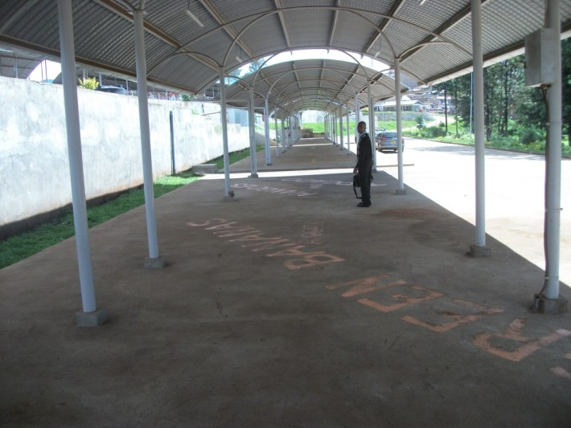
Plate 4.1; Gakomore market of Meru County-Kenya
Source; Murithi, 2013

Overall, the study found that female traders dominate in the market clustering around the age cohort of 30-34 which could hinder their optimal participation in the market due to gender roles ascribed to females by society. Patterns of space use like selling of food in close proximity to metal works were also identified as incompatible by the study reducing efficient operations of the market. Further, the study found that the distribution of traders in the market fails to support equitable access to market resources between male and female traders; as male traders occupy the most favourable positions (market edge) in larger proportions than women.

This was also evidenced by the provision of better infrastructure at the edge. The market edge is dominated by male traders i.e. 27% out of 45% as opposed to the core which is dominated by female traders i.e. 12% out of 20%. Chi square analysis reinforced the discussion that male traders fare better than the female traders in the contest for space as statistics show that they significantly have access to larger spaces; resulting in overcrowding and congestion which reduces efficiency in the market operations due to constrained movement.

4.2.3 Zoning of the Market for the Sale of Different Trade Items
In order to determine the use of space in Kibuye market, the study borrowed from models of space analysis used by (Rozelle, 2002) and (UNHABITAT, 2005 a). In her analysis of rural periodic markets in China, Rozelle divides the market place into three zones (core, next to core and edge). The core as analyzed by Rozelle has the highest demand and competition for space while the edge has the least demand. UNHABITAT (2005 a) divides the land use of Kisumu City into three zones; zone A, zone B and zone C. Zone A is well planned with efficient supply of utilities. As you move towards zone C, the zones are less developed so much that the last zone exhibits charateristics of slums.Mary (1993) emphasizes the importance of traders’ location in the market citing the core as the heart of the market where traders prefer to be located for ease of access to customers. Consequently, the study divided the area of Kibuye market into three zones: core, next to core and edge to investigate the relationship between the zones with regard to equity and efficiency in market operations.

The study found that more male traders are located at the edge of the market as opposed to female traders who are more at the core and next to the coreas displayed in Figure 4.3. The distribution of male and female traders could be explained by findings indicating that carpentry and metal works dominate the spaces on the market edge (Table 4.8) and explain the reason for male traders monopolising the zone. Since female traders are mostly located at the core and next to core as depicted in the Figure 4.3. it is an indicator that they mostly trade in food stuffs which dominate the zone. Evidently gender influences the type of trade a trader deals in. Given the spatial organization of kibuye market, it results in a marked sex segregation of the market as sited by (USAID, 2006) and (Yusuf, 2007). As such areas dominated by carpentry will have more men and those dominated by food will have more women.

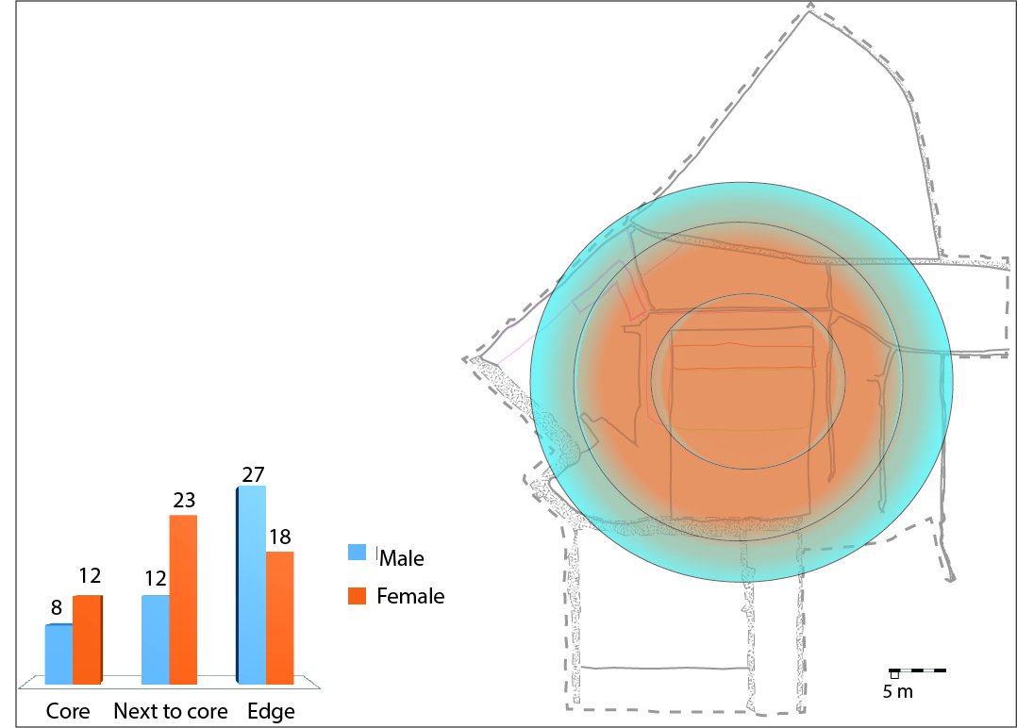

Figure 4.8; Distribution of traders by gender in Kibuye market
Source; Author

As indicated by 42% of the respondents interviewed, the trading posts they occupied were chosen based on proximity to customers. The market edge could thus be considered by traders as the ideal location for a trading post due to the high number of customers passing along the road which the market fronts. However, of the 44% traders located at the edge, 27% are male while 18% are female Figure (4.3.) At the core where the least numbers of traders and variety of goods are found, 12% of the traders are female while 8% are male.

This finding is in contrast with Mary's (1993) findings which state that the core is the most ideal location for traders in terms of access to customers. In Kibuye market, the edge is considered more favourable and is dominated by men. They appear to occupy the most favourable positions in larger proportions than women. This distribution fails to support equitable access to market resources between male and female traders.
Further, the study examined the distribution of goods in the market to evaluate whether similar goods clustered together to form distinct zones. The Table 4.8below illustrates the distribution of goods in the market. Study findings show that 44.9% of traders are located at the market edge and they majorly sell food (16.5%) and clothes (16.3%). At the core, 20.9% of the respondents are located with a majority of 12.8% selling food. The Table 4.8illustrates how mixed the use of space is, in Kibuye market.

Table 4.9; Distribution of goods in the market
Commodities | Location within the market  Percentage (%) |  |  | Total Percentage (%)
 | Core | Next to core | Edge
Clothes | 6.1 | 12.4 | 16.3 | 34.8
Food | 12.8 | 13.9 | 16.5 | 43.2
Carpentry | 0.6 | 3.7 | 7.9 | 12.2
Metal works | 0.6 | 1.4 | 1.8 | 3.8
Residential/shops | 0.0 | 3.0 | 3.0 | 6.0
Total | 20.9 | 34.2 | 44.9 | 100.0

Study findings from the Table 4.8 together with observation were used to generate Figure 4.4 in order to display the actual land use in the market. The findings indicate that at the core; the central most part of the market, traders mostly sell food as indicated in the Figure 4.4.Clothes and furniture are also found in stalls at the market core. Next to the core; food and clothing dominate. Some residential units are also located next to the core on the far eastern side. The market edge is where the bulky goods and are located i.e. metal works, carpentry and warehouses for storage of whole sale goods. The local authority has designated some areas for specific use. The areas correspond to the ones in Figure 4.4 i.e. the area designated for carpentry and metal works. Although specific uses are dominant in the different zones, all three areas have a variety of goods for sale and use of space is not as evenly distributed as displayed in Figure 4.3 above.
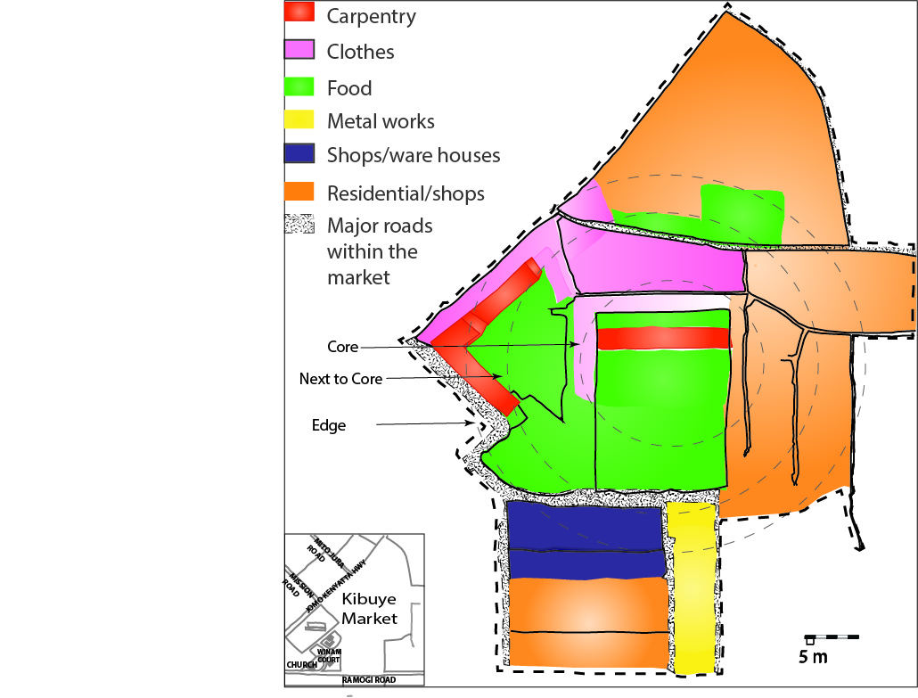

Figure 4.9; Distribution of space use in Kibuye market
Source; Author

Having a variety of goods in the zones could reduce the distance travelled by customers while shopping increasing efficiency in flow of people within the market. However, if not planned for, varying uses of space could result into incompatibility. The Figure4.5. below illustrates how the composition of goods in Kibuye market results in incompatible use of space e.g. selling of food and metal works in close proximity. The Figure 4.5 indicates that at the core of the market, 64% of the space is used to sell foods and 30% used to sell clothes. However a small percentage of 6% is used for carpentry and metal works which could result in contamination of the food. This phenomena is similar to that of bazaars described by Rozelle (2002) where traders place goods anywhere space is available regardless of compatibility. Such practices hinder efficient use of space in the market. Considering that there are 12% female traders and 8% male traders at the core, the female traders are more vulnerable to contamination as 68% of traders selling food are female.
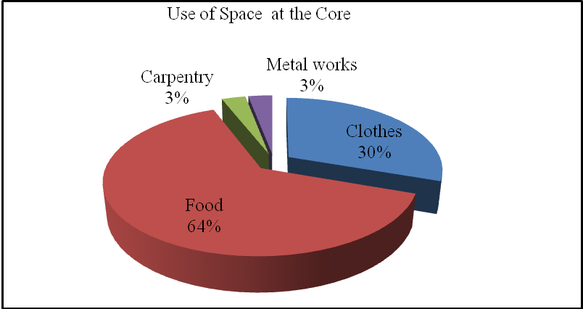

Figure 4.10; Use of space at the core of the market
Source; Author

Zoning of space use within the market could improve efficiency of market operations. Zoning refers to the creation of zones for respective land uses. It is designated to permit uses of land, based on mapping zones which separate one set of land from another as way of regulating the use to which land may be put. Kenyan law acknowledges the importance of zoning to sustainable land use and land management; the Physical Planning Act 1996 and Environmental Management Coordination Act contains zoning laws in Kenya (Sifuna, 2009).

For Kibuye market, the space can be divided into three zones (Figure 4.6 below). Each area could be complete in its composition of goods and services. The plan would improve access to all zones of the market so that being located at the core no longer remains a disadvantage by having less accessibility. Since it is dominated by women, this will contribute to equity in terms of how favourable a location is. The market could be zoned into three distinct areas in which goods would be grouped based on compatibility.

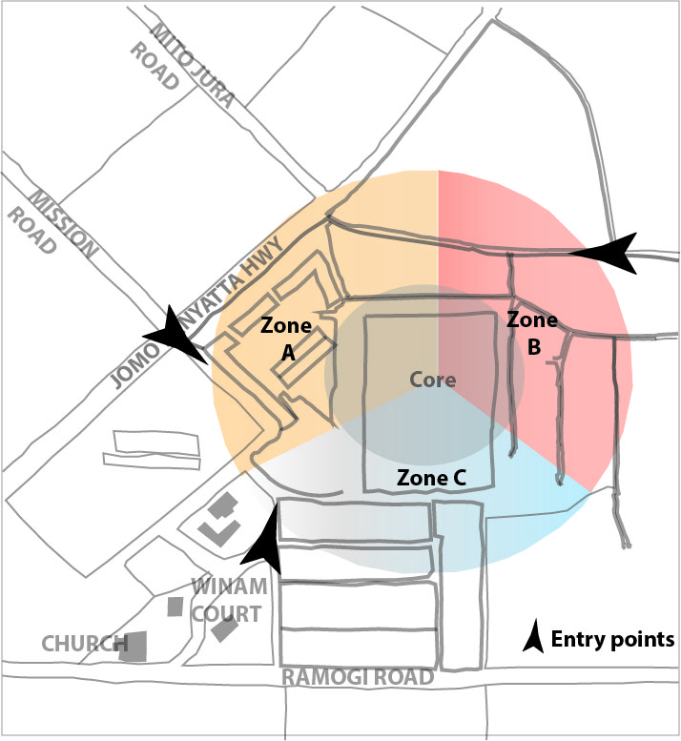

Figure 4.11; Proposed plan for Kibuye market
Source; Author

An illustration of how zones could be organized to ensure compatibility of use is given in the Figure 4.7 below. Stalls at the edge of the market would be designated for uses like carpentry, tailoring, artwork, salons and cereal as well as foods that are not easily contaminated. As stalls and spaces locate closer to the core, use would change to sale of clothing, shoes, bedding and fabric. In this area, food can also be sold with less restriction as trades like carpentry would not be permitted. At the very core of each zone, the spaces would be exclusively designated for sale of food. Highly perishable goods would thus be located at the core of the market. Zoning would thus address incompatibility and order (Mbisso 2011).

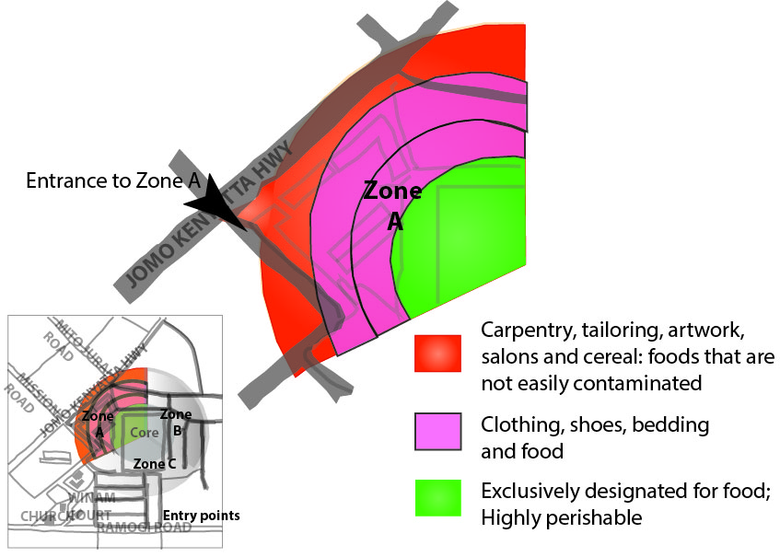
Figure 4.12; An extrapolation of Zone 'A'
Source; Author

4.2.4 Sanitation and Hygiene in the Use of Space within the Market
Evidently the use of space in periodic markets varies as is the case for Kibuye market where traders use space in a variety of ways; ranging from sale of food to carpentry. The existence of a large variety of goods can result in patterns of space use that are compatible or incompatible. Incompatibility in space use was depicted by seven respondents in the study who were selling charcoal and food side by side. However, in Kibuye both patterns of space use are exhibited as depicted in the Plate 4.2 below.


Plate 4.2; Traders selling vegetable next to charcoal
Picture taken at Kibuye market-Kisumu City at 2.00 p.m. showing incompatible use of space at the market core

The market core is designated for sale of food which is main trade in Kibuye market engaging 41% of the traders. Of the 41% traders selling food, 27.3% are women and 13.4% are men. This designation automatically means that a majority of the traders at the core will be women. The Plate 4.3below shows traders at the core of the market displaying grocery.
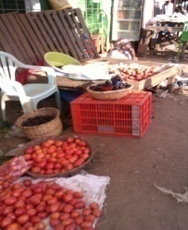
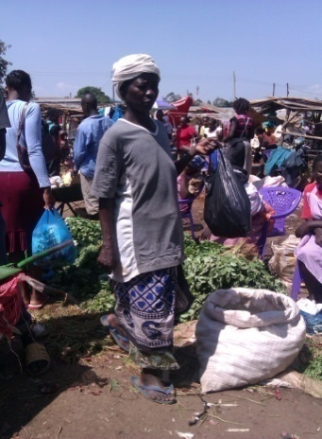
Goods are displayed using different methods. Some are raised from the ground using objects like the crate as displayed in Plate 4.3. Others are placed directly on the ground where they can be easily contaminated. Plate 4.4 illustrates perishable goods like vegetables being displayed under direct exposure to sunlight increasing the risk of them going bad. The methods used to display goods are similar to the ones used in Darajani market in Zanzibar (Ogada, 2013). The traders in Darajani market also display goods directly on the ground or on makeshift stands. Requirements according to Tracey-White (2003) recommend that spaces used for display of food be raised or paved for hygiene purposes. Storage should also be provide especially for traders selling grain. The recommendations are lacking in both Kibuye and Darajani market. Incidentally, the number of stalls in this area (core) is less than that of carpentry dominated areas yet food requires higher hygiene standards than furniture (Tracey-White, 2003). The Table4.9 below shows the percentage of traders with stands to display their goods. At the core where food dominates at (64%), only 8% of Traders display their wares on a stand. At the market edge, 25.6% of traders have access to stands Table 4.9.
Plate 4.3; Innovative ways used by traders to raise displays form the ground
Picture taken at 4.00 p.m. in Kibuye market

Plate 4.4; Vegetables displayed directly on the ground
Picture taken in Kibuye market at 11.00 a.m.
Table 4.10; Percentages of traders with stands for display
Availability of stands in the market.
Percentage (%)
 | Core | Next to core | Edge | Total Percentage (%)
Traders with stands | 8.7 | 20.7 | 25.6 | 55.0
Traders without stands | 13.3 | 13.3 | 18.4 | 45.0
Total (%) | 22.0 | 34.0 | 44.0 | 100.0

Plate4.5 below shows carpentry area with stalls used as stores. This is at the market edge where 25.6% of the traders have stands out of the 44% located at the edge. The stalls are used as stores because furniture is displayed outside the stalls on weekdays. On Sundays, the stalls remain closed to free spaces for food traders who display on the ground.
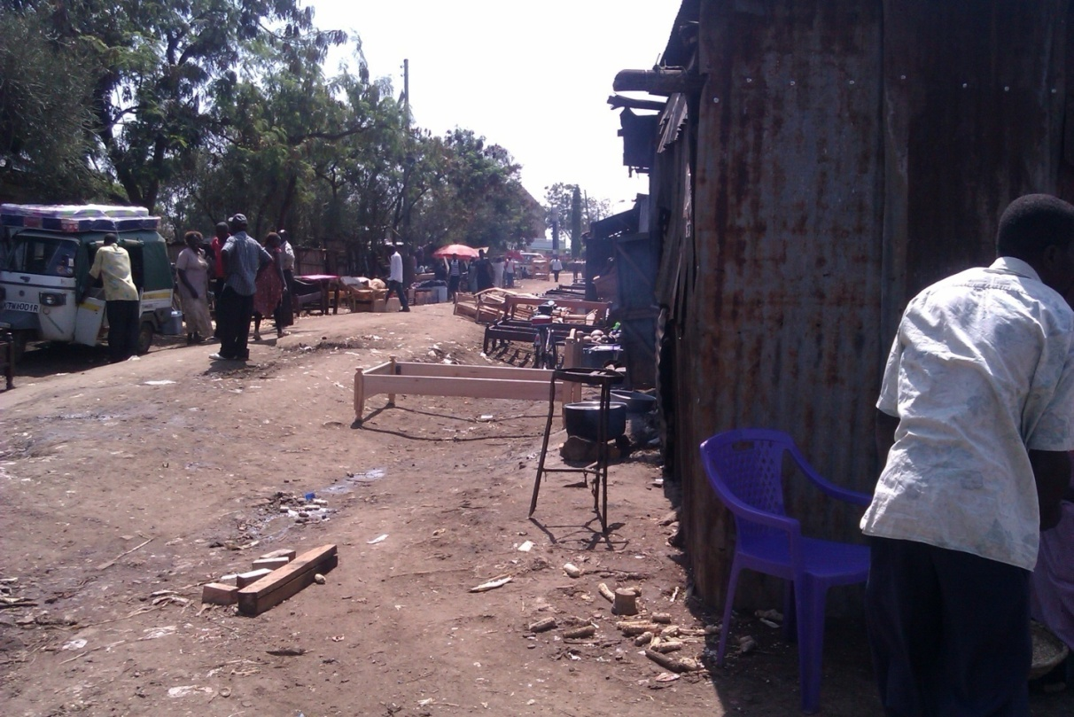

Plate 4.5; Furniture displayed outside workshops in Kibuye market
Picture taken at 12.00 noon on a Monday after the market day

The study finds that in Kibuye market, preference is given to traders at the market edge as they are provided with better infrastructure (lockable stalls). Considering that the core is dominated by female traders i.e. 12% out of 20% and the edge dominated by male traders i.e. 27% out of 45%, there seems to be inequitable distribution of resources between female and male traders. Traders located at the market edge who deal in carpentry don't work on Sundays. The arrangement has been put in place with the aim of providing space for retailers on Sunday. Although the carpentry stalls remain closed, it is the spaces outside the closed stalls that are used by traders to display their goods; often food (Figure 4.8 below).

"When I come to the market, I try to get space close to the carpentry stalls because they are close to the road therefore close to potential customers. Carpenters close their stalls on weekends to give room for traders with less bulky goods "

This results in traders encroaching onto the road as displayed in Figure 4.8. The strategy also leads to underutilization of resources as stalls are closed yet traders are displaying goods on the ground and encroaching on the road.

Design and construction of stalls that can accommodate both traders (Figure 4.9) below could be an alternative to solving the problem. The multifunctional stalls could reduce displaying of goods along the pathways by providing an alternative - consequently increasing efficiency in the market. The stalls could measure approximately 6m by 6m; a measurement guided by the Physical Planning Handbook of Kenya (Kenya. Republic of, 2007 a).

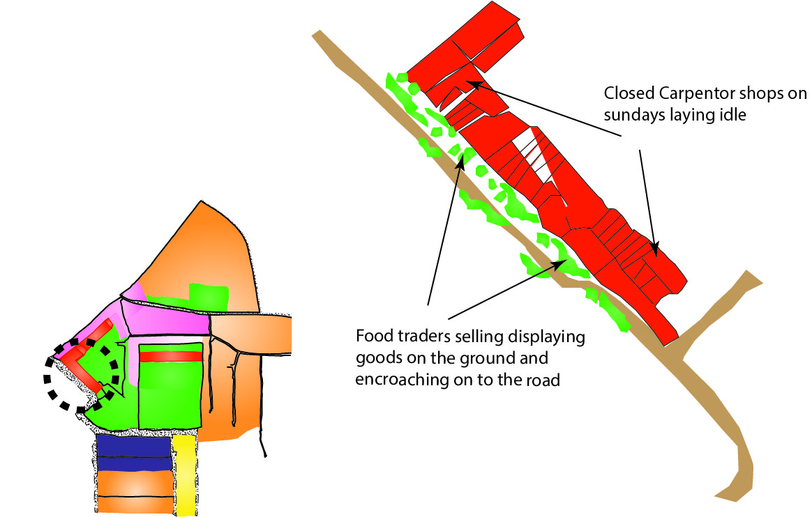

Figure 4.13; Traders encroaching on the road reserve to trade
Source; Author

The design would have two entrances; one for regular traders who operate all week long and another for the trader who operates only on Sundays. The latter space could be smaller by design targeting the small scale traders of food items often displaying their wares on the ground outside closed carpentry workshops on Sundays. A displaying rack could be incorporated in the design for food traders, improving sanitation, as well as freeing up the road reserves for better access to the market improving efficiency.

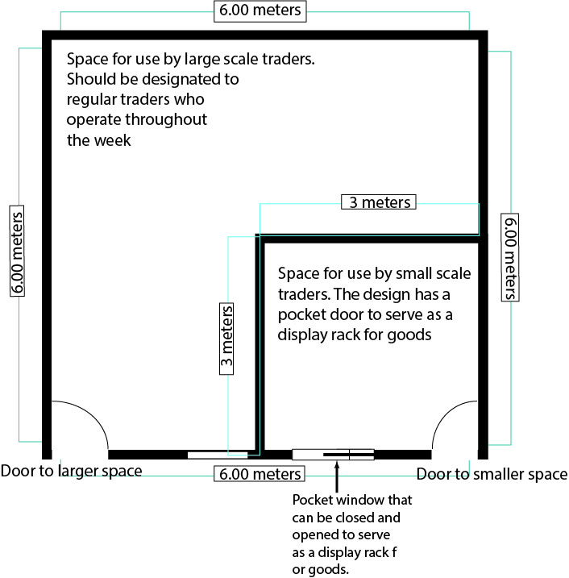

Figure 4.14; Proposed floor plan for the new stall designs
Source; Author

4.3 The Relationship between Gender and Allocation of Space in Kibuye Market
This section addresses the second objective of the study. It seeks to answers the following research question; what is the relationship between gender and allocation of space in a periodic market? It examines the following variables;
- Who allocates space in Kibuye market i.e. the people/institutions that allocate space and what are the allocation processes.
- Who owns the land on which Kibuye market is located, the forms of ownership existing in the market i.e. security of tenure and how this relates to gender?

4.3.1 Persons and Institutions Involved in Allocation of Space
In Kibuye market, both males and females are involved in allocation of space to traders. The Figure 4.10 below illustrates the gender difference of persons involved in allocation of space in Kibuye market. It shows that 83% of persons involved in allocating space are male and 17% female. The study finds that allocation of space in Kibuye market is male dominated with 83% of the persons involved in allocation being male.

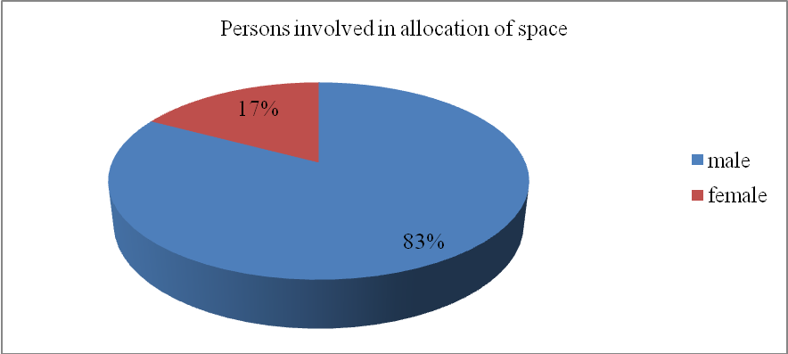
Figure 4.15; Gender of persons involved in allocation of space
Source; Author

The persons involved in allocation of space include; City Council representatives, previous owners and market union representatives. From Table 4.10 the key participants in space allocation are displayed. A majority of the persons involved in allocation of space are male City Council representatives (64.9%). Only 3.4% of City Council representatives engaged in space allocation are female. Interestingly, existence of cartels which refer to groups of traders who have been in the market were also cited as persons involved in allocation of space. This is captured in Table 4.10 under "other".

Table 4.11; Persons involved in allocation of space
Persons involved in allocation of space | Percent (%)
Male - City Council representatives | 64.9
Female City Council representatives | 3.4
Male previous owner | 17.3
Female previous owner | 10.0
Male union rep | 0.6
Other | 3.8
Total | 100.0

The Table 4.10indicates male dominance in allocation of space. Considering that a majority of traders in the market are female with a male: female ratio of 47:53, the male to female ratio of persons involved in allocation (83.17) shows unequal representation. The channels of space allocation in Kibuye market thus resemble the market systems described by Rozelle (2002) and USAID (2006) where allocation of space is not well defined. Traders in the markets often acquire space by first come first served basis. On the contrary, Walker (2011) and Mbisso (2011) report on market systems that have departmental heads responsible for allocating space to the relevant traders. The departmental heads are also charged with the mandate to constantly update trader records in order to know what the space needs are.

As earlier stated, use of space is often gender specific. The needs of each user can therefore best be represented by one who understands them. The lack of a clear mode of space allocation coupled with an imbalance in representation of female traders as seen in Kibuye market could lead to inequitable allocation of resources which would not reflect well for a system that should be gender responsive in its management structure.

4.3.2 Allocation Procedures
Findings from the focus group discussions and key informant interviews indicated that the land on which Kibuye market is located is owned by; the local authority, private undeveloped land, road reserves and central government. However the bulk is owned by the local authority. The legal authority charged with the responsibility of allocating space is the local authority as the body with the mandate to manage land within the city. The study found that spaces in Kibuye market are allocated to traders in different ways;

- Directly from the local authority to the traders,
Participants in the focus group discussion noted that traders in Kibuye are allocated spaces by the local authority. Table 4.10 indicates that 68% of persons involved in allocation of space are from the local authority. The traders are then registered as stall owners and their details taken; personal information and stall number. The registered stall owners are issued with a Temporary Operation Lease (TOL)by the local authority. Security of tenure for temporary structures is not taken very seriously by the City Council of Kisumu therefore the stall owners can be evicted anytime subject to market plans as was highlighted during focus group discussion.

"The space I occupy has been allocated to me by the City Council at a monthly fee. However, the City Councils market plans are never permanent and we risk eviction any time subject to renovations or unknown changes".

This together with male dominance in persons allocating space (64.9% male against 3.4% female), hinders efficiency and equity in market operations.

- Stall owners renting out to traders
Allocation of space is also conducted by registered stall owners 27% as in Table 4.10 above; out of which 17% are male and 10% female. According to the focus group discussion, the stall owners who rent out their stalls to other traders obtain stalls from the local authority for the purpose of renting out and not trading in them. The discussion highlighted biases like requests of sexual favours to female traders in return for speedy allocation of space.

"Traders are sometimes allocated spaces by other traders who own stalls but decide not to trade thereby renting out the spaces. However it is difficult to acquire space for trading if you do not have a boyfriend in the market to help you "

Further, rents are not regulated and depend upon the agreement between the registered stall owners and the traders. Lack of regulation in this mode of space allocation leaves female traders vulnerable to sexual harassment though both male and female traders are barred from efficient operation due to fluctuating rents.

- Cartels of traders who have been in the market for a long time allocating space to new traders
Information obtained from the focus group discussions indicated that there are cartels within Kibuye market that allocate space to traders. Cartels refers to groups of traders who have been in the market for a long time and act as the gatekeepers. They are often led by the oldest market dwellers and are a major entry point into the market. A new comer has to identify a trade of interest then seek out the oldest traders in that business. They are then to advise on availability or lack of space. If a space is available it is issued otherwise one is told to wait till another trader vacates or stops attending the market regularly.

"If you want to get space in the market, you have to look for people selling the goods you want to sell and ask them to create room for you where they are working- or- to find you an appropriate location. You cannot just come here and enter the market without out permission".

"Female traders are sometimes requested for sexual favours in turn of a speedy allocation ".

This system of space allocation is similar to that of Temeko market in Tanzania where an administrative committee receives applications for spaces (Mbisso, 2011). Space is therefore sought in the relevant area due to zoning regulations. If available then the trader is communicated to. However, due to the informality of the cartels in Kibuye market, instances of sexual harassment are sighted as setbacks to this mode of space allocation causing inequitable access to resources in the market.

The findings show that allocation of space in Kibuye market is not well defined. The various modes of space allocation is a manifestation of the lack of order /control in the process of obtaining space for trade. Issuance of Temporary Operation Lease (TOL) to traders results in insecurity of tenure hampering efficient market operations as traders shy away from infrastructural development in case of eviction and demolition at any time hampering efficiency in market operations. Male officials of the city council also dominate in allocation of space which could hinder equitable access to resources in the market. Allocation of space to traders by registered stall owners and cartels is unregulated as respondents cited sexual harassment and fluctuating rental rates. The mode of allocation marginalises the less powerful perpetuating inequality. It also promotes corruption which is a social vice increasing inequalities because only those with money can corrupt their way into getting space. Evidently the manner in which space is acquired is not efficient, reliable or equal to both male and female traders.

4.3.3 Land Ownership and Security of Tenure on Allocated Spaces
In terms of land ownership rights, the study found that traders experienced different levels of ownership as displayed in Table 4.11. Duration of ownership varies from 4 hours to 10 years as displayed in Table 4.11 below. This depends on the agreement made between the trader and the person allocating the space.

"The space I occupy is available for use as long as I pay rent. However, the local authority can decide to pull them down anytime subject to market plans ".

Another respondent reported;

"Space is acquired on a first come first served basis therefore I have to come to the market early to get an ideal location. Otherwise, I make arrangements for other traders to book space for me in order to get space"

A critical condition for retaining ownership rights according to the traders is prompt payment of rent and tax. Despite meeting the conditions, ownership remains subject to market plans and any changes could lead to loss of trading space due to their temporary nature.

Traders who exhibited strong confidence in the tenure system were the male traders. Table 4.11 below illustrates that majority (42.4%) of respondents claiming ownership rights for periods longer than one year are male with 31.3% of female traders claiming the same. The table also shows that female traders claim ownership rights for a shorter duration; 4 hours, 12 hours and 4 months - less than one year. The female traders register higher percentages (21.7%) than male traders (4.6%) for shorter durations of ownership. This means that during the next market day, the space is acquired on a first come first served basis. The data implies that male traders enjoy better security of tenure than their female counterparts indicating inequitable access to resources in Kibuye market.

Table 4.12; Security of tenure in markets
Duration of stall ownership | Respondents gender  Percentage (%) |  | Total  Percentage (%)
 | Male | Female
Permanently | 30 | 25.1 | 55.1
10 years | 3.4 | 0 | 3.4
4 years | 1.8 | 0.6 | 2.4
2 years | 0.6 | 0 | 0.6
1 year | 6.6 | 5.6 | 12.2
4 months | 0 | 5.1 | 5.1
12 hours - whole day | 4.6 | 12.4 | 17
4 hours | 0 | 4.2 | 4.2
Total | 47 | 53 | 100

Sub-totals represent 42.4% male traders and 31.3% female traders

Sub-totals represent 4.6% male traders and 21.7% female traders

The Odds Ratio for data in Table 4.11 was calculated to investigate whether the odds of men occupying larger spaces than women was significantly higher. The Odds Ratio evaluates whether the odds of a certain outcome is the same for two groups. Specifically, the Odds Ratio measures the ratio of the odds that an event or result will occur to the odds of the event not happening (McHugh2009). The data from Table 4.11 was summarised in Table 4.12 below to enable calculation of Odds Ratio.
Table 4.13; Calculation of Odds Ratios
Duration of stall ownership | Respondents gender  Percentage (%) |  | Odds
 | Male | Female | Odds
More than 1 year | 42.4 | 31.3 | 42.4 ÷ 31.3 = 1.35
Less than 1 Year | 4.6 | 21.7 | 4.6 ÷ 21.7 = 0.21
Total | 47 | 53 | 1.35 ÷ 0.21 = 6.43

An Odds Ratio (OR) of 1.00 means that the two groups have equal odds for achieving a certain outcome (in this case - equal odds at having ownership of space for more than 1 year). An OR higher than 1 means that the first group (in this case, Ownership more than 1 year) was more likely to be dominated by male traders than the second group (Less than 1 year). Having calculated an odds ratio of 6.43, the study finds that the odds of men acquiring spaces for durations longer than 1 year are 6.43% times higher, than that of women hence inequitable distribution of resources.

Further, the varying durations of ownership in the Table 4.11 show how diverse security of tenure is in Kibuye market. The Physical Planning Handbook stipulates that public authority should retain title of market areas but lease out spaces to traders for control purposes. However guidance is not given on how long or short the tenure-ship should last (Kenya. Republic of, 2007 a). This explains the varied periods of ownership rights highlighted by the study. Consequently, the current use and allocation of space in Kibuye market disadvantages female traders more than their male counterparts with regard to security of tenure.

On the whole, the study finds that allocation of space in Kibuye market is male dominated with 83% of the persons involved in allocation being male. This coupled with instances of sexual harassment as highlighted in the focus group discussions results in inequitable access to resources more so for female traders. The various modes of space allocation in Kibuye market are a manifestation of the lack of order /control in the process of obtaining space for trade. Evidently the manner in which space is acquired is not efficient, reliable or equal for both male and female traders.

In his publication, Getting New Business, Walker (2011) illustrates a mode of space allocation that is very practical for periodic markets. Traders are registered as either regular or casual. These two categories of traders are present in Kibuye market and most periodic markets therefore the technique can be adopted. In the case of Kibuye, the main market day attracts different traders each week and establishing a register for all would be challenging. For Kibuye, all traders would then be treated as casual if the system is to be adopted. The administrative structure of Temeko Stereo market place in Dar e Salaam Tanzania, could also be a reference point for improving processes of allocation in Kibuye market (Mbisso, 2011). The administrative structure has a local authority representative at the top. Administrative functions are then delegated to different departments that are responsible for registration of traders and allocation of space. The delegation system would be ideal for allocation of space in periodic markets.

To ease the process of allocation, spaces in the market would have to be paved and numbered. This would comply with the Physical Planning Handbook. It recommends that large markets should have hard standing surfaces, fixed stalls and divisions (Kenya, Republic of. 2007 a). Figure 4.11 below illustrates the process of space allocation proposed by the study. A database containing space and stall numbers could also be compiled. It could categorize the stalls and spaces in terms of use (Food/Carpentry/Clothing).

The register of traders would be very important as well as the record of existing stalls. Data could be entered into a market database. This could be done in collaboration with IT companies. Currently mobile banking allows for consumers to pay for retail goods via mobile phones at no extra cost. The same technology could be used by traders in paying for stalls before the Sunday market day. This would require collaboration between the IT investors and Local authority that manages the market. It would call for sensitization amongst the traders who are the key stakeholders. Traders would then pay for stalls through mobile banking on their phones or over the counter and a receipt issued for assurance. This could introduce control in allocation of space thereby levelling the field for both female male traders in terms of; regulated rents and reduced instances of harassment.

During application, a trader would need to specify his or her category of trade to help in proper stall allocation. The receipt would hold the stall or space number issued to avoid confusion. It is important to note that this form of allocation could be ideal for traders who operate in the market on Sundays only. Regular traders would continue acquiring space through the City Council after which Temporary Operation Lease (TOL)would be granted. This could help traders in claiming ownership over longer periods of time increasing security of tenure.

The flow chart below is an outline of how the proposed system of allocation would work.
Construction of a database.
The database includes; stall numbers, designated use and location (zones)
Creation of an application form; soft and hard copy
The form includes; trader’s ID number, full names, trade type and category
Setting up a desk for manual stall application and a web page for the same.
NB; the web page should be very simple and easy to fill
Applications should be read and confirmation made to the trader on space availability before payment is made.
Allocation of space after payment; a receipt with the stall number and zone should be issued upon payment; hard copy or e-receipt.

Figure 4.16; Proposed system of allocation
Source; Author

The proposed strategy in Figure 4.11 could provide a reliable mode of space allocation creating an even ground for entry into the market for both male and female traders thus improving both equity and efficiency in market operations.

4.4The Link between Gender and Use of Time in Kibuye Market
This section addresses the third objective of the study thereby seeking to answer the question on the difference of use of time between male and female traders. The study examines the following parameters in order to provide answers to the question.
- Time of arrival in the market
- Time spent in the market
- Lateness

4.4.1 Time of Arrival in the Market
Use of time in periodic markets is a crucial factor due to their fluid nature. Opening hours of the market are thus critical to optimal utilization of space. Kibuye market resembles the markets described by Rozelle (2002) as it starts its operations before dawn. The Figure4.12 below shows the time of arrival at the market for male and female traders as found by the study. The earliest traders arrive at 4.00 a.m. in the morning of which 40% are male and 0% female. Traders arriving at 6.00 are mostly female i.e. 45% female and 4% male. Beyond 7.00 a.m. 8% of traders arriving at the market are female and 3% male. The data shows that male traders arrive at the market earlier than female traders.
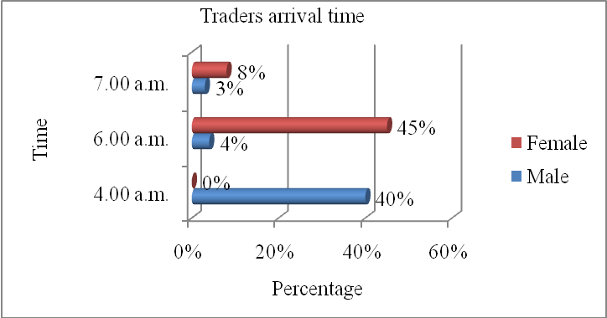

Figure 4.17; Arrival time of traders in the market
Source; Author

The Jua Kali(informal sector) Association chairman for Kibuye market reiterated that traders stream in as early as Four o'clock in the morning on market days. Such traders operate in large groups for safety as the market place lacks security lights as well as enough guards. The traders often book the spaces in which they are to display their goods then wait for six o’clock to start setting up their wares. Due to the extreme hours of operation, these traders are often exclusively male. Women are constrained by security issues and cannot get to the market very early. The study finds that market operations begin too early to favour equal participation of both male and female traders; promoting inequitable distribution of resources. This relates to findings by USAID (2006) that women are barred from equal participation due to issues of insecurity.

4.4.2 Time Spent in the Market
The time spent by traders in the market varies for male and female traders in terms of duration and activities conducted. The Table 4.13 indicates that a majority of traders( 96%) spend the whole day in the market. More women (50.8%) spend the whole day in the market compared to men (45%). Clearly a majority retain their trading posts all day long making it important to get a space when the market opens in order to get the best location.

Table 4.14; Traders operating in shifts
Traders operating in shifts | Respondents gender  Percentage (%) |  | Total  Percentage (%)
 | Male | Female
No Shifts | 45.5 | 50.8 | 96.3
Shifts | 1.4 | 2.2 | 3.6
Total | 46.9 | 53.1 | 100.0

However 3.6% of the traders leave the market before evening. They operate in shifts; an arrangement that favours traders who are unable to get to the market very early. The Focus group discussions revealed that there are times when the traders agree to use the same space but at different time periods. For instance a trader would sell his/her goods in the morning hours and let another one use the same space to sell his/her goods in the afternoon. The shifts usually begin at 2.00 p.m. in the afternoon. Table 4.13indicates that 3.6% of the respondents leave early so that another trader can use the same space. Out of this, 1.4% is male and 2.2% female. However the agreements are sometimes broken. According to the study, approximately 40% of the traders who change shifts cited scuffles during this change. The scuffles ensue due to extension of time by a trader beyond the agreement. The disagreements are settled by the Market superintendent or other City Council representatives operating within the market. All the dispute resolvers in the past have been male. Study findings indicate a high incidence of noncompliance (40%) to sharing arrangement leading to scuffles between traders. Considering that a majority of traders operating in shifts are female, occurrences of scuffles further impede their efficient operation in the market.

Consequently there have been attempts at setting up a clear mode of operation by traders who operate in shifts as highlighted in the focus group discussions. In example, for traders who arrive at the same time, space is shared equally between the two of them. Some have strict working hours in which the first trader spends eight hours at the market while the other spends three hours in the evening. The traders who operate later in the day mostly sell food items (41%); a trade dominated by female traders. The element of shifts is characteristic of markets e.g. Temeko market in Tanzania (Mbisso,2011). Traders in Temeko market however have less conflict when changing shifts because wholesalers are the first to exit the market at 9.00 a.m. after supplying retailers. One category is the source of the others commodity therefore less conflict.

In Kibuye market, goods may differ between traders operating in shifts. The Table 4.14 below shows the nature of commodities between traders who work in shifts. The commodities sold differ for every shift. For 16.5% of traders operating in shifts, sale of food gives way to sale of charcoal as shown in Table 4.14. Food requires clean environment and cool storage while charcoal is very dirty and needs lots of free space away from food (Tracey-White, 2003). A clear structure of space use between traders competing for the same space is lacking giving room to inefficiency in space use. In well designed markets like Temeko market in Tanzania, zoning of space use has aided in reducing instances of incompatible space use as opposed to the case in Kibuye market.

Table 4.15; Goods sold by traders who change shifts
Goods sold by traders working in shifts |  | Total Percentage (%)
1st shift | 2nd shift
Food | Charcoal | 16.5
Furniture | Clothes | 25.5
Food | Shoes | 16.5
Toys | Food | 41.5
Total % |  | 100

Some traders in Kibuye market use the same location to sell different goods at different times. The pie chart shows the percentage of traders who shift from one commodity to another(Figure 4.13). These traders begin by selling a particular commodity for a while before changing to another. Majority of them are female (83%).
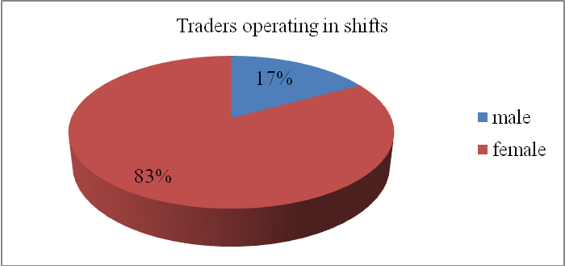

Figure 4.18; Gender of traders dealing in more than one good
Source; Author

This high female percentage (83%) could be due to the fact that most of the traders dealing in this type of business sell food items (41%). The change is often from a more perishable to a less perishable food type. An example is that of a trader changing from the sale of tomatoes to onions. This reduces their chance of returning home with goods that will not last till the next market day. This mode of operation increases the variety of commodities sold in the market exhibiting efficient use of space. However, lack of a clear mode of operation for changing shifts hampers efficiency in accessing trading spaces for female traders who majorly operate in shifts.

4.4.3 Late arrival in the market
According to the study findings 20% of the traders interviewed i.e. 78 respondents, attested to finding their spaces occupied by other traders when they arrived at the market late. In such instances the new comers were removed by regular traders close by. Although the strategy is good for the regular trader, it is also a barrier for new traders in accessing the market. However this rarely happens as 80% of the respondents have never experienced such an incident. Of the ones who had experienced an intruder, the market superintendent was instrumental in solving the case. In some cases, the trader had to look for alternative locations or wait for the intruder to finish selling their goods. Ideally, space should be occupied by the person who gets to it first. Lateness leads to displacement and conflict as indicated by 20% of the respondents hence disruption of trade. This disadvantages women who cannot get to the market early thereby reducing efficiency in market operations due to conflict and inequity due to time barrier for women.
The proposed system of space allocation would help eliminate such issues as it issues a receipt to the person who pays for the space first; possibly reducing incidences of intruders. Instances of traders going to the market at predawn to book spaces would thus subside levelling the field for all parties. As it is, late arrival at the market leads to displacement and conflict according to 20% respondents, this disadvantages women who cannot get to the market early due to insecurity. As such, female traders are not accorded equal chances for competition in the market.

Men arrive in the market earlier than women-as early as 4.00 am- and take up the best positions. Women on the other hand cannot arrive very early due to security issues and end up getting less favourable positions. This implies that women are disadvantaged in terms of the amount of sales they can make. A man selling the same commodity as a woman is likely to make more sales because of his favourable location in the market. We can conclude that time factor contributes to the inequalities between gender in periodic markets because it favours men in terms of securing favourable locations for selling their trade items. Improving security would enable women to arrive earlier and this would reduce the inequalities created when men arrive earlier than women.

Most traders (96%) spend the whole day in the periodic market but a small group (3.6 %) spend only part of the day in the market and surrender their space to another trader on agreement. There is a high incidence of noncompliance to the sharing arrangements leading to scuffles (40%).These scuffles interfere with the efficient operations of the market as such disputes must be resolved. Many of the evening traders (41%) sell foods items—a trade dominated by women.
Many women (83%) sell different things at different times on the same site; while men tend to sell the same item the whole day. The women increase efficiency in the market because they increase the trade items in the market. Traders who are late to arrive in the periodic market are often (20%) displaced which leads to conflicts as they try to reclaim their space. The conflicts reduce efficient operations of the market. Women who cannot come early due to security issues are often victims and this disadvantages them creating inequity

4.5 Gender Responsiveness of Institutions Managing Kibuye Market
This section addresses the fourth objective of the study. It attempts to provide answers to the following research question; “How gender responsive are the institutions managing a periodic market?” Thus it examines the following parameters;
- Institutions that are involved in the management of Kibuye market and their roles
- Gender considerations in each institution

4.5.1 Institutions Involved in Management
Kibuye market is managed by various institution which include; City Council of Kisumu, Jamii bora, Kibuye jua kali association, self help groups and UN-HABITAT. The Figure 4.14below shows interlinkages between the institutions in operation within the market. The innermost ring encompasses the institutions in operation within the market only. The second ring contains institutions in operation within the market and Kisumu City. Institutions operating within the market and beyond Kisumu City are displayed in the outermost ring. Institutions connected by arrows indicate those that provide similar services.

5
6
1 2

3 4

1 | Jamii bora
2 | Market unions
3 | Kibuye jua kali association
4 | Self help group
5 | UN-HABITAT
6 | City Council of Kisumu

Figure 4.19; Linkages between institutions working in Kibuye market
Source; Author

The Figure 4.14above shows that most of the institutions in operation are specific to the market. The services they offer only serve the market population. However, the City Council of Kisumu operates beyond the market as it serves the whole of Kisumu City. The UN-HABITAT is an international organization with several projects globally. It however has a project in Kibuye market as well. Evidently few external institutions and organizations have taken interest in the development of the market. The ongoing development initiatives in Kibuye market can therefore be majorly attributed to the institutions specific to the market like the Jua kali association.

All the institutions are connected by arrows to at least one other institution indicating that they provide similar services. Unfortunately each of these organizations operate on their own as highlighted during the focus group discussion. A key example is the construction of toilets. The Physical Planning Handbook of Kenya specifies that within a market there should be a toilet every 100m² (Kenya. Republic of. 2007 a). In Kibuye market, study findings show that over 80% of the respondents attest to the market having 5 toilets serving its population yet the market is 8.29 ha in area. The City Council of Kisumu and UN-HABITAT are both addressing the issue of toilets yet separately. As it is, the lack of coordination between the institutions hinders efficient provision of services to Kibuye market.

4.5.2 Gender Considerations in Institutions that are Involved in Management
The Table 4.15below gives an account of the services provided by different institutions in operation within Kibuye market according to the findings of the study.

Table 4.16; Institutions in operation within the market
Institutions | Services provided
Jamii bora | Stalls
Market unions | Settling disputes
Kibuye jua kali association | Issuing loans and dividends
Self help group | Loans and welfare services
UN-HABITAT | Bio-gas toilets
City Council of Kisumu | Stalls, electricity, hygiene, security

4.5.2.1 Jamii Bora
Jamii bora is a local CBO that supports the informal sector by building their capacity and improving their work environment.During the focus group discussion it was noted that Jamii bora has constructed stalls for traders who are registered with them as members. The stalls are constructed for traders who have been allocated spaces in need of repair or new structures, by the local authority.Discussions further revealed that for a trader to register with Jamii Bora they have to pay a membership fee of one hundred shillings. The types of stalls constructed by Jamii Bora are temporary and made out of wood as shown in the Plate 4.6 below as observed during study visits. Terms of use are the same for both men and women as they are both required to pay two thousand shillings in cash or instalments of one hundred shillings per week for a stall to be constructed. Preference is therefore not made for any gender in terms of provision of stalls promoting equitable access to resources.

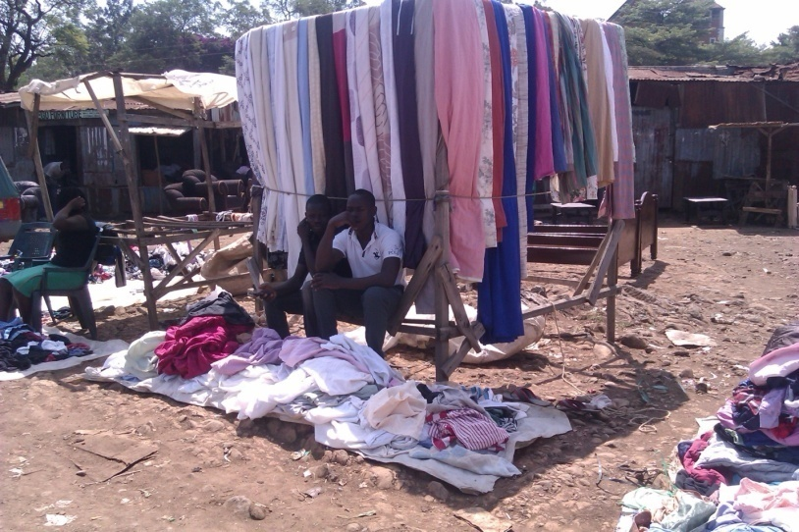

Plate 4.6; Wooden structure acting as a stall
Source; Author
Picture taken in Kibuye market on a Monday after the market day

4.5.2.2 Market Union
The market union is a body comprising of traders and is formed for the purpose of defending the rights of traders. Traders are all encouraged to join the market union though not mandated. Focus group discussions revealed that although both male and female traders have access to the union as members; the management is exclusively male dominated. The union is also known to settle disputes related to allocation of space in the market. Traders however feel that the union is not representing them well as they it is often compromised by bribes. Equity in accessing the service provide by the market union is thus hampered by allegations of corruption and male dominance in management. This could lead to marginalisation of the economically disempowered and female traders respectively hindering their efficient operation within Kibuye market
4.5.2.3 Kibuye Jua Kali Association
Kibuye Jua kali Association is one of the most established institutions in the market. It is a Community Based Organization for traders at Kibuye market as was highlighted during an interview with the chairman. Both male and female traders are encouraged to join the association. The association issues loans to members at low interest rates.
4.5.2.4 Self Help Groups
Self help groups are also found in Kibuye market. Discussions with respondents indicated that the groups restrict membership to people that are known to each other. They are thus small in size having as few as 10 members. They majorly issue loans to their members, offer welfare services like burial and wedding arrangements increasing their popularity among the traders. Their loans can be as little as one hundred shillings. Both Kibuye Jua Kali Association and Self help groups were highlighted as instrumental sources of income. However, their operations provided services equally to both male and female traders without bias.
4.5.2.5 UN-HABITAT
UN-HABITAT which is an international organization has presence in Kibuye market as cited during focus group discussions. Unlike the other forms of organization, traders do not join UNHABITAT rather it provides services to the market. The NGO has an ongoing project of bio gas toilets in Kibuye market that serves the traders while bio-gas is harvested from them (Plate 4.7).


Plate 4.7; Bio digester toilets in Kibuye market
Source; Author
Picture taken in Kibuye market at 3.00 p.m. showing location of toilets

The toilets can be accessed by traders at a fee of ten shillings for all. However, the environment around the toilets is not conducive for female traders due to the location of a pub on the second floor as can be seen in the picture. This can lead to harassment of female traders by intoxicated people as was experienced during the study visit reducing efficiency of their use.

4.5.2.6 City Council of Kisumu
The City Council of Kisumu is the main body responsible for the management of Kibuye market as stated by the market superintendent. The study evaluates the performance of the City Council of Kisumu in fulfilling its duty in the management of Kibuye market
- Collecting tax
The City Council of Kisumu collects revenue from traders on every market day. On Sundays, taxes range from twenty shillings to one thousand five hundred shillings as opposed to the normal range of twenty to fifty shillings on weekdays. Some traders pay an additional rent on top of the daily tax. Traders who are registered owners of stalls pay a fixed rate daily. Such traders often sublet the spaces outside their stalls to traders without stalls. The traders are then expected to pay stall owners for allowing them to use the space as well as pay the council its daily tax. More female traders display goods on the ground i.e. (52% female and 48% male). This group is charged twice for the spaces they occupy. Evidently, the City Council of Kisumu lacks a fixed rate for collecting tax resulting in a situation in which more female traders pay double fees hence inequity.

Provision of toilets and water points is critical to the maintenance of hygiene within the market. Table 4.16below shows accessibility to toilets within the market. From the Table 4.16, the study found that Kibuye market has five water closets and five pit latrines. The toilets charge people five shillings on average for every usage.

Table 4.17; Toilets within Kibuye market
Type of toilets and the cost of using the facility | Number of toilets within the market  Percentage (%) |  |  |  | Total  Percentage (%)
 | 1 -5 | 6 -10 | 11 – 15 | Don’t know
Water closets 5/- | 62.9 | 9.5 | 6.1 | 0.0 | 78.5
Water closet 10/- | 0.6 | 0.6 | 0.6 | 0.0 | 1.8
Pit latrines 5/- | 15.0 | 0.6 | 0.0 | 0.0 | 15.6
Pit latrines 10/- | 1.8 | 0.6 | 0.0 | 0.0 | 2.5
Other specify | 0.6 | 0.0 | 0.0 | 0.9 | 1.5
Total | 81.0 | 11.3 | 6.7 | 0.9 | 100.0

With ten toilets serving a population of 6,674, the ratio of toilet to trader is 1:600. Such a toilet would be a great challenge to maintain hence the unhygienic state of most toilets. The focus group discussion cited that male traders are often comfortable using dark corners and corridors as a substitute. Table 4.16 indicates the percentage of traders who use dark corners. The figures are found under "other". This was however noted to be challenging for female traders who at times are brave enough to do the same. Hygiene is not the only hindrance to accessing the toilers but also the charges. Traders feel that they should not be charged for using the toilets as they already pay tax to the council. Inadequate provision of toilets hinders efficient operation of traders in the market more so female traders who are not able to use dark corners as an alternative.

In Kibuye market tonnes of solid wastes are generated necessitating a proper waste management system. The key participant in waste management as given by the respondents is the City Council of Kisumu (CCK) at 84%. as displayed in the Figure 4.15 below.
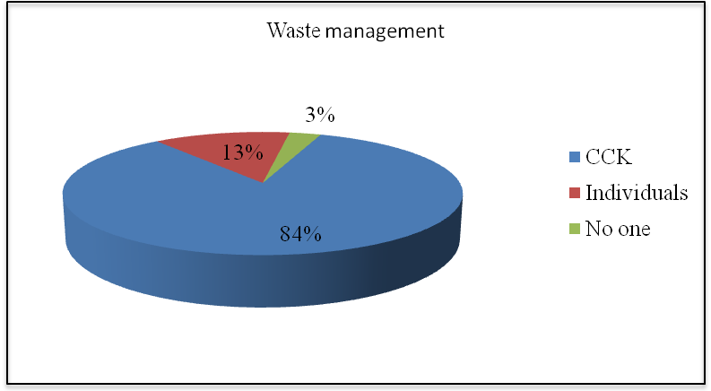

Figure 4.20; Key participants in waste management
Source; Author

The CCK hires labourers to clean and collect waste within the market. The market superintendent for Kibuye market elaborated that a dumping site has been designated at the core of the market from which trucks collect the waste regularly. The collecting truck has a tendency of collecting garbage on Saturdays in readiness for the Sunday market. Traders are therefore left with decomposing garbage throughout the week as the council sees no urgency in collecting it. The area designated for garbage collection is used by traders selling food as it is at the core of the market. Female traders who monopolize food trade are yet again disadvantaged as they are left with unsanitary conditions. Consequently, traders lack a disposal site for waste on Sundays which is the main market day. Conditions at the market are therefore often unbearable with waste lying next to fresh supplies. It is proposed that garbage collection points be provided with 0.1 hectare, be environmentally friendly, located on the leeward side having a 100 meter-protection belt (Kenya. Republic of, 2007 a); a condition yet to be met by the City Council of Kisumu in its management of waste.

- Water and sanitation
Study findings show that the City Council of Kisumu provides 74% of water within Kibuye market i.e. tapped water as displayed in the Figure4.16 below. Water kiosks and vendors supply the market as well. The tapped water is accessed for free by traders therefore reducing their expenditure on water. It is noteworthy that until 2012 the market lacked tap water. The focussed group discussions highlighted that it is as a result of a strike led by the female traders that the City Council of Kisumu installed tap water in the market.

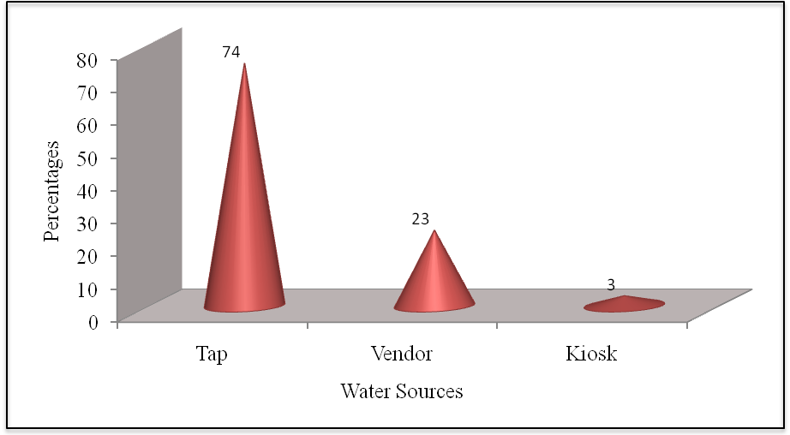

Figure 4.21; Sources of water for Kibuye market
Source; Author

Three water points were installed in close proximity to each other. They are located at the core of the market which is dominated by food. Although this increases access by food traders - traders located away from the core are inconvenienced in accessing the water. The City Council of Kisumu responded to the needs of the female traders bringing water to Kibuye market which improved efficiency in market operation for the traders selling food. However, access to water is not equal for all traders especially the ones located away from the core.

- Roads
Respondents highlighted that the roads are managed by City Council of Kisumu and traders as shown in the Figure 4.17. A majority 47% of traders feel there is no maintenance of access roads within the market. Only 27% of respondents feel the presence of the City Council of Kisumu (CCK) in maintaining roads.
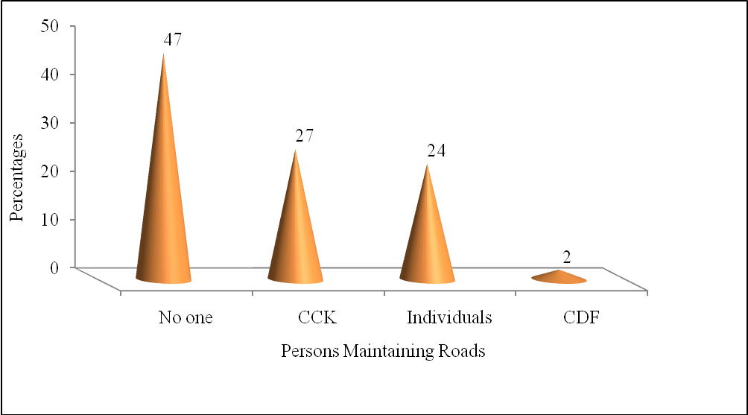
Access roads within the market serve traders well during dry seasons. When the rains come, the roads are often inaccessible due to poor drainage that floods the roads (Plate 4.8) as was observed during the field study. Unfortunately, traders displaying their goods on the ground continue to do so as depicted in the Picture 4.8.
Figure 4.22; Parties involved in road maintenance
Source; Author



Plate 4.8; Condition of access road in Kibuye market during rainy season
Source; This study
Picture taken in Kibuye market at 11.00 a.m. on a weekday

Study findings illustrate that 45.9% of the traders display goods on the ground are (48% male and 52% female) consequently the ones affected during the rainy seasons. The current management of roads thus hampers the efficient operations of this category of traders; more so the ones selling food(41% of all traders) majority of whom are female(68% female 32% male).

In order to further analyze management in Kibuye market, findings on the gender of managers and their education qualifications were cross tabulated. The Table 4.17below displays gender balance and education levels of managers in the different institutions operating within the market.

Table 4.18; Gender and education qualifications of persons in management
 |  | Institutions Managing Kibuye Market
Gender Balance in Management and in Education qualifications |  | City Council Of Kisumu |  | Market Unions |  | Kibuye Jua Kali Association |  | Self help group |  | UN HABITAT |  | Total
GenderBalance in Management |  | Male | Female | Male | Female | Male | Female | Male | Female | Male | Female
 |  | 24 | 23 | 30 | 15 | 12 | 6 | 3 | 3 | 3 | 0 | 119
Gender Balance in Education qualification | Below Primary Education | 2 | 12 | 15 | 8 | 0 | 0 | 0 | 1 | 0 | 0 | 38
Gender Balance in Education qualification | Primary Education | 8 | 4 | 6 | 4 | 0 | 0 | 1 | 2 | 0 | 0 | 25
Gender Balance in Education qualification | Secondary Education | 7 | 7 | 9 | 3 | 4 | 2 | 2 | 0 | 3 | 0 | 37
Gender Balance in Education qualification | Tertiary Education | 7 | 0 | 0 | 0 | 8 | 4 | 0 | 0 | 0 | 0 | 19

Table 4.19; Education qualifications of persons in management
 | Gender of managers
Education qualification | Male | Female
Below Primary Education | 17 | 21
Primary Education | 15 | 10
Secondary Education | 25 | 12
Tertiary Education | 15 | 4

Study findings displayed in the Table 4.17 above show that the City Council of Kisumu has a total of 47 employees working within Kibuye market on Sundays; 24 are male and 23 female. The other institutions; Jua Kali association, Market unions and UN-HABITAT also indicated male dominance in management as per Table 4.17. Collectively, the study finds that 60% of management is male as data collected from all the institutions and organizations interviewed indicate larger presence of men than women in management. The finding complements research by Anthon (2007) which states that in most African cities the retail distribution system of markets and street vending is female dominated, while governments and bureaucracies are overwhelmingly male. Management of institutions thus seems to display gender bias with management seeming to exclude females.

The Table 4.17 further shows the gender balance in education qualification of managers for the different institutions interviewed. Overall, the Table 4.17 shows that out of the 119 managers in the market, tertiary education has been achieved only by 19 managers. Female managers cluster in the category of managers whose qualifications fall below primary education at 38 out of the 119 mangers interviewed. An extrapolation from Table 4.17 is presented in Table 4.18 indicating the dynamics of education for both male and female managers. The Table 4.18 summarises the figures in Table 4.17 showing that female managers have less education qualifications that male managers. This is indicated by the fact that 15 out the 19 managers with tertiary education are male while only 4 are female. Low education levels among female managers could thus be a reason for their exclusion in management as is highlighted by UN-HABITAT (2012 a).

UN-HABITAT (2012 a) asserts that in developing countries, the reason for women remaining outside the workforce is related to a lack of access to education with 70% of girls representing the percentage of children that lack access to education. The author affirms that the lack of education impacts livelihood opportunities when children become adults; as is the case in the management structure of Kibuye market. The study therefore finds that management in Kibuye market is characterized by male dominance and low education levels more so for female managers.

Overall, the institutions managing the market provide services like provision of piped water and toilet facilities according to study findings. However, the manner in which the services are provided is not gender responsive as recommended by (UN-HABITAT, 2009 a) and (Kiura 2014). Installation of water due to strikes by women fails to promote equitable access as the water is located at the core which is dominated by females(60% female and 40%male). In addition, over 80% of the respondents cited 5 toilets in the market which the study found to have been provided by the UNHABITAT and the City Council of Kisumu individually. The lack of coordination in service provision between institutions and the people could have a gender insensitive outcome as seen in the bio digester toilets that are not appropriately located for female traders due to their close proximity to a pub.

Management in the market is therefore not gender responsive as female traders are unable to efficiently use toilets due to their location in addition to the higher taxes they pay. Provision of water also fails to cater for the needs of male traders who are more at the market edge while all the water points are located at the core that is dominated by female traders. Studies by Anthon (2007) and Patel (2008) highlight the reason for management that is unresponsive to gender. The studies attribute gender unresponsiveness to male dominance in governance and management as is experienced in Africa and South Asia with female representation being as low as 20%.Low education levels among the managers may also be a contributing factor to management that is gender unresponsive as it locks women out of management due to low education levels (UN-HABITAT, 2012 a). Such are the imbalances that lead to lack of equity and efficiency in market operations as seen in Kibuye market where management is also male dominated with 60% men 40% women coupled with low education levels among the managers inhibiting their aptitude to deliver services in an equitable and efficient manner.

UN-HABITAT (2009 a) and Kiura (2014) emphasize the need for gender responsiveness in all aspects of local government programs and activities in order for equity to be realized. In the case of Kibuye market, the lack of equitable participation of traders calls for gender mainstreaming and capacity building in management to ensure the needs of male and female traders are efficiently addressed.

CHAPTER FIVE: SUMMARY OF RESULTS, CONCLUSIONS AND RECOMMENDATIONS

5.1 Summary
Introduction
This chapter summarises key findings of the study drawing conclusions from them. It further evaluates best options for engendering management to ensure equity and efficiency in market operations under recommendations. The study set out to examine the impact of gender on use of space in periodic markets. Kibuye market in Kisumu City – Kenya was selected as a case study being the largest periodic market in the western region of Kenya. Summary, conclusions and recommendations will be given in line with the study objectives;
- To establish the relationship between gender and use of space in a periodic market.
- To examine the relationship between gender and allocation of space in a periodic market.
- To determine the link between gender and use of time in a periodic market.
- To evaluate gender responsiveness of the institutions managing a periodic market.
- Gender and Use of Space
The study found that female traders were more than male traders in the market. Their ages clustered between 25 and 34. The implication of this phenomenon as given by (USAID, 2006) is that the optimal participation of female traders in the market could be hindered due to gender roles ascribed to females by society resulting in time poverty. The most dominant form of trade as found by the study was the sale of food with 76% of traders operating as retailers. However, there was inefficiency in distribution of space with vendors taking up more space than they require while retailers and wholesalers fail to access the required sizes of space. Use of space is therefore inefficient as the required standards are not met. The ones affected adversely are female retailers who form 55% of the retailers in the market.

The space in Kibuye market was divided into three distinct zones, core, next to core and edge. Spaces at the market edge were found to be in high demand and not the core as proposed by (Mary,1993). Further, provision of infrastructure (stalls) at the market edge which was dominated by male traders i.e. 27% out of 44% was better; as opposed to the core which was dominated by female traders i.e. 12% out of 20%. Male traders therefore enjoy better spaces than female traders in terms of infrastructure and proximity to customers depicting inequitable distribution of resources. Further, the study finds that male traders occupy larger spaces than female traders - as larger spaces measuring 1m by 3m and above are dominated by men (14.3%) with 7.4% of female traders occupying such spaces. A majority of female traders - 17.7% occupy spaces measuring 1m by 1 m and below while 6% of male traders occupy such spaces. The study thus finds inequitable distribution of space where female traders are disadvantaged.
- Gender and Allocation of Space
The study found that 83% of the persons involved in allocation of space were male. Further, instances of sexual harassment were also cited as setbacks to the current modes of space allocation. Male dominance in allocation leaves female traders vulnerable to harassment thus hindering efficiency and equity in the allocation process. The different modes of space allocation found in the market included; direct allocation from the local authority to the traders, stall owners renting out to traders, cartels of traders who have been in the market for a long time allocating space to new traders.

Availability of alternative process of allocation could mean flexibility which could improve efficiency. However, it also indicates the lack of a clear process through which space can be allocated. Consequently rent is unregulated leaving female traders vulnerable to sexual harassment though both male and female traders are barred from efficient operation due to fluctuating rents. Lack of regulation additionally exacerbates security of tenure at the expense of female traders. Female traders registered higher percentages (83%) than male traders (17%) for shorter durations of ownership; less than one year. The study finds that the manner in which space is acquired is not efficient, reliable or equal for both male and female traders.
- Gender and Use of Time
The study finds that market operations begin too early - 4.00 a.m. - to favour equal participation of both male and female traders; promoting inequitable distribution of resources. This relates to findings by USAID (2006) that women are barred from equal participation due to issues of insecurity. It also results in the emergence of shifts as traders who get to the market early leave before evening. The spaces they leave are often occupied by traders who arrive in the market at approximately 2.00 p.m. when shifts begin. This mode of operation increases the variety of commodities sold in the market exhibiting efficient use of space. However, lack of a clear mode of operation for changing shifts hampers efficiency in accessing trading spaces and consequently female traders who majorly operate in shifts. Ideally, open spaces in markets should be occupied by the persons who get to them first. Lateness leads to displacement and conflict as indicated by 40% of the respondents hence disruption of trade. The study finds that this disadvantages women who cannot get to the market early due to insecurity thereby reducing efficiency in market operations.
- Gender Responsiveness of Management
Institutions involved in managing the market include; City Council of Kisumu, Jamii bora, Kibuye jua kali association, self help groups and UN-HABITAT. However, allegations of corruption and male dominance hamper equity in accessing the services provided. Further, the study found a lack of coordination between service provision and the gender needs which could be attributed to low education level of managers as only 19 out of 119 have attained tertiary education. This was depicted in the location of bio digester toilets next to a pub inhibiting female traders from using them. Further, Provision of services e.g. installation of water due to strike by women fails to promote equitable access as the water is located at the core which is dominated by females (60% female and 40% male). Provision of services is thus not gender responsive provoking traders to extreme measures like organizing strikes which hinder efficient operations of the market and further inequity; as the service is taken close to the demonstrators (female traders) disregarding the needs of others (male traders). Evidently, the operations of the market foster unfair competition between male and female traders with lack of regulation in use of space, time and allocation resulting in inequity and inefficiency.

5.2 Conclusion
- Gender and Use of Space
Use of space is characterized by inequity and inefficiency. Female traders, who are majority in the market, fail to acquire the recommended sizes of spaces for their trade. Additionally, their distribution is concentrated in zones with least infrastructural development. The zones are also furthest from customers yet they dominate in the sale of the most delicate commodity - food. Evidently, male traders fare better than female traders in the contest for space. The distribution of space use in the market thus fails to display equal and efficient access to resources by both male and female traders.
- Gender and Allocation of Space
Male dominance in allocation leaves female traders vulnerable to harassment thus hindering efficiency and equity in the allocation process. Lack of a clear mode of space allocation further results in unregulated processes in which female traders are faced with constant incidences of conflict due to insecurity of tenure. As such female traders are disadvantaged in the allocation of space resulting in inequitable access to resources.
- Gender and Use of Time
The study concludes that time factor contributes to the inequalities between gender in periodic markets because it favours men in terms of securing favourable locations for selling their trade items. Women who cannot come early due to security issues are often victims and this disadvantages them creating inequity. Improving security would enable women to arrive earlier and this would reduce the inequalities created when men arrive earlier than women.
- Gender responsiveness of management
The study concludes that male dominance in market management coupled with low education level among of managers leads to gender unresponsiveness. Women are locked out of management due to low education levels barring them from contributing to market management whereas female traders are a majority (53%) in Kibuye market. Services provided thus fail to consider the needs of both male and female traders. Consequently, there is a skewed distribution of resources in which both genders are disadvantaged hence inefficiency and inequity.

5.3 Recommendations
1. Zoning Land Uses in the Market
The study recommends zoning of the market in order to increase efficiency in market operations. The market would be divided into three zones each identical to the other. The edge of the market should be designated for uses like carpentry, tailoring, artwork, salons and cereal as well as foods that are not easily contaminated. Next to the core, use changes to sale of clothing, shoes, bedding and fabric. In this area, food can also be sold with less restriction as trades like carpentry would not be permitted. The significance of the zones would be that goods will be placed based on compatibility and the spaces fitted with the relevant infrastructure e.g. hard surfaces for open spaces where food will be placed. The strategy would improve the order of space use in the market as well as the quality of spaces thus fostering equity and efficiency in the use of space for both male and female traders.
2. Redesigning the stalls
In order to address the challenge of male dominance in prime locations, the study recommends the design and construction of stalls that can accommodate both traders (Figure 4.9) at the market edge. The proposed design would have two entrances; one for regular traders who operate all week long and another for the trader who operate only on Sundays. The latter space is smaller by design as it targets the small scale traders of food, often displaying their wares on the ground outside closed carpentry workshops on Sundays. The aim is to reduce displaying of goods along the pathways by providing an alternative consequently increasing efficiency as well as equity in accessing the market edge.
3. Regulating the Process of Space Allocation
In line with the study findings, the study recommends the formulation of a clear mode of allocation to reduce the biases in the current modes of space allocation. The new allocation process would entail; setting up systems through which traders can apply for allocation at a central office, online or via their phones. The point of departure is to reduce contact between the person allocating space and the trader seeking space. This renders their gender insignificant, thus reducing incidences of sexual harassment. The systems will require the creation of traders' database from which regular attendants to the market are given an opportunity to attain the status of permanent traders increasing security of tenure. This would introduce control in allocation of space hence levelling the field for both female and male traders.
4. Designating Official Time for Market Operation
The unregulated starting hours of the market which hinder optimal participation of female traders could be countered by introducing a clear system for acquiring space. The system will issue receipts to traders specifying the duration within which one can operate in the market i.e. starting time and stopping time. The establishment of a clear mode of space allocation will increase equity in market operations by guaranteeing security of tenure to traders after making of payments. As such the need for booking spaces at predawn will be eliminated leveling the contest for space in the market for both male and female traders. The system could also create a database of traders to help it in identifying regular traders thereby creating a basis for issuing permanent allocation of space increasing security of tenure.
5. Adoption of a Management Structure that is Gender Representative.
For provision of services in a gender responsive manner, the study recommends adoption of a management structure that is representative of both men and women. This could be done through capacity building for market mangers in order to equip them with the relevant knowledge for market management. Capacity building more so for women will also position them for management opportunities. This will increase the capacity of management to be gender responsive in provision of services within the market. As such services provided would factor in varying needs and conceptions of traders resulting in optimal utilization of resources within the market creating efficiency in market operations.

Recommendations have focused on the provision of adequate infrastructure as the key to equitable and efficient market operation. The rational is that a well organized market with regulated management systems will offer equal opportunities for traders both male and female. Market operations will thus ensure efficiency reinforcing sustainability.

5.4Areas for further Research
Further research on the carrying capacity of the market would be of importance to the recommendations made i.e. provision of infrastructure. This would entail research on the optimal number of traders, roads, utilities and customers that the market can hold at a given time. In order to evaluate the needs of both male and female traders, a gender base line survey would also be necessary. The information of traders would thus be captured with sensitivity to their gender in order to capture underlying differences. The information would be instrumental in planning for the adequate provision of infrastructure to foster equity and efficiency in the market.

REFERENCES
Alao, N, A. (1988). Periodic markets in Western Nigeria, theory and empirical evidences. North Western University, Department of Geography.

Anthon, E. (2007). The Integration of Periodic Markets in Mayan Guatemala: A Gravity Approach. Middle Tennessee State University, Murfreesboro.

Baron, R, A., Markman, G, D., & Hirsa, A. (2001). Perceptions of women and men as entrepreneurs: Evidence for differential effects of attributional augmenting. Journal of Applied Psychology, 86, 923–929. 7th September 2014.

Barrett, C, B. (2005). Agricultural Markets in Developing Countries, in Blume, L.E. and Durlauf, S.N. (eds), The New Palgrave Dictionary of Economics, Second Edition, London, UK: Palgrave Macmillan

Central Bureau of Statistics. (2003). Executive summary, Report of 1998/99 Labor Force Survey. Kenya, Nairobi: Ministry of Planning and National Development.

Colin, P. (2005). Market Survey; NRSP Project R7962 “Linking Soil Fertility and Improved Cropping Strategies to Development Interventions”. UK Department for International Development.

Corbett, J., & Rebich, S. (2011). Marketing in Rural China, 1964–1965. University of California, Santa Barbara. http://www.csiss.org/classics/content/96. 22nd October 2014.

Ehinmowo, A. (2010). Periodic Market, a common marketing feature in Akoko Southwest. Journal of Geography and Regional Planning Vol.3.

Emeagwali, G. (1998). Comparative Gender Relations. http://www. gender /comparative/ relations/. 15th September 2014.

Emily, S. (1998). World Urbanization at Macelester College. http://www.macalester.edu/courses/geog61/bangkok/periodic.markets.html. 20th September 2012.

FAO. (2010). Food Supply and Distribution Networks and How Markets Work in Africa. http://www.fao.org/docrep/003/X2919E/x2919e04.htm. 8th May 2013.

Folkesson, E., &Skarp, F. (2012). Trade Outside in; an exploration of food market places in Kisumu, Kenya. Blekinge Institute of Technology, School of Planning and Media Design & Chalmers University of Technology, Department of Architecture.

Goodwin, B, K. (1994).Agricultural price analysis and forecasting. New York, NY: Wiley

Hay, A. (1971). Notes on the Economic Basis for Periodic Marketing in Developing Countries. Geogr. Analysis J. 3(1): 393-401.

Hodder, B. (1969). Rural Periodic Day Markets in Part of Yoruba Land. Trans. Inst. British Georg. , 65(2): 149-151.

http.imagery2012Ones/Spot Image. DigitalGlobe.GeoEye 27 September 2013.
Karl, P.(2011).www.caribbeangardens.com.au/market/index.php/our-market/how-to-have-a-stall. 23rd March 2013.

KEMRI. (2013). http://www.faces-kenya.org/2013/10/kibuye-market-in-kisumu-mapped/. 3rd January 2014.

Kenya Market Trust. (2012). www.Kenyamarkets.org/who-we-are/strategic-plan/. 7 April 2013.

Kenya National Bureau of Statistics. (2010).2009 Kenya Population and Housing Census: Volume 1A. Kenya, Nairobi: Republic of Kenya.

Kenya, Republic of. (1994). Proposed Plan for; Jua kali site, Government chemist, Blood donor Section, Police dog section, Fish storage and Market. Ministry of Lands and Settlement: Physical Planning Department, Kisumu. Part Development Plan.

Kenya, Republic of. (2007 a). Physical Planning Handbook. Ministry of Lands; Physical Planning Department, Department of Urban and Regional Planning. Government Printers, Nairobi.

Kenya, Republic of. (2007 b). Vision 2030, Government Printers. Nairobi.

Kenya, Republic of. (2009). 2009 Population and Housing Census; Volume II. Central bureau Of Statistics, Government Printers. Nairobi.

Kenya, Republic of. (2010). Kisumu Concept Plan: Ministry of Lands-Physical Planning Department, Government Printers. Nairobi.

Kerlinger, N. (1983), Foundations of Behavioral Research, (2nd edition), New York: Rinehart
and Wilson Inc.

Kiura, L. (2014). Gender mainstreaming in the Government of Kenya. http://www.slideserve.com/aglaia/republic-of-kenya-gender-mainstreaming-in-the-government-of-kenya-presented-by-leah-kiura.

Kola, M., Onyango, G, M.,& Oindo, B, O. (2013). The Status of Public Transportation in unplanned suburbs of Kisumu Municipality, Kenya. International Journal of Arts and Commerce. http://www.ijac.org.uk/images/frontImages/Vol_1_No_1_/2_Kola_Public_Transport_Paper.pdf.

List, A, J. (2009). The Economics of Open Air Markets. National Bureau of Economic Research. NBER Working Paper Series, Working Paper 15420. Massachusetts, Cambridge. http://www.nb er.org/papers/w15420.

Liu, S. (2007). Emerging Modernity in a Periodic Marketplace of Southwest China. Institute of Ethnology, Academia Sinica Taiwan. Journal of Anthropology.

Malaza, N. (2009). Gender in Planning and Urban Development. Commonwealth Secretariat. Marlborough House. London, United Kingdom.

Mary, A. (1993). An Ethnographic Study of an Urban Periodic Marketplace: Lessons From the Midville Farmers Market. Chicago: Illinois.

Mbisso, D. (2011). Petty Trading in Marketplaces: Space Generation, Use and Management at Temeke Stereo Marketplace in Dar es Salaam, Tanzania. Department of Architecture, Chalmers University of Technology. Gothenburg, Sweden 2011.

McHugh, M, L. (2009). The odds ratio: calculation, usage, and interpretation. Biochemia Medica http://dx.doi.org/10.11613/BM.2009.011 School of Nursing, University of Indianapolis, Indianapolis, Indiana, USA

Municipal Council of Kisumu. (2004). Lake Victoria Region City Development Strategy for Improved Urban Environment and Poverty Reduction: Kisumu City
Development Strategy 2004‐2009.

Odidi, G, A. (2014). Tourism in Kisumu Kenya. http://www.nileguide.com/destination/kisumu-kenya/things-to-do/kibuye-market/1180187). 3rd January 2014.

Ogada, K., Darj, K., & Anderson, J. (2013). Wanawake Tusonge Mbele; Women Let's Move Forward. Reality Studio 2013- Dar es Salaam, Zanzibar. Chalmers University of Technology. Goteborg, Sweden.

Omole, F. (2009). Analysis of Some Factors Affecting Market Patronage in Osun State; Asian Journal of Business Management. © Maxwell Scientific Organization.

Onyango, G, M., Wagah, G, G., Omondi, L, A., &Obera, B, O. (2013). Market Places: Experinces from Kisumu City. Maseno University Press. Kisumu, Kenya. http://www.mistraurbanfutures.org/sites/default/files/market_places-experiences_from_kisumu.pdf.

Oso, W. (2008). A General guide to Writing Researcher Proposal and Report. Makerere University Printery. Kampala: Uganda.

Patel, V. (2008). Governance Through a Gender Lens. http://southasia.oneworld.net/resources/governance-through-a-gender-lens#.UVQL+KCYYc 28th March 2013.

Phillips, L. (2005). Gender Mainstreaming; The Global Governance of Women. Canadian Journal of Development Studies. Volume 26, Supplement 1. Pages 651-663.

Poulton, C. (2005). Linking Soil Fertility and Improved Cropping Strategies to Development Interventions. United Kingdom. http://www.nrsp.org.uk/database/documents/2153.pdf.
Raji, Y. (2005). Women in Pre-colonial Yourubaland, West Africa. History Department, University of Ilorin, Nigeria.

Reuters. (2014). Nairobi's Gikomba Market Is Like Fifth Avenue, Except Everything's Second-hand. http://www.businessinsider.com/r-the-global-business-of-secondhand-clothes-thrives-in-kenya-2014-10. Reuters Business. Kenya.

Rose, A, D. (2013). Understanding and interpreting the Chi-square Statistics (X²). WVU School of Nursing. Charleston Division.http://www.hsc.wvu.edu/Charleston/son/Student-Resources/PDF/Class%202%20chisquare%20DiMaria.pdf. 2013-06-18.

Rozelle, S. (2002). Continuity and Change in China’s Rural Periodic Markets; Department of Agricultural and Resource Economics. University of California Davis; California.

Sifuna, N. (2009). Public Regulation of the Use of Private Land: Opportunities and Challenges in Kenya’, 5/1 Law, Environment and Development Journal (2009), p. 38, available at http://www.lead-journal.org/content/09038.pdf.

Tracey-White, J. (2003). Marketing Extension Guide; Planning and Designing Rural Markets. Food and Agriculture Organization of the United Nations. Rome, Italy.

UN‐HABITAT.,& Municipal Council of Kisumu. (2005 a). “Cities Without Slums: Sub Regional Programme for Eastern and Southern Africa, Kenya Slum Upgrading
Programme: Situational Analysis of Informal Settlements in Kisumu,” Nairobi.

UN-HABITAT. (2005 b). http://unhabitat.org/downloads/docs/3589_41974_kisumu_cds.pdf. 2nd August 2014.

UN-HABITAT. (2006). Kisumu Urban Sector Profile. Kenya, Nairobi.

UN-HABITAT. (2009 a). Local Governance and Gender Mainstreaming. http://www.unhabitat.org/content.asp?cid=7243&catid=260&typeid=6&subMenuId=0. 23rd March 2013.

UN-HABITAT. (2009 b). Planning Sustainable Cities: Global Report on Human Settlements. Great Britain, London and USA, Washington DC:Earth scan.

UN-HABITAT. (2009 c). Women Watch, gender equality, and sustainable urbanization - Fact Sheet. http://www.un.org./womenwatch/feature/urban/

UN-HABITAT. (2012 a). Gender and Urban Planning. Issues and Trends. Nairobi, Kenya.

UN-HABITAT. (2012 b). Kisumu Rapid Urban Planning Studio Workshop Results. Nairobi-Kenya.

United Nations. (2012). The Millennium Development Goals Report. Department of Economic and Social Affairs of the United Nations; Periodic assessment towards the Millennium Development Goals. United Nations, New York.

United Nations Conference on Environment & Development. (1992). AGENDA 21. Rio de Janerio, Brazil.

USAID. (2006). Pro-poor Growth, Gender and Markets: Creating Opportunities and Measuring Results. United States Agency for International Development (USAID). The report was prepared by Development & Training Services, Inc (dTS).

Vaa, M. (2002) .Urban Governance, Gender and Markets. The Nordic Africa Institute's research programme on 'Cities, Governance and Civil Society in Africa'. 17 October 2012 (http://www.gdrc.org/u-gov/gender/ug-g-m.html).

Walker, J. (2011). Getting New Business. 19 Alboin Street, Halifax. http://www.2054.dial.pipex.com. 28th March 2013.
Wambugu, S, K. (2005). An analysis of the Nature and extent of integration of maize markets in Kenya. PhD Thesis. Kenyatta University.

Watson, J. (2001). How to Determine a Sample Size: Tipsheet #60, University
Park, PA: Penn State Cooperative Extension.
Available at: http://www.extension.psu.edu/evaluation/pdf/TS60.pdf.

Yavuz, E. (2014). Early Civilizations. https://www.google.co.ke/search? q=Early+ civilizations% 2C+text+by+Erdal+Yavuz&rlz=1C1CHMO_enKE523KE524&oq=Early+civilizations%2C+text+by+Erdal+Yavuz&aqs=chrome..69i57.3713j0j4&sourceid=chrome&es_sm=122&ie=UTF-8 15th September 2014.

Yusuf, O. (2007). The Dynamics of Periodic Markets on Rural Traders’ Profit and Welfare in Kwara State, Nigeria. Bello University: Nigeria.

APPENDICES

Appendix 1; Questionnaires designed for the traders at the market.

Maseno University
School Planning and Architecture
Department of Urban and Regional Planning
Study: Gender Perspectives in the Allocation and Use of Space in Kibuye Market
Questionnaire for the traders at Kibuye Market aimed at collecting information to guide the study in drawing credible conclusions.
Section 1: Introduction
Questionnaire number
Name of interviewer
Name of respondent
Gender of respondent | 1.Male 2.Female
Age

- What category of traders do you belong to?

- Wholesaler ii) Retailer iii)Vendor iv)Broker

- (i) Do you have other sources of income? i) Yes ii)No

b If yes, is business formal or informal? i) Formal ii) Informal

- What is your monthly income from the other source?

- 3000 and below ii) 3000-5000 iii)5000-10000 iv) 10000 and above

Section 2: Spatial organization of market places

- What part of the market are you located in?
    - Core
    - Next to the core
    - Outer part/edge of the market

- What commodities do you sell/trade in?

- How do you transport your goods and equipment?

- Where do you store your goods and for how long?

- State the cost of storage if any?

- Why have you chosen this location for your business?

- What is the size of your area of operation in meters?

- 1 m by 1m and Below ii)1 m by 2 m iii) 1 mby 3 m iv)Above 1 mby 3 m (specify)

- What commodities do you prefer being placed next to your goods?
- Similar commodities
- Substitute commodities
- Different commodities
- Doesn’t matter what commodity is placed next to mine

- What are your reasons for the answer above?

- Do you use this space for the same activity throughout the day on market days? If no, what other activities do you carry out in the space?

- Do you work for a while then leave after which the space is occupied again?

- Do scuffles ensue when you extend your time? If so who resolves your disputes and what is the gender of this referee?

- Is there an arrangement between the two of you on your mode of operation? Describe this.

- What does this other person trade in and for how long does he/she occupy the space?

- What time do you get to the market?

- Do you have a stand or do you display your goods on the ground?
- I have a stand
- I display on the ground
- i) In case you have ever found someone occupying your space, what was there gender?

ii) If so, how did you resolve the issue?

- Who did you consult before occupying the space you now use and what was their gender?

- For how long can one claim to own a space or is ownership on first come first served basis every market day?

Section 3: Participation of the Local Authority in Management of Kibuye Market.
- What forms of revenue do you pay?

- To whom do you pay it?

- In what ways is the revenue collected used to develop the market?

- How do you acquire the stands used to display your goods?

- How is solid waste managed in the market?

- Who is in charge of this waste management?

- How many toilets are in the market?
- Below 5 ii) 5-10 iii) 10-15 iv) 15-20
- What type of toilets are they and what are the charges for using them? Pick the type of toilet most available and indicate the cost of using it.
- Water closets
- Pit latrines
- Other specify
- How is the local authority instrumental in providing toilets within the market?

- What are your sources of water within the market?
    - Tapped water
    - Water vendors
    - Water kiosks
    - Other (Specify)
- Who are the owners of these water sources?
    - The Local Authority
    - Private owners

- What is the market’s source of electricity?

- Who maintains the road especially after heavy rains have damaged it?

Section 4: Ways of Strengthening Linkages within Kibuye Market
- Which institutions or organizations participate in the management of the market?(Name them)

- In what manner are they involved in the management of the market? (Indicate what each institution or organization does).

- What recommendations would you propose with regards to the participation of local authority in the market? ( key areas; water, electricity, toilets, roads, revenue)

- What improvements would you advocate for in terms of the use of space? (Grouping items and creating entry/exit points should be discussed.)

- What improvements would you advocate for in terms of the allocation of space? (Allocation based on size of business, revenue and permanent allocation should be discussed)

Appendix 2; Key informant questionnaires

Maseno University
School Planning and Architecture
Department of Urban and Regional Planning

Study: Gender Perspectives in the Allocation and Use of Space in Kibuye Market
Key informant questionnaire for the Local Authority/management of Kibuye Market. The questionnaire is aimed at collecting information to guide the study in drawing credible conclusions.

- What kind of services do you provide for Kibuye Market?

- Do you have an office from which you operate within the market?

- If yes, what activities are conducted in this office?

- What is the population of the vendors within the market? (give a breakdown in terms of gender)

- In what ways are you involved in the allocation of trading spaces/locations?

- What forms of revenue do you collect from the vendors?

- How do you keep track of the vendors and their payment records?

- What initiatives have you put in place to improve the condition of the markets?

- In terms of budgetary allocation, what have you set aside for the development of the market?

- What policies have you put in place to address the issues of land and property rights, gender and access to social services and infrastructure?

- How many of your employees are: Male
Female

Education Level
Focus group discussion
List of issues
- Mapping of resources; toilets, water points, roads, institutions, landmarks
- Mapping of institutions, local, national, international
- Make a list of activities conducted by each institution
- Map institutions based on the ones working together
- Map expectations of the traders.

Appendix 3; Research Permit from the Local Authority



Appendix 4; Mapping of Activities in Relation to Time

 | Time:  Before 7.00 a.m. - 9.00 a.m.  - Traders booking locations for trade  - Traders captured in the picture were dominantly male
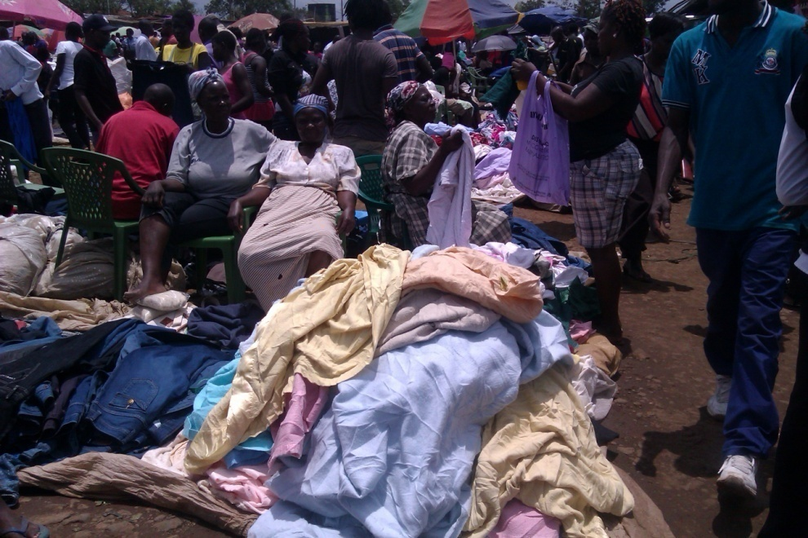 | Time: 9.00 a.m. - 12.00 p.m.  - Peak hours of the market.  - More female traders are represented at this hour.
 | Time: 12.00 p.m. - 3.00 p.m.  - Traders are experiencing reduced sales.  - Customers have reduced.
 | After 3.00 p.m.  - Traders begin to leave the market gradually.  - Picture indicates a higher representation of female traders in the market after 3.00 p.m.

