Evaluation of the antagonistic effects of some actinomycetes species isolated from Maseno Soils on Pyricularia grisea infecting finger millet (Eleusine coracana (L.) Gaertn).

BY

WERE JOHN JOSE OKUMU

A thesis submitted in partial fulfillment of the requirements for the Award of the Degree of Master of Science in Botany (Plant Pathology)

SCHOOL OF BIOLOGICAL AND PHYSICAL SCIENCES

MASENO UNIVERSITY

© 2016
DECLARATION
I certify that this thesis has not previously been submitted for a degree award in Maseno University or any other University.
The work reported herein is my own individual work and all sources of information have been acknowledged by way of references.

Signature_____________________________ Date__________________________

Were John Jose Okumu
Pg/Msc./00010/010
Department of Botany,
School of Biological and physical sciences
Maseno University.

This thesis has been submitted for examination with our approval as the University supervisors.

Signature_____________________________ Date__________________________

Dr. George O. Opande
Department of Botany,
School of Biological and physical sciences
Maseno University
Private Bag
MASENO.

Signature_____________________________ Date__________________________
Prof. Peter F. Arama
School of Agriculture, Natural Resources and Environmental Studies
Rongo University College
P.O. Box 205
RONGO.

ACKNOWLEDGMENTS
This research would not have been possible without the unwavering support of my supervisors Prof. Peter F. Arama and Dr. George Opande. May I specially acknowledge the material support that Professor Arama availed to me throughout this work. I am sincerely grateful to you all.
It is also wise to acknowledge technical support offered to me by Prof. S. Wagai. Prof. I am grateful for your support during characterization of actinomycetes, your time and help during photomicrography. Allow me not to forget your special review of the proposal draft, you made my work easy, God bless you.
This work would not have been possible without the technical team from the department of botany led by the chief technician. In this regard I am very much grateful to brother and friend Dan Buyela for his good work. Dan I was honored to have a great man like you.

DEDICATION
This thesis is dedicated to my parents Anjeline Odera Were and late Robert Were Omuandho for their encouragement and selfless sacrifices in the provision of my education. Their moral support and efforts are highly cherished. You two are pillars that I always leaned on.
Also to my dear spouse Ms. Monica Akinyi Okumu for her encouragement, financial support and assistance as well as my daughter Snyder and son Benard for their patience and perseverance during my study.
I also dedicate this thesis to my siblings Ken, Vitalice, Sister Mildred, the late Bernard and Benter for their co-operation, prayers, material and financial support throughout my education. A special salute to my teacher, god father and brother late Edward Odhiambo Were without whom this would have been an impossible dream, may your soul rest in peace.

ABSTRACT
Finger millet (Eleusine coracana (L.) Gaertn) is one of the most important crops among the small millets. In Kenya yields are generally low, because of blast caused by the fungus Pyricularia grisea. Low finger-millet production accelerates incidences of malnutrition. Management has been challenging with cultural approach showing minimal success. Comparatively the use of actinomycetes species as a bio-control agent in management of rice blast caused by a similar pathogen, has shown some success hence a need to look at its candidacy as agent in the control of finger millet blast. Little is known about success of such a control strategy in Maseno University area using soil actinomycetes extracts. The objective was to isolate actinomycetes from soils collected in Maseno area, test against Pyricularia grisea and fungicidal ones characterized. The P. grisea were isolated from infected finger millet earlier grown in Maseno University’s botanical garden. Soil samples were collected a long a line transect drawn from Siriba-Main campus road. Soil samples collected were pre-treated by air drying at room temperature for 3 days, after which they were dissolved in distilled water, homogenized and spread over modified Kuster’s agar from where colonies were isolated. The actinomycetes cultures were grown together with the fungus, in a fresh Kuster’s agar and incubated for 4 days at 28°C. The species with the inhibitory ability such as AT2 and AT4 were characterized using classical approach according to Bergy’s manual of Determinative bacteriology. Then AT2, AT4 and AT6 were grown in Kuster’s broth in a shaker incubator at 28°C and 200 rpm for six days, and extracts obtained from each tested for inhibitory effect against the pathogen. 50mg/ml of AT2, AT4, AT6 extracts and Probenazole were mixed with the pathogen spores at 7.2 x10⁶ spores/ml of corn oil and used as treatments. Five Treatments were replicated three times in a Randomized design and Disease severity (DS) scored using a 1-5 visual scale. Area under disease progress stairs (AUDPS) indicating efficacy based upon the records were obtained by calculating the area of each step function, and then adding up the areas. The Data collected was subjected to analysis of variance (ANOVA). The means were separated and compared using LSD at P≤ 0.05. Fifteen Actinomycetes (AT1, AT2, AT3, AT4, AT5, AT6, AT7, AT8, AT9, AT10, AT11, AT12, AT13, AT14 and AT15) were isolated from the samples and picked for invitro tests against Pyricularia grisea. When the actinomycetes cultures were grown together with the fungus, AT2 had a mean inhibition distance of 10 mm, AT4 had 8 mm, AT1, AT3 and AT6 had less than 1.0mm. Extracts of AT4 and AT6 had no fungicidal effects while extracts of AT2 showed fungicidal effects against Pyricularia grisea. AT 2 was identified as Streptomyces sindeneusis and AT 4, Streptomyces plicatus. Plants exposed to the mixture of pathogen and AT6 showed no significant difference in disease incidence with the plants exposed to the Pyricularia grisea alone. AT2 treatment had highest resistance at AUDPS of 24.8, however there was a significant difference between it and the spores exposed to Probenazole, AUDPS of 13.5. AT4 at AUDPS of 40.2 had a weak resistance; however it was significantly different from either AT6 at 47.5 AUDPS or pathogen alone at 50.5 AUDPS. Maseno soils have actinomycetes, some of which have inhibitory ability against finger millet blast. A few produce extracts that can resist spread of Pyricularia grisea in host plant. Streptomyces sindeneusis in this study had a significant ability in the control of finger millet blast both invitro and invivo. The findings of this study will be useful to any work involving isolation of actinomycetes within Maseno. It has also pointed at a possibility of formulating a bio-control agent among the actinomycetes isolates for many other pathogenic fungi.

TABLE OF CONTENTS
Tittle page………………………………………………………………………………………….i
Declaration ii
Acknowledgments iii
Dedication iv
Abstract v
Table of contents…………………………………………………………………………………..vi
Acronyms and Abbreviations ix
List of Tables xi
List of Plates xii
List of Appendices xiii
CHAPTER ONE: INTRODUCTION 1
1.1 Background information 1
1.2 Statement of problem 4
1.3 Justification 4
1.4 Objectives 6
1.5 Hypotheses 6
CHAPTER TWO: LITERATURE REVIEW 7
2.1 Finger millet 7
2.1.1 Economic value of Finger Millet 8
2.2 Finger millet blast 9
2.2.0 Description of agent 9
2.2.1 Hosts and symptoms 10
2.2.3 Life cycle of Pyricularia spp. 12

2.3 Management strategies of Pyricularia 14
2.3.1 Cultural Control of blast 14
2.3.2 Preventive measures to blast 15
2.3.3 Biofungicide control of blast 16
2.4 Actinomycetes 17
2.4.1 Biology of actinomycetes 17
2.4.2 Role of actinomycetes in agriculture 18
2.4.3 Isolation of Actinomycetes from Sediments 19
2.4.4 Identification of actinomycetes 20
CHAPTER THREE: MATERIALS AND METHODS 21
3.1 ISOLATION OF ACTINOMYCETES 21
3.1.1. Study area 21
3.1.2 Sampling procedure……...………………………………………………………………21
3.1.3 Sample preparation in the laboratory…………………………………………..……….21
3.1.4 Incubation of actinomycetes on Kuster's medium……………………………………...22
3.1.3 Characterization………………....………………………………………………………..23

3.2 INHIBITION TESTS OF ACTINOMYCETES ON Pyricularia grisea
AND CHARACTERIZATION OF THE PATHOGENIC ACTINOMYCETES………….25
3.2.1 Collection and isolation of Pyricularia grisea 25
3.2.1.1 Confirming the identity of the Pyricularia isolate 25
3.2.1.2 Preparation of Pyricularia Inoculum 26
3.2.1.3 Constituting the inoculums using Hemacytometer counts 27
3.2.2 Inoculation of Actinomycetes isolates with the Pyricularia grisea on petri-dish 27
3.2.3 Inoculation of P.grisea on PDA with wells filled with Actinomycetes extracts 29
3.2.4 Characterization of AT2 and AT4 fungicidal Streptomyces……………………………..30

3.2.4.1 Aerial mass colour…………………………………………………….……….…..…30 3.2.4.2 Melanoid pigments……………………………………………………………………30
3.2.4.3 Reverse side pigments……………………………………………………………...…31
3.2.4.4 Soluble pigments……………………………………………………………….…….31
3.3 EFFICACY OF ACTINOMYCETES EXTRACTS 32
3.3.1 In vivo greenhouse studies 32
3.3.2 Data analysis 33

CHAPTER FOUR: RESULTS 34
4.1 ISOLATION OF ACTINOMYCETES 34
4.2 INHIBITION TESTS OF ACTINOMYCETES ON Pyricularia grisea
AND CHARACTERIZATION OF THE PATHOGENIC ACTINOMYCETES….............36
4.3 EFFICACY OF ACTINOMYCETES EXTRACTS……………………………………….. 43

CHAPTER FIVE: DISCUSSION: 47

CHAPTER SIX: CONCLUSION AND RECOMENDATIONS……………………………51
REFERENCES………………………………………………………………………………...53
APPENDICES…………………………………………………………………………………59

ABBREVIATIONS AND ACRONYMS
ANOVA Analysis of variance
AIDS Acquired immunodeficiency syndrome
AT ( AT1-AT5) Actinomyces
AUDPC Area under disease progress curve
AUDPS Area under disease progress stairs
CGIAR Consultative group on international agricultural research
DAS Days after sowing
DS Disease severity
EARSAM East African’s regional workshop on sorghum and millet
ECA East and Central Africa
HIV Human Immunodeficiency Virus
ICRISAT International crops research institute for the semi-arid tropics
IRRI International rice research institute
ISP International Streptomyces Project
KALRO Kenya agricultural and livestock research organisation
LSD Least significance difference
NRI . UK National Research Institute
PDA Potato Dextrose Agar
PRA Participatory Rural Appraisal
R(R1-R3) Replications
LIST OF TABLES
Table 4.1 Isolates of actinomycetes ……………………………………………………………..35
Table 4.2 Inhibitory levels of isolated actinomycetes isolates 37
Table 4.3 Inhibitory levels of isolated actinomycetes extracts……………….………….…...…..40
Table 4.4 Morphology and Physiology of AT2 and AT4 isolates ……...........41
Table 4.5 Efficacy levels of actinomycetes extracts……………………………………………...44

LIST OF PLATES
2.01 Infected finger millet with head blast………………………………………………….……11
2.02 Infected finger millet with leaf blast………………………………………..……………......11
2.03 Life cycle of Pyricularia grisea…………………………………………………………….…15
3.01 Prepared soil samples in test tubes………………………………………………..…………23
3.02 Plating of Actinomycetes……………………………………………..………….………....24
3.03 Mycelium of Actinomycetes………………………………………………………………...25
3.04 Pyricularia grisea spores…………………………………………………………..……..…..27
3.05 Pots covered to provide green house effects………………………………….…………….34
4.01 A seven day old Pyricularia grisea …………………..………………………...……….….39
4.02 A seven day old Pyricularia grisea laced with probenazole ……………………..….…..39
4.03 Suppressive reaction of AT6 on Pyricularia grisea…...........................................................42
4.04 Suppressive reaction of AT2 on Pyricularia grisea ….…………..………………………..43
4.05 Suppressive reaction of AT4 on Pyricularia grisea …….………………..…....….…….....43
4.06 Aerial mycelia of AT2……………………………………………………………..……….43
4.07 Aerial mycelia of AT4……………………………………………………………….…..…43
4.08 Pigments of AT4 and AT2 on Kuster's media……………………………………..………44
4.09 Plants after exposure to Pyricularia grisea spores……………………………………........46
4.10 Plants exposed to the mixture of fungal spores and AT2 extracts………….……..…...….46
4.11 Plants exposed to the mixture of fungal spores and AT6 extracts…………….…….…..….47
4.12 Plants exposed to the mixture of fungal spores and Probenazole………..….…….…...….47

LIST OF APPENDICES
Appendix1.0: Actinomycetes isolation. 60
1.1 Soil samples collected. 23
1.2 AT1 isolate on 1/2 yeast-starch 59
1.3 AT2 on 1/2 yeast-starch medium 60
1.4 AT 3 on 1/2 yeast-starch medium 60
1.5 Isolates AT1-AT7 on sterile glass slides 62
1.6 Kuster broth and 1.5% Kuster’s agar . .62
Appendix 2.0: Inhibition tests of isolated actinomycetes……….…………………………….60
2.1 Pricularia isolates ……………………………………………….……………………..……..63
2.2 Inhibitory effects of isolated actinomycetes 62
2.2.1 AT3 against Pyricularia in kuster’s medium. 62
2.2.2. AT1 against Pyricularia in Kuster’s medium. 63
2.2.3. AT 2 against Pyricularia on Kuster’s medium. 63
2.3 Table summarizing inhibitions……………………………………………………………….64
2.4 Table summarizing efficacy of extracts in a well technique………………………………… 65
Appendix3.0: Efficacy of actinomycetes on Pyricularia grisea……..……….………..…….…66
3.1.Pots of finger millet (P224) varieties at 40 days after sowing. .66
3.2 Table of disease severity score……………………………………………………...……67

CHAPTER ONE
1.0 INTRODUCTION
1.1 Background information
The control of many plant diseases has been primarily through the application of chemical fungicides, despite the potentially toxic effects it has on humans, wildlife, and the environment (Lee and Oh, 2000). The advent of new pathogen races that are resistant to fungicides has been another problem to plant pathologists and agro chemists. According to Arifuzzaman et al., (2010), new fungicides that are safe to humans and wildlife and have benign environmental profiles, and high specificity to target organisms are needed to ensure stable crop production. Micro-organisms and their natural products are potentially important for the biological control of crop diseases without detrimental effects to the environment (Nonoh et al., 2010). However, biological control of plant diseases is slow, gives few quick profits, but can be long lasting; inexpensive and harmless to life (Lee and Oh, 2000). There is need to address these challenges by offering a non- chemical method, biological friendly system and an environmentally cheap approach in the control of finger millet blast in Kenya.
Pyricularia grisea is a filamentous ascomycete, which causes rice, barley, wheat and finger millet blast disease. Millet blast is the most serious disease of cultivated millet and therefore poses a threat to the East and Central Africa most important food security crop (Mgonja et al., 2007). The pathogen is highly destructive and economically important causing in excess of 50 % reductions in yield where the panicle is infected, and particularly in wet years (Hayden, 1999). Pande et al. (1995) reported losses of 10 – 90 % in field studies in Uganda, 64 % in Kiboko in Kenya and near total losses in India. These losses are due to reductions in both grain number and grain mass. Seeds, crop debris and weed hosts have been implicated as potential disease sources (Takan et al., 2004). Isolates causing leaf, neck and panicle blast on finger millet were genetically similar indicating that the same strains were capable of causing different expressions of blast under suitable conditions (Wanyera, 2007). This suggests that host resistance in general should be effective against all expressions of blast (Takan et al., 2004). Pyricularia grisea has been shown to be associated with infected seed (Wanyera, 2007). There are reports that heavily contaminated seeds show poor germination and there is, therefore, little opportunity for infected plants to reach maturity. However, there are reports of suspected seed transmission resulting in infection within the field. Wanyera (2007) suggested that seed is a key source of inoculums and extremely low seed-borne incidence may initiate a blast epidemic.
In Kenya research information pertaining to production and disease of finger millet (Eleusine coracana (L.) Gaertn) by mainstream research organizations such as Universities, Kenya Agricultural and Livestock Research Organisation (KALRO) and other organizations is limited, thereby a lack of realization of the potential productivity of this important crop. Increased production, utilization and trade of finger millet in East Africa is currently limited by a number of constraints that reduce yields to levels of 0.5-0.75 tonnes ha⁻¹ from a realistic on-farm potential of 1.5-2.0 tons ha⁻¹(Mgonja et al., 2007).
The most serious constraints are those related to productivity enhancement, especially varieties that are susceptible to blast disease caused by the fungus Pyricularia grisea (Talbot, 2003). It is especially serious in the Busia, and Kisii counties of Kenya and in the main finger millet areas in north and east Uganda (Mgonja et al., 2007). Finger millet blast is the most serious and widely spread disease for this crop. Blast affects finger millet at all growth stages, from seedling stage to affecting the panicle causing neck and/or finger blast. Blast caused by Pyricularia grisea has been identified as the highest priority constraint to finger millet production in East Africa, (Takan, 2004).
Most of the finger millet land-races and a number of other genotypes are highly susceptible to blast (Talbot, 2003). In Uganda and Kenya, damage by blast is a priority for intervention, as regards poor subsistence farmers (Mgonja et al., 2007). In particular, neck and head blast inhibit grain formation/cause shriveling of grains, and in extreme cases yield losses up to 90% (Takan, 2004). Information is available on the pathogen diversity and epidemiology from the region (Takan, 2004). Knowledge on the disease intervention points and identification of varietal resistance is vital. There is also a need to develop sustainable disease management strategies and fully exploit the potential of finger millet.
Actinobacteria is one of the dominant phyla of the bacteria. Most Actinobacteria of medical or economic significance are in subclass Actinobacteridae, order Actinomycetales. While many of Actinomycetales cause disease in humans, Streptomyces is notable as a source of antibiotics. The other genus in the family Streptomycetaceae is Micromonospora (Waksman and Henrici 1943). A bioprospect of soil actinomycetes has revealed their wide antifungal activity (Tinatin and Nurzat, 2006). The predominant species of actinomycetes is Streptomyces. Streptomyces are some of the most attractive sources of biologically active substances such as vitamins, alkaloids, plant hormones, enzymes and enzyme inhibitors (Zarandi et al., 2009). Soil Streptomyces are the major contributors to the biological buffering of soils and have roles in decomposition of organic matter conducive to crop production (Zarandi et al., 2009). Streptomycetes sindeneusis has been successfully used in the control of Rice blast under greenhouse conditions (Zarandi et al., 2009). What has not been explored, however, is the possibility of using streptomyces extracts to control Pyricularia grisea in finger millet as has been used in Pyricularia oryzae of rice blast.

  - Statement of the problem
Most of the finger millet land-races and a number of other genotypes are highly susceptible to blast (Talbot, 2003). In western Kenya, damage by blast is a priority for intervention, as regards poor subsistence farmers. In particular, neck and head blast inhibit grain formation/cause shriveling of grains, and in extreme cases yield losses up to 90%. Little is known about the success of using actinomycetes to control Pyricularia grisea in finger millet in Maseno area and Western Kenya in general.
  - Justification
Many soil resident species of actinomycetes are harmless to animals and higher plants, while some are important pathogens. Others are sources of antibiotics (Kavitha et al., 2010). They are one of the major groups of soil population and are very widely distributed (Nonoh et al., 2010). Their occurrence and distribution in Maseno University soils is unknown.
There is an urgent need to solve human food difficulties and boost the production of the native crops that are drought resistant and cheap to produce. Finger millet leads the list of these native crops. Any disease grossly affecting millet production among the poor rural population must be addressed and controlled (Mgonja et al., 2007). Finger millet blast currently provides one of the greatest challenges to millet production. Control of the disease has for many years been through cultural practices such as early planting, timely weeding and use of clean seeds. Most of the finger millet land-races and a number of other genotypes are highly susceptible to blast. The resource poor farmers do not buy certified seeds but rely heavily on the seeds got from the previous harvest (Talbot, 2003). Recycling these infected seeds, results into the disease epidemics. What has not been addressed is the possibility of using bio-fungicides in its control. Soil actinomycetes especially the Streptomyces have been in use in the control of Pyricularia oryzae in Rice. Extracts of actinomycetes have been harvested and successfully used as a bio- fungicide in the management of rice blast in the host plant under green house conditions (Zarandi et al., 2009). The same extracts have not been tested on finger millet blast, hence the need of this study.
The study will generate useful information on the possibility of using actinomycetes in control of finger millet blast. It therefore forms a basis for further research on the potentials of actinomycetes use in the fields. These research findings will be very useful not only to farmers but also to the pharmaceutical industries in researching for possible fungicides.

1.4 Objectives
1.4.1 General objective
To study antagonistic effects of actinomycetes isolates for potential management of Pyricularia grisea.

1.4.2 Specific objectives
1. To isolate actinomycetes species in soils around Maseno University.
2. To determine inhibitory effects of isolated actinomycetes against Pyricularia grisea
cultures and characterize the pathogenic ones.
3. To determine the efficacy of the active actinomycetes extracts on Pyricularia grisea infecting finger millet.

1.5 Hypotheses
H1: There are actinomycetes species from Maseno University soils.
H2: Actinomycetes species within Maseno have inhibitory effects on Pyricularia grisea
H3: Actinomycetes species isolates from Maseno University soils produces active
extracts that can inhibit the development of the Pyricularia grisea on the host plant.

CHAPTER TWO
2.0 LITERATURE REVIEW
2.1 Finger millet
Among the small millets which include pearl millet, Proso millet, Kodo millet, foxtail millet, Barnyard millet, Little millet and finger millet (Kavya,2013). Finger millet is the most important crop among Kenyans. This is a crop within the class Liliopsida (monocotyledons), order Cyperales and family Poaceae – Grass family. It takes averagely 75 days to flowering and can grow to a height of 110 cm. It’s wide adaptability from hill slopes and undulating fields to shallow and gravelly soils, makes it the most popular small millet in India, Africa and, to some extent, dry regions of Sri Lanka. Finger millet is photoperiod sensitive, the critical being 12 h (Desmond et al., 2007). Problems of photoperiod sensitivity are encountered in the crop which otherwise grew successfully in the USA as far north as Davis, California (Hayden et al, 1999). It can be grown in any soil type, but requires rainfall of at least 800 mm per annum, and will not tolerate flooding (Desmond et al., 2007)
In Kenya, it is grown by small-scale farmers for both food and cash. About 65,000 ha are planted annually in Western, Lake and Lower Eastern regions (Oduori and Kanyenji, 2007) and about 500,000 ha in Uganda (Wanyera, 2007). The main production areas are west of the Rift Valley (Oduori and Kanyenji, 2007). Yields on farmers’ fields are generally just 15% of their theoretical maximum in Kenya (Oduori and Kanyenji, 2007). According to Oduori and Kanyenji, (2007), finger millet acreage in Kenya has been declining since 1978. Though often known as a food crop for the poor, it is fast becoming a popular food crop among people of all wealth categories (Mgonja et al., 2007). It is less susceptible to pests and diseases than other grain crops, blast being the only major disease, but it has a poor ability to compete with weeds (Agobe et al., 2007).
2.1.1 Economic value of Finger Millet
The crop has outstanding nutritional properties as a subsistence food crop. Its small grains are an excellent dietary source of calcium, iron, manganese, and methionine, an amino acid lacking in the diets of hundreds of millions of the poor who live on starchy foods such as cassava, polished rice, and maize meal (Wanyera, 2007). It is a versatile grain crop, used in many different types of food and for brewing beer. The grain is considered to be more nutritious than any other major cereal species. The phosphorus, iron and vitamin B contents are particularly valuable in the diets of young children and pregnant or lactating women. Finger millet grain is a staple diet of many subsistence farmers in Kenya, especially in the eastern and northern regions of the country, and is an important source of calories and protein (Wanyera, 2007). Finger millet protein contains a very good source of sulphur containing amino acids. In addition, it has the unique distinction of being the only cereal with over 300 mg/100g of calcium in the grain. It is recommended as the ideal food for diabetics, elderly, and the sick especially those affected by HIV and AIDS (Mgonja et al., 2007).
In Kenya and Tanzania it is known as wimbi and ulezi, respectively. In these two countries as well as in Uganda it is used to make porridge and can be mixed with other energy rich foods to make stiff porridge popularly known as ugali; similarly known as sadza or nsima in Zimbabwe and Zambia, respectively (Oduori et al., 2007). Finger millet is also used to make local beers, for example, bussa/ ajono in Kenya among the Teso. Finger millet can be stored for long periods, a critical trait in ensuring food security for poor households in drought-prone areas. Finger millet is therefore increasingly becoming a major cash crop. The grain can be sold directly for cash at local markets or shops soon after harvest or may be stored until the market conditions become favorable. Often the grain is a key ingredient in brewing and the beer sold for cash. The grain may be used as a means of payment for labour wages either directly or in the form of beer or used in the barter exchange for other commodities like meat, livestock or chicken (Hayden et al., 1999). Finger millet straw makes good animal fodder, containing up to 60% total digestible nutrients.

2.2 Finger millet blast
2.2.0 Description of agent
Pyricularia grisea is an ascomycete fungus, a member of the sac fungi in the division ascomycotina, class ascomycetes, order Magnaporthales and family Magnaporthaceae (Couch and Kohn, 2002). One of the features of these fungi is that they generate spores, called conidia or conidiophores that can be easily dispersed by the wind and splashing rain. These spores can stay in cereal grains and grass stubble and can infect new crops the following year. Conidia generated in the diseased plant can further spread the infection. The blast fungus, Pyricularia grisea, exists as numerous physiological races (Hayden et al., 1999). The considerable speculation which exists about the possibility for races of the pathogen is based on similarities with the related Pyricularia grisea, causal agent of rice blast. However, the race structure of finger millet blast has not been described. Magnaporthe is the sexual or perfect form of the fungus and it is not seen in the wild although the name is used in the scholarly literature when the genetics of the pathogen are investigated (Talbot, 2003).

2.2.1 Hosts and symptoms
The disease is first seen as elliptical gray-white lesions with reddish edges on the leaves (plate 2.1) and stems of the plant (Talbot, 2003). The lesions run parallel to the long axis of the leaf or stem. Most damage occurs when the fungus spreads to the area below the seed head of the plant (plate 2.2), causing it to break off (rotten neck). Otherwise, the disease prevents the maturation of the millet grains (panicle blast).
Pyricularia grisea isolates from weed hosts compared with isolates from finger millet are in general not genetically distinct. In most cases isolate from weed host, belong to the same genetic group as isolates from finger millet.This underlines the potential of weeds to serve as source of inoculum sources (Agobe et al., 2007). A pathogenicity test revealed that the isolates from weeds were pathogenic to finger millet, with some weed isolates being as aggressive as some of the finger millet isolates (Takan et al., 2004). Field experiments carried out in Uganda suggested that seed borne inoculum contributed to initial blast development, as higher disease incidence was observed with seeds containing higher proportion of inoculum (Wanyera, 2007).
According to Takan, (2004) most farmers were aware of blast symptoms both in Uganda and Kenya. Had native name for the disease, such as Ebwetelele, Obapu and Kalajajwa –generally meaning ‘dry heads’ in Uganda among the Teso and known as egetabo in Kisii, Kenya. However, they were not aware of the cause, modes of transmission and control measures (Sreenivasaprasad et al., 2007). Both Kenyan and Ugandan farmers in general reported a lack of crop pest and disease management information. Pathogenicity tests have been performed with a representative set of characterized isolates by spray inoculation of 6-week-old finger millet seedlings. Variation in pathogenicity has been recorded among the Pyricularia grisea isolates analyzed both on a particular variety as well as in infecting different varieties. Preliminary studies addressed the effect of plant debris on the development of blast and infected debris had been shown to be associated with severe infections (Agobe et al., 2007). Several weed species including wild Eleusine spp., Digitaria spp. and Setaria verticillata, were able to support the pathogen. This suggested that these collateral hosts could have been important under field conditions (Hayden et al., 1999). Epidemiological studies had demonstrated that yield losses were related to time of disease onset. However, little is known of disease progress on different genotypes, especially those showing a measure of tolerance or resistance to the pathogen (Agobe et al., 2007).

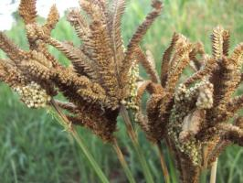
Head blast
Neck blast
Plate 2.1 infected finger millet
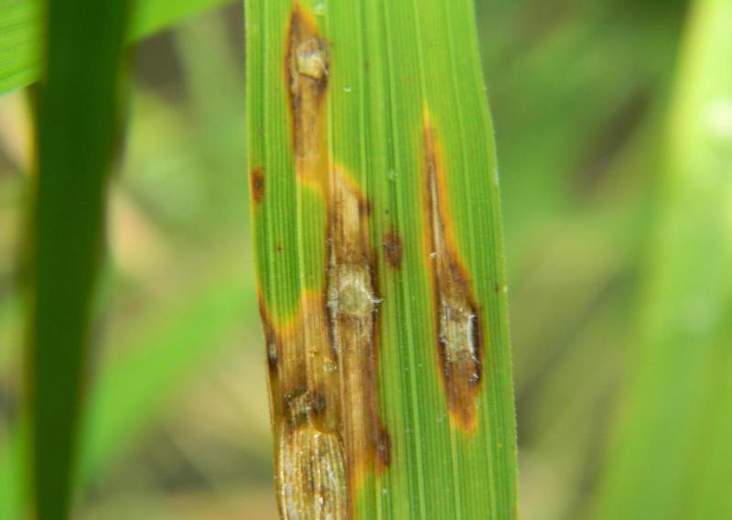
Elliptical grey lesions
Reddish edges
Plate 2.2 finger millet with leaf blast
2.2.3 Life cycle of Pyricularia spp.
Conidiogenesis which is the appearance of necrotic disease lesions is accompanied by the development of aerial conidiophores (Gilbert et al., 1996). Conidia are arrayed at the tips of these aerial hyphae (plate 2.3). Mitotic division of a single progenitor nucleus produces a three-cell conidium. Thereafter, the hyphal tip moves to the side of the conidium and produces a second spore until three to five conidia are produced in a whorl at the conidiophore tip (Talbot and Wilson, 2009). Mature conidia are three-celled, spear-shaped, and bear a basal appendage at the point of attachment to the conidiophores (plate 2.3). As spores reach maturity, the apical cell wall of the conidium breaks open, and a droplet of viscous sticky material is produced while the conidium is still attached to conidiophores (Lee et al., 1994). This material serves to attach the conidium to the wax-covered host surface upon contact in a nonspecific manner. Once attached, even vigorous attempts to dislodge adherent conidia from surfaces are typically unsuccessful (Talbot, 2003). Appressorium formation is a stage in fungus development characterized by development of appressoria that infect aerial tissues of the host.
Sexual reproduction occurs when two strains of opposite mating types meet and form a perithecium in which ascospores develop. Perithecium is a small flask-shaped fruiting body that develops during sexual cycle of the fungus and contains ascospores (Howard et al., 1991). Ascospore is a specialized cell produced from the germ tube of the conidium (appressorium formation stage). Development of the appressorium requires a hard, hydrophobic surface and/or the absence of exogenous nutrients (Talbot and Wilson, 2009). Appressorium is a dome-shaped cell with a highly differentiated cell wall structure. Its cell wall is rich in chitin and contains a layer of melanin on the inner side of the wall. The melanin is a virulence characteristic of the fungus; it is well known that the appressorium is able to generate an enormous turgor pressure and physical force, allowing the fungus to breach the host cuticle and invade plant tissue (Lee et al., 1993). It is also known that melanin-deficient mutants cannot generate the pressure of the magnitude required for penetration of the plant cuticle (Talbot and Wilson, 2009).
The region of the appressorium adjacent to the substratum, appressorium pore, lacks both, chitin and melanin (Gilbert et al., 1996). The pore develops a new cell wall through which the penetration peg emerges that perforates the host surface and conveys the content of the appressorium into cells of the leaf epidermis.
Spore germination requires the presence of free water and is very rapid, within 2-4 hours of landing on the leaf; a polarized germ tube extends for a short distance from one of the apical cells of the conidium. It swells at its tip and changes direction while becoming flattened against the leaf surface a process known as hooking (Talbot and Wilson, 2009). Hyphae grow intracellularly invading adjacent epidermal cells as well as underlying mesophyl cells. After penetration of the plant cuticle and cell wall, the penetration peg enlarges to form a primary infection hyphae that subsequently differentiates into a branched and bulbous secondary hypha, which enables proliferation throughout the host tissue (Bourett et al., 1990).

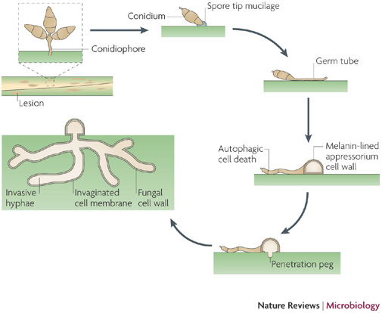
Plate 2.3 Life cycle of Pyricularia grisea

2.3 Management strategies of Pyricularia grisea
2.3.1 Cultural Control of blast
Blast was noted to be favored by excessive nitrogen fertilization in aerobic soils, and drought stress (Gouramanis, 1995). High nitrogen rates and nitrate nitrogen increased rice susceptibility to the disease. Extended drain periods encouraged the disease by aerating the soil. It also encourages conversion of ammonium to nitrate and causes drought stress to rice. Use of proper seed sampling and testing to identify and avoid the use of blast-infested seed in areas where blast is not a problem has also been an effective strategy (Wanyera, 2007). This helps limit the introduction of the disease into non-infested areas. Water seeding was recommended to reduce or eliminate disease transmission from seed to seedlings (Gouramanis, 1995). Drill seeding was often not recommended because it allowed seed transmission, nitrate formation, and resulted in drought stress (Gouramanis, 1995). Continuous flooding was recommended to limit blast development. Avoidance of field drainage, especially for extended periods was recommended because it allows the formation of nitrate and may cause drought stress. Some studies (Gouramanis, 1995), in other areas suggested that shallow water can be more favorable to blast development than deeper water. Some of these practices may not be applicable in management of blast in finger millet. For example millet cannot grow under water-logged soils (Talbot and Wilson, 2009); hence flooding may not be encouraged. Drought stress is a common challenge in millet growing areas. Cultural practices such as timely planting, field hygiene, close season, crop nutrition are in use. Field hygiene involves weeding, planting disease free seeds, removing harvested straws from the field. Weeding help eliminate possible alternative hosts (Soytong, 1991).
Factoring all the challenges cultural method faces, there is need for a more effective approach (Talbot and Wilson, 2009).
2.3.2 Preventive measures to blast
Use of fungicides has also been reported (Hayden et al., 1999). Application of the protective fungicide, Dithane, followed by Benlate, a systemic fungicide, during wet and cloudy periods, has been effective (Hayden et al., 1999). Varieties with resistance to blast have been identified. Varieties P224 (blast tolerant) and Gulu E (moderately resistant) has been investigated on-farm by participating farmers, and by a wider audience through community workshops and farmer days (Hayden et al., 1999). The genes encoding many antifungal characteristics are currently being used by agronomists to create genetically modified plants that have increased fungal resistance in the field. Soil Actinomycetes particularly Streptomyces spp. has antagonistic activity against wide range of plant pathogens. In the recent decades they have attracted high interests as biocontrol agents (Opandey et al., 2013).

2.3.3 Biofungicide control of blast
In sustainable agriculture natural bio fungicides are safe (Arifuzzaman et al., 2010). Since most of synthetic fungicides do harm the ecosystem to some extent, their usage should be discouraged and safer strategies as biological control techniques be encouraged. Zarandi et al. (2009) found potential antifungal metabolite in S. sindeneunsis isolate against M. oryzae. Antifungal activity of the isolate found in the study highlights its importance as a candidate for further investigation in biological control of the world-wide destructive rice blast disease (Arifuzzaman et al., 2010).
In search for finding such principles, in vitro suppression of Magnaporthe oryzae the causal agent of rice blast disease was studied by use of Streptomyces sindeneusis isolate in greenhouse (Zarandi et al., 2009). Spraying of rice seedling-leaves with mixed spore suspension of the pathogen and S. sindeneusis isolate resulted in strong inhibition of the pathogen and suppression of leaf symptoms (Zarandi et al., 2009). Nonoh et al. (2010) in their study of Streptomyces species with antifungal activity from selected national parks in Kenya showed that protected areas may harbor Streptomyces species which could be useful in protecting plants against fungal pathogens such as Fusarium wilt, dumping-off and coffee berry disease in fungi.

2.4 Actinomycetes
2.4.1 Biology of Actinomycetes
Actinomycetes are a group of Gram-positive bacteria with high guanine and cytosine content. They can be terrestrial or aquatic and are noted for a filamentous and branching growth pattern that results, in most forms, in an extensive colony, or mycelium (Sarigulu et al., 2013). They produce branching mycelium which may be of two kind’s viz., substrate mycelium and aerial mycelium. The mycelium in some species may break apart to form rod- or coccoid-shaped forms. Many genera also form spores on the sporangia, or spore cases on aerial hyphae, on the colony surface, or free within the environment. Motility, when present, is conferred by flagella. Many species of Actinomycetes occur in soil and are harmless to animals and higher plant (Arifuzzaman et al., 2010). While some are important pathogens, many others are beneficial sources of antibiotics. They are one of the major groups of soil population and are very widely distributed. The number and types of Actinomycetes present in a particular soil would be greatly influenced by geographical location, soil temperature, soil type, soil pH, organic matter content, cultivation, aeration and moisture content (Devi et al., 2013). Actinomycetes populations are relatively lower than other soil microbes and contain a predominance of Streptomyces that are tolerant to acid conditions (Arifuzzaman et al., 2010). Arid soils of alkaline pH tend to contain fewer Streptomyces and more of the rare genera such as Actinoplanes and Streptosporangium. In Kenya their population is high in Western part of the country with few numbers along the coastal region and a relatively small amount in the central region (Nonoh et al., 2010). This is due to the varying ecological factors and altitude.
2.4.2 Role of actinomycetes in agriculture
Based on several studies among bacteria, the actinomycetes are noteworthy as antibiotic producers, making three quarters of all known products; the Streptomyces are especially prolific (Arifuzzaman et al., 2010). A search of the recent literature revealed that at least 4,607 patents have been issued on actinomycete related product and processes (Sarigullu et al., 2013. Streptomyces covers around 80% of total antibiotic product, with other genera trailing numerically; Micromonospora is the runner up with less than one-tenth as many as Streptomyces(Sarigullu et al., 2013. According to Hopwood (2000); if we include secondary metabolites with biological activities other than antimicrobial, actinomycetes are still leading. Microbes are gaining resistance to existing antibiotic. Still, there is a desperate need of screening actinomycetes for antimicrobial compound to be used in various fields including medicine and agriculture.
Actinobacteria are important source of antibiotics, enzymes and bioactive products (Basavaraj et al., 2010). Because of their ability to synthesize numerous compounds that exhibit extreme chemical diversity, Streptomyces strains are major part of industrial strain collections used in screening for new bioactive molecules (Dastager et al., 2006) which have been used in control of plant pathogens. Studies have shown that actinomycetes are a promising group of the fungus antagonistic root colonizing microbes (Arifuzzaman et al., 2010). Streptomyces species and a few other actinomycetes have been shown to protect several different plants to various degrees from soil-borne fungal pathogens (Arifuzzaman et al., 2010). Streptomyces rochei and Streptomyces rimosus from the chickpea rhizosphere were found to be strong antagonists of Fusarium oxysporum f. sp. ciceri. Streptomyces hygroscopicus var. geldanus, grown in sterile soil, antagonized Rhizoctonia solani, the pea root rot fungus, via geldanamycin production (Dastagar et al. 2006). A few actinomycetes have also been shown to produce herbicidal and insecticidal compounds (Debananda et al., 2009).

2.4.3 Isolation of Actinomycetes from Sediments
There have been a number of reports in the literature dealing with selective isolation of the higher fungi at the expense of bacteria or of bacteria at the expense of molds (Basavaraj et al., 2010). Several investigators used antibiotics as the selective agents (Arifuzzaman et al., 2010). For example, Beech and Carr (1955) found cycloheximide, gliotoxin, and frequentin to be effective selective yeast and mold inhibitors in apple juices and ciders (Arifuzzaman et al., 2010). Some studies found cycloheximide to be inactive against representatives of 27 species of bacteria and suggested that this antifungal antibiotic might be used to rid bacterial cultures of contaminating molds (Arifuzzaman et al., 2010). Baskaran et al. (2011) found sodium propionate to be an effective fungal inhibitor, useful for their Streptomyces program. They reported cycloheximide to be the more effective compound of the two and recommended its addition to actinomycete isolation media at a level of 40 µg per ml of agar as cycloheximide at 100 µg per ml showed no suppression of any of 85 actinomycete cultures.
Development of Streptomyces colonies on agar plates could be favored over bacteria by selection of the nitrogen source in the medium (Arifuzzaman et al., 2010). They noted that L-arginine is readily attacked by most streptomycetes and they recommended the use of this amino acid as a replacement for the glycine of the glycerol-glycine medium (Arifuzzaman et al., 2010).

2.4.4 Identification of actinomycetes
Various approaches for the identification of actinomycetes are given (Sivakumar, 2010).
Molecular Approach is the most powerful approach and involves the study of nucleic acids. Because these are either direct gene products or the genes themselves and comparisons of nucleic acids yield considerable information about true relatedness (Basavaraj et al., 2010).
Chemotaxonomy is another method which involves the study of chemical variation in organisms and the use of chemical characters in the classification and identification. It is one of the valuable methods to identify the genera of actinomycetes (Dastager et al., 2006).
Numerical taxonomy involves examining many strains for a large number of characters prior to assigning the test organism to a cluster based on shared features. The numerically defined taxa are polythetic; so, no single property is either indispensable or sufficient to entitle an organism for membership of a group. Once classification has been achieved, cluster‐specific or predictive characters can be selected for identification (Sivakumar, 2010).
Classical approaches for classification make use of morphological, physiological, and biochemical characters. The classical method described in the identification key by Nonomura (1974) and Bergey’s Manual of Determinative Bacteriology (9thedition) is very much useful in the identification of streptomycetes (Sivakumar, 2010). These characteristics have been commonly employed in taxonomy of streptomycetes for many years. They are quite useful in routine identification.

CHAPTER THREE
3.0 MATERIALS AND METHODS
3.1 ISOLATION OF ACTINOMYCETES
3.1.1 Study area
Isolation of Actinomycetes was carried out around Maseno University in Kenya. Maseno University is located 25 km along Kisumu-Busia highway. It is situated on Latitude – 0.0048 and Longitude 34.6. Administratively it is in Kisumu west sub-county in Kenya. The area receives good rainfall that is well distributed. It receives Long rains in March to June and short rains in October to December.
3.1.2 Sampling procedure
Soil samples were collected a long a line transect (Siriba-Main campus road) in Maseno University. Sampling sites were picked at an interval of 50m along a 2.5 km stretch from the Main campus gate to the University’s hospital. Each site sampled was cleared of vegetation using a machette. The area measured 2m by 2m. Using a hoe, a vertical cut was made on one point within the cleared area, thereafter a panga was used to cut a slice along the vertical cut. (Pandey et al., 2013). Slices were reduced to about 100gms using a weighing scale. Slices were then placed in labeled sterile plastic bags. The above procedure was repeated five times in each of 50 sites. More pictures and information on plate 1.1 of appendix one.
3.1.3 Sample preparations in the Laboratory
Samples collected were taken to the laboratory. Where they were air dried at room temperature for three days. Samples collected from each site were mixed and about 100gms taken as representative sample and labeled S1-S50. 100gms of each soil sample was dissolved in 1000ml sterile distilled water in a 1000ml conical flask. The samples were then shaken vigorously to homogenize the mixture before allowing it to stand for one hour (Devi et al., 2013). Twenty millimeters of the portion in a conical flask was placed in test-tubes that were later immersed in a water bath at 75 ⁰C for 15 minutes (Baskaran et al., 2010). The samples were allowed to cool on a test tube rack before plating (plate 3.1).
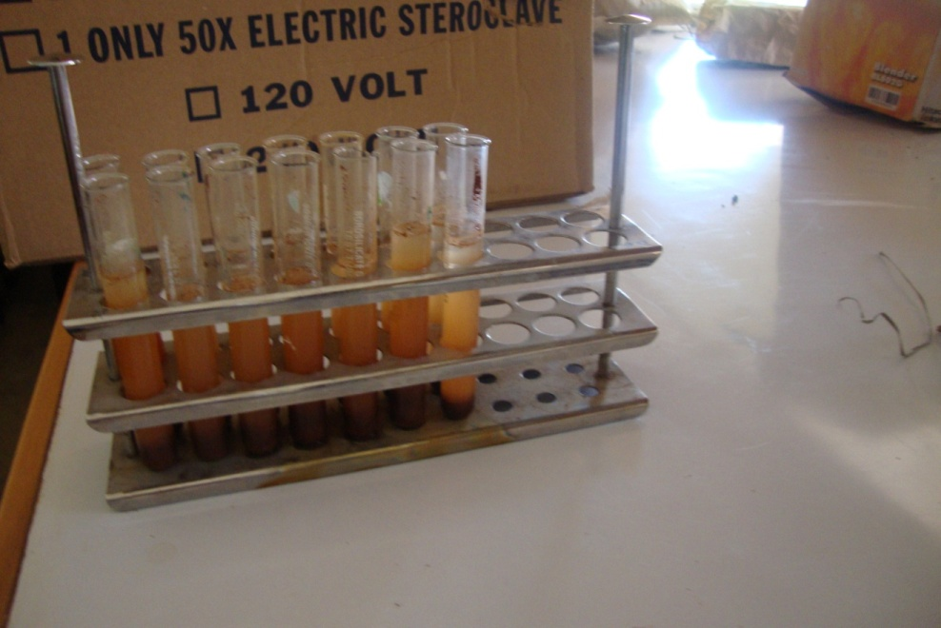
Plate 3.1 Are the test-tubes with various soil samples during serial dilutions. The contents of
These test-tubes were pre-treated in a water bath at 75 ⁰C for 15 minutes.

3.1.4 Incubation of Actinomycetes on Kuster’s medium
About 0.1 ml of the soil sample prepared as earlier described in sect. 3.1.3 was inoculated on modified Kuster’s agar medium prepared according to Baskaran et al., 2010,that is g/l: Starch 10 gms, glycerol 0.3 gms, KNO₃ 3 gms, K₂HPO₄ 2gms, NaCl 2 gms, MgSO4 0.05 gms, CaCO₃ 0.02 gms, FeSO₄ 0.01gms, agar 16 gms; pH 7.0 + 0.1. The above reagents were mixed to Constitute Kuster’s medium, where the reagents above were weighed using an electronic balance and poured into a 1000ml glass beaker half full of water. The beaker was then heated over a hot plate to allow dissolution of the reagents, and water added to top up the contents to 1000ml. The contents of the beaker were transferred into a conical flask and covered with aluminum foil. It was then autoclaved at 120 ⁰ C for 15 minutes and allowed to cool to 40 ⁰ C. The contents of the flask were later poured in plates under laminar flow chamber and allowed to gel.
Using a micropipette, 0.1 ml of the soil samples prepared in section 3.1.3 was inoculated in modified Kuster’s agar. The plates were incubated and plates were observed every day for growth. Growing cultures were re-isolated and plated onto fresh medium. A small portion of typical isolated colonies was streaked on Kuster’s agar media and incubated at 25°C for 7 days. All the morphologically different actinomycetes colonies were sub-cultured on Kuster’s agar medium and maintained in the same medium for further investigations (Debananda et al., 2010).
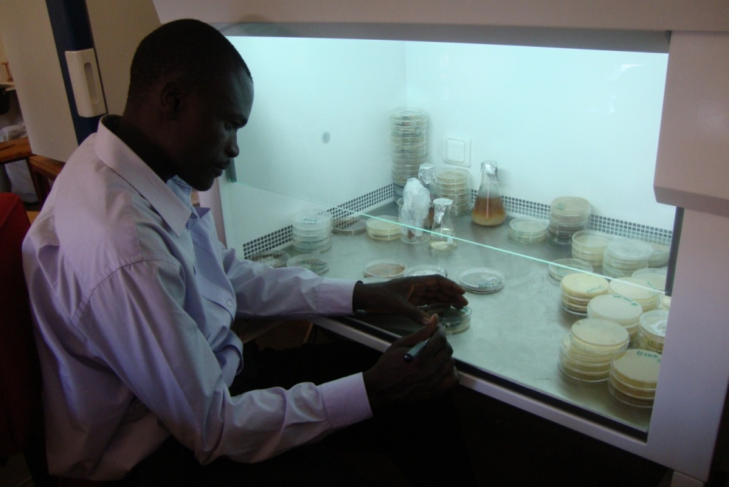
Plate 3.2: This is the researcher working inside the laminar flow, during plating of actinomycetes.

3.1.5 Characterization

The Gram stain is a differential stain, which allows most bacteria to be divided into two groups, gram positive bacteria and gram-negative bacteria. Morphological characters of isolates were observed by smears from colonies up to 10 days, stained by Gram’s Method as described by Pandey et al., (2013). Microscopic characterization was done by cover slip culture method ((Pandey et al., 2013). Plate 1.4 of appendix one shows the glass slides that were prepared. The mycelium structure, color and arrangement of conidiospore and arthrospore on the mycelium were observed through the oil immersion (1000×, Olympus) microscope. The observed structure was compared with Bergey’s manual of Determinative Bacteriology, ninth edition (2000) and the organism was identified. Colonies were identified on the basis of their colony morphology and color (Pandey et al., 2013). Color of aerial mycelium was determined from mature, sporulating aerial mycelia of the actinomycetes colonies on Kuster’s agar. Biochemical test including nitrate reduction and casein hydrolysis were performed as recommended by ISP. Chemotaxonomical properties such as utilization of carbon source namely starch and nitrogen sources namely L-tyrosine were tested in Kuster’agar medium.

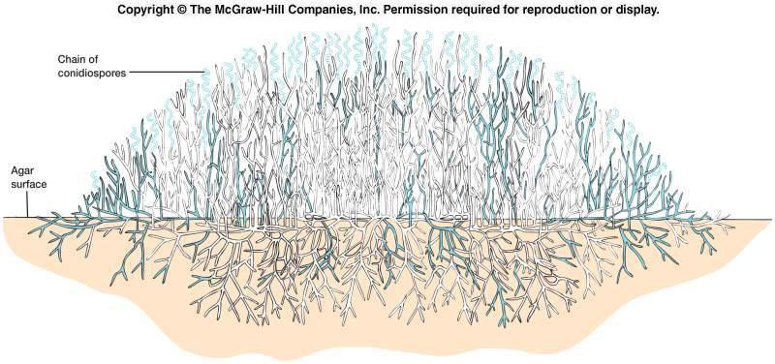
Plate 3.3. Structure of actinomycetes
3.2 INHIBITION TESTS OF ACTINOMYCETES AGAINST Pyricularia grisea
AND CHARACTERIZATION OF PATHOGENIC ONES

3.2.1. Collection and isolation of Pyricularia grisea
Diseased plants were collected from finger millet earlier grown in Maseno University farm. The samples were dried and preserved within the laboratory in closed cabinets. The leaves and heads showing diseased lesions were cut into pieces measuring 1.0 cm long and 1.0 cm wide mainly within the borders of the lesions (Opande et al., 2013). The pieces were surface sterilized by dipping in 2.5% NaOCl for one minute followed by rinsing in sterile water and then dipped in 70% ethanol for one minute. The sterilized pieces were then plated on ½ starch-yeast agar (yeast 2.0 gms, Starch 4.0 gms, agar 16 gms ) and incubated at 28 ⁰C (Zarandi et al., 2013). Colonies developing were re-isolated and sub-cultured on fresh medium under continuous fluorescent light to promote Conidiation.

3.2.1.2 Confirming the identity of Pyricularia grisea
The initial stages in confirming the identity of the isolate involved observing the pathogen on its natural host exhibiting the symptoms of finger millet blast and its confirmation in conformity to Koch’s postulates. A thin cross sectional cut on the affected leaves showing the host pathogen relationship was made on a slide, before mounting them on the microscope for the observation and photographing at X 400 (plate 3.4). The second investigation involved observing the growth pattern, mycelia structure and spore shapes, colour on the medium that was compared to identification key for genus Pyricularia (Olga, 1986)
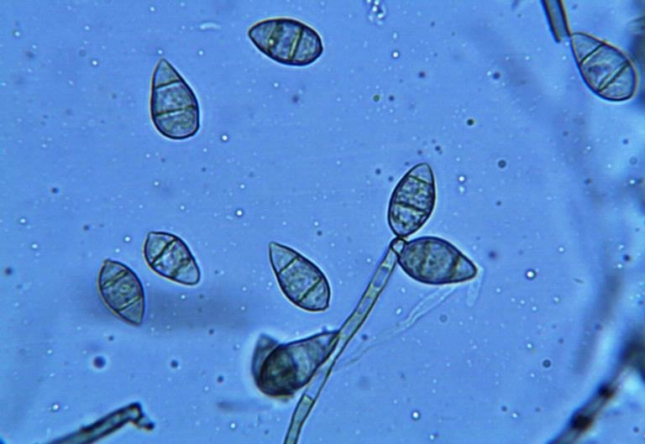
Sporangiospore
Basal appendage
Ascospore
Plate 3.4 Structure of Pyricularia grisea spores

3.2.1.3 Preparation of Pyricularia Inoculum
Conidia were harvested from 7 day old cultures in sterile distilled water. Harvesting was done by adding 3 ml sterile distilled water to Petri dishes of well grown lawn culture of pathogen and collecting the liquid in small beakers (Zarandi et al., 2009). The spore suspensions were prepared with sterile distilled water in which corn oil at 0.03% concentration was added. Conidial suspensions were filtered to remove mycelia and adjusted to a concentration of 7.2 x 10⁶ spore/ ml. The suspensions were used as inoculums.

3.2.1.4 Constituting the inoculums using Hemacytometer counts
The conidia in the harvesting solution were counted and constituted to 7.2 x10⁶ conidia /millimeter according to Hayden et al., (1999). The initial count had an average of 28 cells within the larger centre square. The second reading after first dilution gave a reading of 18 cells. The third dilution had approximately 8 cells and therefore is the concentration that was used to infect the millet plants in the greenhouse.
Cell count on the fourteenth day old culture
8 cells counted on large counting grid
Sample diluted 2 times
Volume of the filtrate 0.45 ml
Cell = cell number / volume of grid
= 8 /10⁻⁶
=8.0 x10⁶
Total cell population in original volume = dilution factor x volume x cell
= 2.0 x 0.45 ml x 8,000,000
= 7.2 x 10⁶

3.2.2 Inoculation of Actinomycetes isolates with the Pyricularia grisea on Petri-dish.
A single steak of isolates whose identities were established to be actinomycetes was made on a fresh Kuster’s agar and incubated for 4 days at 26 ⁰C (Zarandi et al., 2009). After observing a good ribbon like growth of actinomycetes, the fungal pathogen was streaked, 20 mm, at right angle to the original streak of actinomycete. The inhibition zone (mm) was measured after 24th, 48th, 72^{nd,} 96th and 120 hours of streaking. During incubation, growth or lack of growth of the fungus was observed both visually and microscopically (Pandey et al., 2013). Control plates included some without inoculating Streptomyces, that of a fungus and the other plates of fungi laced with probenazole. Antifungal activity around the Streptomyces agar disks was evaluated according to the key provided by Zarandi et al., (2009).
1 = no inhibition or mycelial of the fungus merge with those of the actinomycetes
- = weak inhibition or partial inhibition of mycelia growth, measured as a diameter of 5-9 mm,
- = moderate inhibition or almost complete inhibition of mycelial growth, measured as a diameter of 10-19 mm,
4 = strong inhibition or complete inhibition, in which most mycelia were not grow, measured as a diameter of >20 mm.
A control included plain agar disks. Three plates were used for each treatment.
The area under the disease progress stairs (AUDPS) was used to combine multiple observations of disease progress into a single value. Degree of inhibition was observed after every 24 hours during incubation. Extent of inhibition was assessed at each observation using scales of 1-4. These repeated observations were combined into a single value by calculating the area under the disease progress stairs (Simko and Piepo, 2012). The observations were performed at regular time units of 24 hours,

AUDPS $=ȳx$ n
Where,
$ȳ$ is the arithmetic mean of the observation value.
n the number of observations

3.2.3 Inoculation of P. grisea on PDA with wells filled with Actinomycetes extracts.
In tests using actinomycetes extracts, Kuster’s broth (Starch 10 gms, glycerol 0.3 gms, KNO₃ 3 gms, K₂HPO₄ 2 gms, NaCl 2 gms, MgSO4 0.05 gms, CaCO₃ 0.02 gms, FeSO₄ 0.01 gms; PH 7.0 + 0.1) was prepared the same was as in section 3.1.4, except that agar was not added. Plate 1.5 of appendix one shows the Kuster broth prepared.Using a scapel, 2 mm x 2 mm block of well grown fungicidal actinomycetes from the results of 3.2.2, was cut and placed in 500 ml conical flask containing Kuster’s broth. Extracts were prepared by allowing the Streptomyces to grow on Kuster’s broth for a period of fourteen days then placed in a shaker incubator incubated for six days at 28°C and 200 rpm (Zarandi et al., 2009). The broth media was then centrifuged for 20 min at 12,000 rpm to remove the microbial cells.
Using a sterile loop sterilized over a flame until red hot, spores of Pyricularia grisea from section 3.2.1.1 were harvested and inoculated on the PDA plates (Nonoh et al. 2010). Cork borer measuring 8 mm in diameter was used to drill wells on the PDA at a depth of 4 mm. Wells were then filled with the extracts and incubated for three days in the laminar flow. Three plates were used for each treatment. The diameter of the clear zone around each well was measured in millimeter and assigned scale. Observations were made at regular time interval of 24 hours for 120 hours. Extent of inhibition was assessed at each observation using scales of 1-4.
- = no inhibition or mycelial grow into the well,
- = weak inhibition or partial inhibition of mycelia growth into the well,
3 = moderate inhibition or almost complete inhibition of mycelial growth in to the wells, measured as a diameter of 2mm,
4 = complete inhibition of mycelia into the well, measured as a diameter of >3 mm
The area under the disease progress stairs (AUDPS) was used to combine multiple observations of disease progress into a single value. Degree of inhibition was observed several times during incubation. These repeated observations were combined into a single value by calculating the area under the disease progress stairs (Simko and Piepo, 2012).
AUDPS $=ȳx$ n
Where
$ȳ$ is the arithmetic mean the observation value.
n the number of observations
Data was analyzed using SAS GLM computer package. ANOVA’s Duncan’s test was used for multiple comparisons of means at 5% level of significance.

3.2.4 Characterization of AT2 and AT4 (fungicidal Streptomyces)
3.1.3.1 Aerial Mass Colour
The colour of the mature sporulating aerial mycelium was observed and recorded (White, grey, red, green, blue and violet). When the aerial mass colour was between two colour series, both the colours were recorded. Whenever the aerial mass colour of a strain under study showed intermediate tints, then both the colour series were noted (Kavitha et al., 2010).
3.1.3.2 Melanoid Pigments
The grouping was made on the production of melanoid pigments (i.e. greenish brown, brownish black or distinct brown, pigment modified by other colours) on the medium. The strains were grouped as melanoid pigment produced (+) and not produced (‐) (Kavitha et al., 2010).

3.1.3.3 Reverse Side Pigments
The strains were grouped according to their ability to produce characteristic pigments on the reverse side of the colony, namely, distinctive (+) and not distinctive or none (‐) (Kavitha et al., 2010).

3.1.3.4 Soluble Pigments
The strains were divided into two groups by their ability to produce soluble pigments other than melanin: namely, produced (+) and not produced (‐). The colours under observation included: red, orange, green, yellow, blue and violet (Basavaraj et al., 2010).

3.3 EFFICACY OF ACTINOMYCETES EXTRACT
3.3.1 In vivo greenhouse studies
Seeds of susceptible finger millet variety P224, were grown under greenhouse conditions in plastic pots containing sterilized sand and humus of decayed leaves (3:1 w/w). Seeds were planted 3-4 cm below soil surface per pot. The day temperature mean during study within the green house was 26 ⁰ C., with a relative humidity of 60%.
The plants were grown for twenty eight days, in which they were separated in five groups with three pots. The spores were mixed with the respective treatment just before inoculation.
A) Pyricularia grisea inoculums
(B) AT4 extracts in a mixture with Pyricularia spores
(C) AT2 extracts in a mixture with Pyricularia spores
(D) AT6 extracts in a mixture with Pyricularia spores
(E) Probenazole with Pyricularia spores.
At 28 days plants were inoculated. Each treatment was inoculated on three pots. A one litre hand sprayer was used to spray 100 ml of spore suspensions at 7.2x10⁶ conidia ml⁻¹in each treatment until leaf wetness. Plants were then covered using plastic bags (plate 3.3). They were incubated in a greenhouse for three days then the plastic bags removed. The severity of the infection after the incubation period was measured on a 1 – 5 scale according to Hayden et al.,1999.; 1-no infection
2-slight infection
3 - moderate infection (50% of leaf infected.)
4- severe infection (75% of leaf infected)
5- complete necrosis (100% infection).
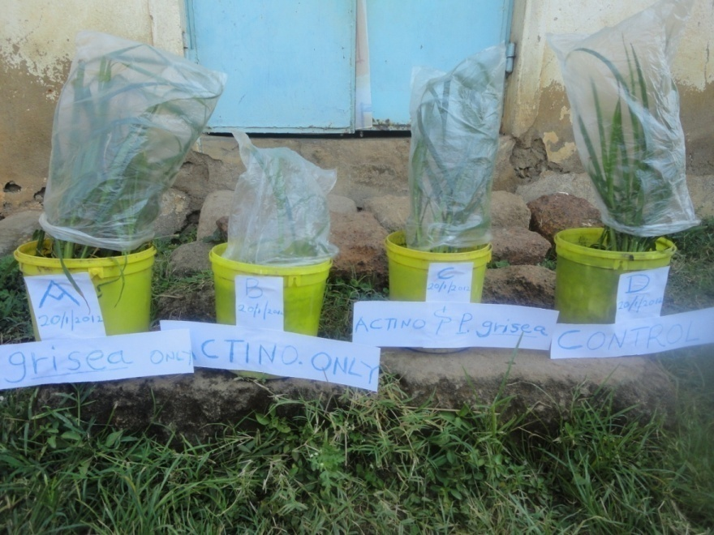
Plate 3.5. Pots covered with polythene bags to provide the green house effects.

The area under the disease progress stairs (AUDPS) was used to combine multiple observations of disease progress into a single value. Progress of disease on plants was observed several times during pathogen epidemics. Extent of disease was assessed at each observation using scales of 1-5 based on severity. These repeated observations were combined into a single value by calculating the area under the disease progress stairs (Simko and Piepo, 2012).
AUDPS $=ȳx$ n
Where,
$ȳ$ is the arithmetic mean the observation value.
n the number of observations
3.3.2. Data analysis
Data was analyzed using SAS GLM computer package. ANOVA’s Duncan’s test was used for multiple comparisons of means at 5% level of significance.
CHAPTER FOUR
4.0 RESULTS
4.1.1 ACTINOMYCETES ISOLATED
Out of the 50 sites sampled, only seven sites had actinomycetes isolates (Table 4.1). Colonies having characteristic features such as powdery appearance with colours ranging from white, grey to yellow were selected. Of the fifteen isolates, 10 (AT1, AT3, AT5, AT7, AT9, AT10, AT11, AT12, AT13 and AT14) had white mycelia with chalk like appearance on the culture plates. Only two (AT4 and AT8) had grey mycelia, but their growth was slow even after several sub culturing. Other isolates that had yellow mycelia were AT2, AT6 and AT15, they equally had a very fast growth with a dense mycelium that was hard to pick. The fifteen Actinomycetes isolate had distinct spore forms such as spiral chains, rectiflexious and rectinaculiarpeti. Those with spiral chains were dominant followed by Rectinaculiarpeti and rectinaflexious (Table 4.1).
Actinomycetes population varied with the area of isolation (Table 4.1). Only three isolates; AT1, AT2 and AT3 were isolated from lawns. Paddocks had two isolates: AT4 and AT5. Jacaranda groove had two isolates, AT7 and AT8. Prunus groove had the highest number of isolates; AT9, AT10, AT11 and AT12. Crop fields had the lowest number of isolates with only AT13 while Eucalyptus groove had two; AT14 and AT15.
The table below summarizes various isolates collected along Siriba-Main campus road within Maseno University

Table 4.1. Actinomycetes isolated from soils collected within Maseno University.
Site | Nature of the site | Actinomycetes isolate | Colour of aerial mycelium | Growth/spore form | Utilization of carbon source |  | Utilization of nitrogen source
S1 | Lawn | AT1 | white | Rectinaculiarperti | +ve |  | +ve
S2 | Lawn | -
S3 | Lawn | -
S4 | Lawn | AT2 | yellow | Rectiflexious | +ve |  | +ve
S5 | Lawn | -
S6 | Lawn | -
S7 | Lawn | -
S8 | Lawn | AT3 | white | Rectiflexious | -ve |  | +ve
S9 | Paddock | -
S10 | Paddock | -
S11 | Paddock | AT4 | Grey | Spiral chain | +ve |  | +ve
S12 | Paddock | -
S13 | Paddock | -
S14 | Paddock | AT5 | white | Rectinaculiarperti | +ve |  | -ve
S15 | Paddock | -
S16 | Paddock | -
S17 | Paddock | -
S18 | Jacaranda groove | -
S19 | Jacaranda groove | -
S20 | Jacaranda groove | AT6 | yellow | Rectiflexious | -ve |  | -ve
S21 | Jacaranda groove | AT7 | white | Spiral chain | +ve |  | -ve
S22 | Jacaranda groove | -
S23 | Prunus groove | AT8 | Grey | Rectinaculiarperti | +ve |  | +ve
S24 | Prunus groove | -
S25 | Prunus groove | -
S26 | Prunus groove | -
S27 | Prunus groove | AT9 | white | Rectinaculiarperti | -ve |  | -ve
S28 | Prunus groove | -
S29 | Prunus groove | -
S30 | Prunus groove | -
S31 | Prunus groove | AT10 | white | Rectinaculiarperti |  | -ve |  | -ve
S32 | Prunus groove | AT11 | white | Spiral chain |  | +ve |  | +ve
S33 | Prunus groove | AT12 | white | Spiral chain |  | -ve |  | +ve
S34 | Crop fields | -
S35 | Crop fields | -
S36 | Crop fields | -
S37 | Crop fields | AT13 | white | Spiral chain |  | -ve |  | -ve
S38 | Crop fields | -
S39 | Crop fields | -
S40 | Crop fields | -
S41 | Crop fields | -
S42 | Crop fields | -
S43 | Eucalyptus | -
S44 | Eucalyptus | AT14 | white | Rectinaculiarperti |  | -ve |  | +ve
S45 | Eucalyptus | -
S46 | Eucalyptus | -
S47 | Eucalyptus | AT15 | yellow | Spiral chain |  | +ve |  | +ve
S48 | Eucalyptus | -
S49 | Eucalyptus | -
S50 | Eucalyptus | -

KEY; S-sites of soil collection,
AT-Actinomycetes

4.2 INHIBITORY EFFECTS OF ISOLATED ACTINOMYCETES AGAINST Pyricularia grisea CULTURES AND CHARACTERIZATION
4.2.1 Pyricularia isolate
The growth of the pathogen was found to be very luxuriant on Kuster’s at a temperature of 28⁰ C. The pathogen had a mass of white mycelium that formed concentric rings (Plate 4.01). A tinge of purple colouration was also observed on Kuster’s medium. Fluorescent light exposure seemed to have an effect on the rate of growth. The spore production in PDA was very slow and the spores were only sported fourteen days after seeding. The conidia formed (X400) were three-celled, spear shaped and beard a basal appendage (Plate.3.4). When probenazole fungicide was added to Kuster’s the growth of the fungus (Pyricularia grisea) was affected (Plate 4.02). It exhibited a dense chalk like growth that was totally different from the growth of the same fungus on pure Kuster’s agar (Plate 4.01).
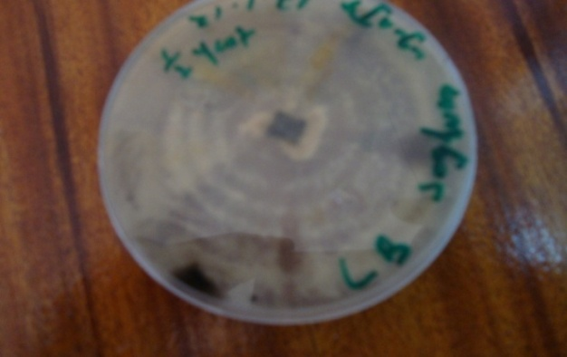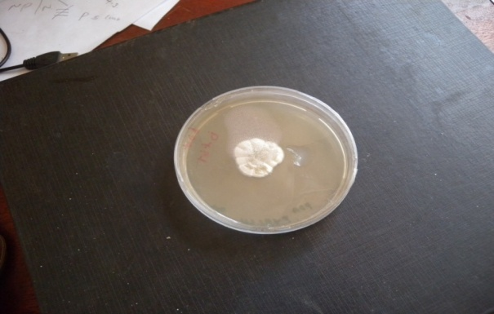
P.grisea
P.grisea
Plate 4.01: A seven day old Pyricularia on Plate 4.02 A seven day old Pyricularia on
Kuster’s agar Kuster’s agar laced with Probenazole

4.2.2. Inoculation of Actinomycetes isolates with the Pyricularia grisea on Petri-dish
AT6 had the lowest AUDPS of 408. It could not significantly inhibit Pyricularia grisea growth in culture plates. AT2 had the highest AUPDS of 1184. It significantly inhibited Pyricularia grisea growth in culture plates. When AUPDS values for the fifteen isolates were analyzed at P≤ 0.05, with LSD of 175.527, AT1, AT3, AT5, AT6, AT7, AT8, AT9, AT10, AT12, AT13, AT14, and AT15 had no significant difference within them. Only AT2 and AT4 had a significant inhibition, however there was a significant difference between them. Table 2.1 of the appendix two also shows some of the data recorded.

Table 4.2 Analyzed data of inoculating actinomycetes with Pyricularia grisea
Atinomycetes isolate AUDPS
AT2 1184 a
AT4 929 b
AT12 607c
AT7 597c
AT11 572c
AT10 559c
AT14 542c
AT15 527c
AT13 523c
AT1 506c
AT9 467c
AT5 444 c
AT8 437c
AT3 424c
AT6 408 c
Lsd= 175.527
N/B Means followed by same letters in a column are not significantly
different at 5%. Means of three replicates

4.2.2.1 Reactions on culture plates
All the actinomycetes isolates when grown with the fungus had good growth within the first 24 hours. In AT6 growth was uninterrupted until it merged with fungus (Pyricularia grisea) (Plate 4.03).

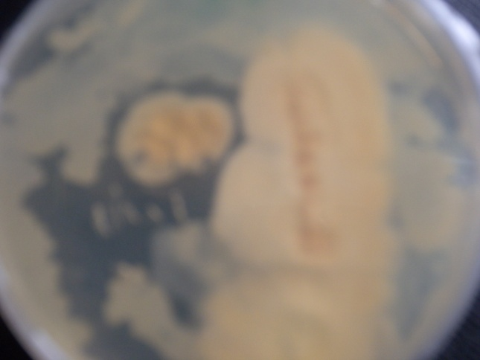
Merging area
P.grisea
AT6
Plate 4.03: Suppressive reaction of AT6 isolate on Pyricularia grisea.
Left: Streptomyces isolate (AT6) and right; Pyricularia grisea

In isolate AT2 and AT4, the growth was normal in the first 46 hours after which it almost stagnated after 72 hours of incubation (Plates 4.04 and 4.05). AT2 suppressed Pyricularia growth on sides closer to it and the region of inhibition was clearly defined (plate 4.04). AT4 had a weak inhibition (plate 4.05) compared to AT2, but a stronger one in comparison to AT6.
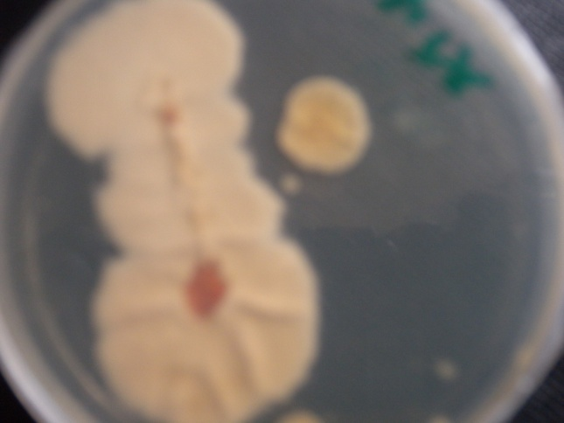
Inhibition zone
AT4
P.grisea
Plate 4.04: Suppressive reaction of AT4 isolate on Pyricularia grisea.
Right: Pyricularia grisea. and left; Streptomyces isolate (AT4)

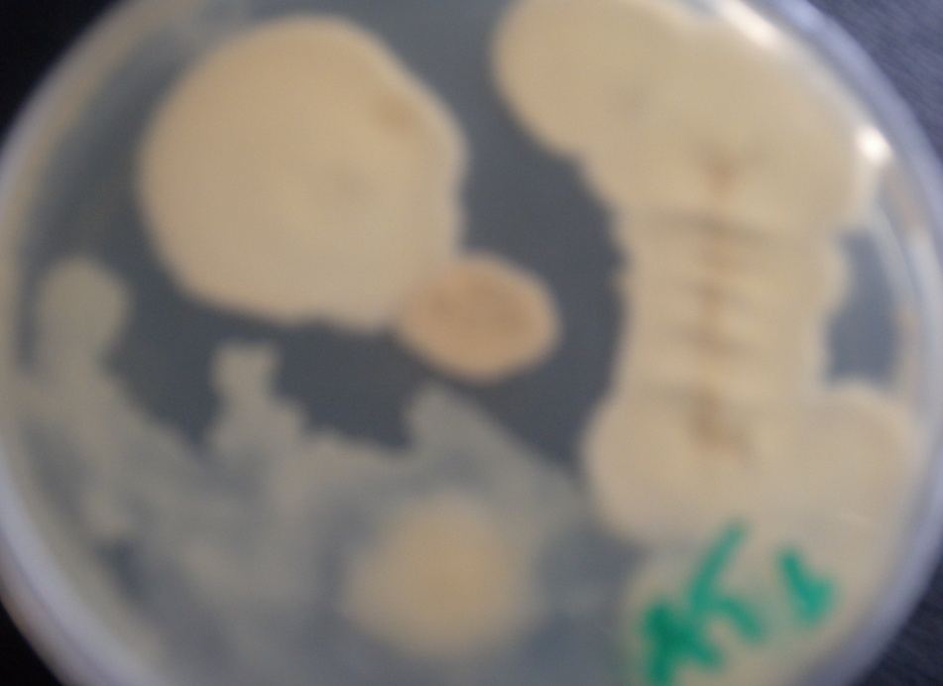
Inhibition zone

P.grisea
AT2
Plate 4.05: Suppressive reaction of AT2 isolate on Pyricularia grisea.
Left: Pyricularia grisea. and right; Streptomyces isolate (AT2)

4.2.3 Inoculation of P. grisea on PDA with wells filled with Actinomycetes extracts.
Pyricularia growth in the PDA varied with each treatment. The experimental results are also captured in table 2.2 of appendix two. There was a clear zone around wells in each plate filled with probenazole. The same observation was noted in the wells of plates inoculated with AT2. However there was no zonation in AT6 treatment and a significantly reduced zone in AT4. Probenazole had the highest inhibition while AT6 had the lowest.

Table 4.3 Analyzed data on wells filled with Streptomyces extracts and probenazole
Streptomyces extracts AUDPS
Probenazole 60a
AT2 53a
AT4 42b
AT6 32c
Lsd = 8.66
N/B Means followed by same letters in a column are not significantly
different at 5%. Means of three replicates.

4.2.4 CHARACTERIZATION OF STREPTOMYCES ISOLATES
Results presented in table 4.4 indicate that most of the isolates were of the genera Streptomyces. They showed good sporulation with compact, chalk like dry colonies of different colours. The colour of aerial mycelium of AT2 was pale brown on Kuster’s agar (Plate 4.08). Its growth was moderate, with yellow pigmentation on the media. Its spores were chalk like in rectiflexious (Plate 4.06). AT2 utilized nitrogenous sources such as KNO₃, and carbon source such as sucrose (Table 4.4). It had a good growth on a pH of 7.0. AT2 was positive in the gram staining test. AT2 could not produce the pigments on the reverse side, and therefore have a negative test.
The above characteristics were compared to the index in Bergy’s manual and AT2 indentified as Streptomyces sindeneusis.
The colour of aerial mycelium of AT4 was dark grey on Kuster’s agar (Plate 4.08). Its growth was abundant and leathery with violet pigmentation on the media. Its spores were oval in spiral chains (Plate 4.07). AT4 utilized nitrogenous sources such as KNO₃, and carbon source such as sucrose. It had a good growth on a pH of 7.0. AT4 was positive in the gram staining test. AT4 produce the pigments on the reverse side, and therefore have a positive test.
The above characteristics were compared to the index in Bergy’s manual and AT4 indentified as Streptomyces plicatus.
Table 4.4 Morphological and physiological characteristics of the isolates AT2 and AT4
Isolate | Aerial mycelium | Growth & colony form | Soluble pigments | Spore forms | Melanoid pigments | Reverse side pigments | Starch  hydrolysis | Gram staining test | Utilization of nitrogen source
AT2 | Pale-brown | Moderate, rhizoids | yellow | Chainlike in rectiflexious | -ve | -ve | +ve | +ve | +ve
AT4 | Dark grey | Abundant and leathery | Violet | Oval spore in spiral chains | -ve | +ve | +ve | +ve | +ve

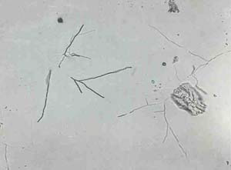
AT2
Plate 4.06: Aerial mycelia of AT2 isolate observed using microscope at X400.

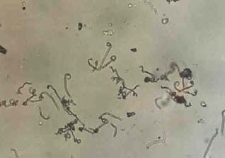
AT4
Plate 4.07: Aerial mycelia of AT4 isolate observed using microscope at X400.

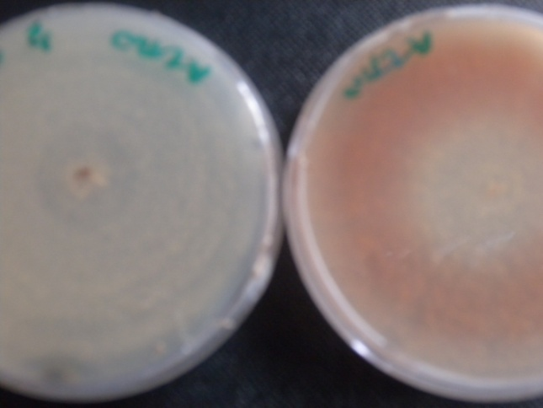
AT2
AT4
Plate 4.08: On the left is AT2 and AT4 on the right showing pigmentation
on Kuster’s medium.

4.3 EFFICACY OF ACTINOMYCETES EXTRACTS
AUPDS values of the five categories of treatments are summarized in table 4.5. The plants sprayed with the pathogen spores only suffered the most, with almost complete drying of the leaves observed. It had the highest AUDPS value of 49. Those sprayed with AT6 extracts and the fungal spores had the second highest AUDPS of 46. It resulted in typical disease symptoms. Plants exposure to the mixture of AT4 extracts and fungal spores had some level of resistance on the fungus. It had reduced disease incidence when compared to AT6. It had AUDPS value of 26. Plants exposure to the mixture of AT2 extracts and fungal spores had some level of resistance on the fungus. It had reduced disease incidence when compared to AT4. Its AUDPS of 20 was the second lowest. When the spores were mixed with probenazole (Group E) sprayed on the plants, total control of the pathogen development on the host plant (finger millet) was noted. When the values were statistically analyzed at P≤ 0.05 and LSD of 3.633, the AUDPS values of group A and plants of group D were not statistically different from each other. Group A plants were statistically different from those of group B and C hence plants of group B and C were not seriously affected, but not as resistant as those of E. Table 3.1 of appendix three gives more results.

Table 4.5 Analyzed efficacy levels of Streptomyces extracts in host plants
Treatments AUDPS
A (Fungal spores) 49 a
D (Fungal spores + extracts of AT6) 46a
B (Fungal spores + extractsof AT4) 26b
C (Fungal spores+extracts of AT2) 20 c
E (Fungal spores in probenazole) 16d
Lsd = 3.633
N/B Means followed by same letters in a column are not significantly
different at 5%. Means of three replicates.

4.3.1 Plates of greenhouse tests
The results of biological control of Streptomyces sindeneusis isolate AT2, against Pyricularia grisea are indicated in the Plates 4.09, 4.10, 4.11 and 4.12. Treatment of plants with pathogen only resulted in typical blast symptoms (75%) evaluated as a percentage of diseased area (Plate 4.09). In plate 4.09, the leaves started with dry patches which merged with each other to cause entire drying of the leaves.
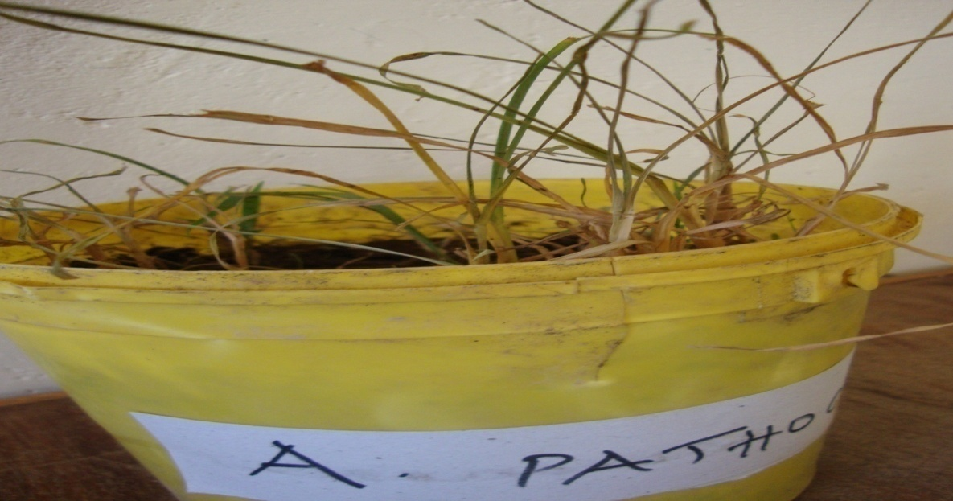
Drying leaves
Plate 4.09 Finger millet after exposure to Pyricularia grisea spores
Treatment of pathogen plus (AT6), plate 4.10, resulted in typical symptoms of the disease, however the degree of infection was much reduced as witnessed by the number of lesions on the leaves and the stems. The level of infection was not as severe as that of plate 4.09 and more pronounced compared to plate 4.11.
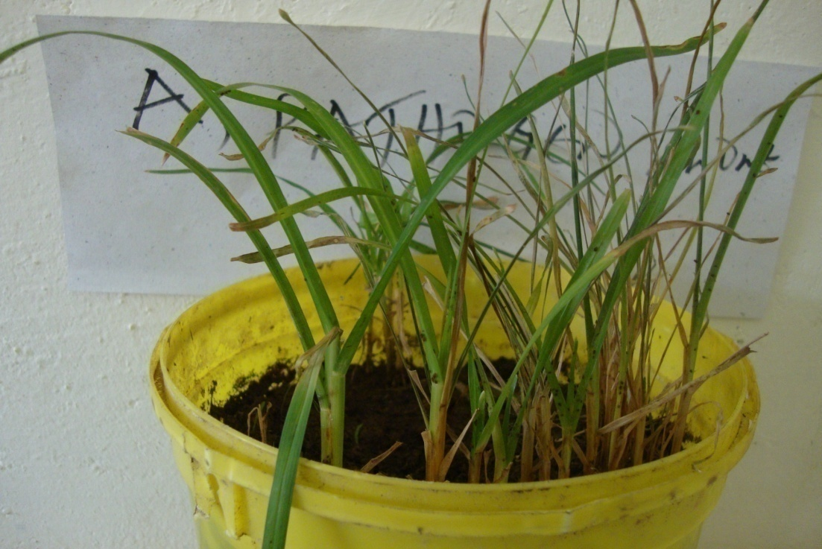
Drying leaves
Healthy leaves
Plate 4.10 Finger millet after spraying the mixture of fungal spores and the (AT6) extracts.

Plants exposed to a mixture of Pyricularia grisea and isolate AT2 (Streptomyces sindeneusis) (plate 4.11) suffered the symptoms of the disease that with time the plant recovered from.; however the infection was not as serious as that of plate 4.09. When the plants were exposed to the mixture of Probenazole and spores (plate 4.12) the disease progress was reduced. Plants grew normally with very few symptoms of the disease.
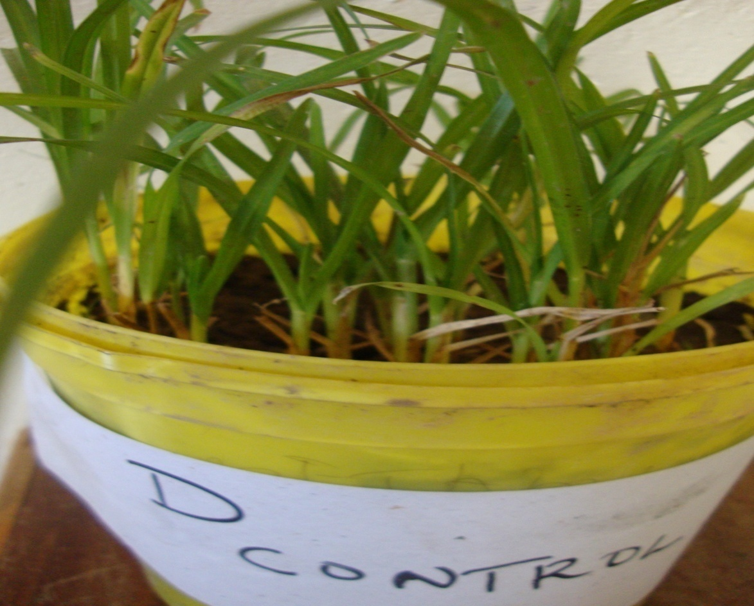
Healthy leaves
Lessions forming
Plate 4.11 Finger millet after spraying with the mixture of fungal spores and the (AT2)
Streptomyces sindeneusis extracts.
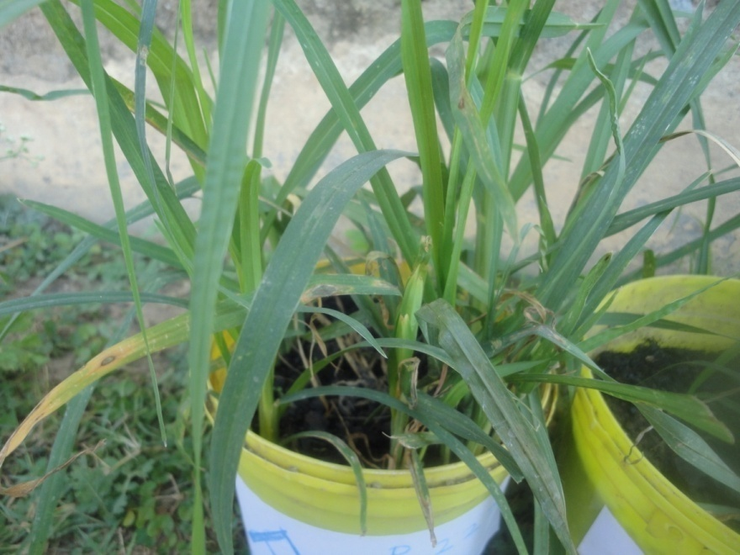
Healthy leaves

Plate 4.12: Finger millet after spraying with the mixture of fungal spores and Probenazole.
CHAPTER FIVE
5.0 DISCUSSION
The predominance of Streptomyces species among the actinobacterial isolates from protected areas as observed in this study was also noted by Nonoh et al., (2010) on soils from reserved areas in National parks in Kenya where soils were shown to have a high diversity of actinobacteria . All the fifteen isolates in this study were Streptomyces. Crop field had fewer numbers of actinomycetes species compared to barn yards Research undertaken by Lo et al., (2002) in the Croker Range Sabath confirmed the distribution of actinomycetes to be concentrated in protected areas. However protected areas such as paddocks which are rich in organic manure, lawns with their undisturbed soil structure and forested areas (jacaranda, Prunus and eucalyptus) known for their richness in humus and cool temperatures had high number of isolates. Hence, protected areas have high number of actinomycetes (Nonoh et al., 2010). The high population of streptomycetes in the protected areas in this study is attributed to undisturbed soil structure which favours flourishing growth. This piece of information might not be good news to the farmers as continuous cultivation lowers actinomycetes population. Reduced population may not give plants benefits of active extracts of actinomycetes. It further points to the benefits a farmer may get if a practice such as minimum tillage is engaged.
Morphological characterization has been reported to be a marker by which an individual strain can be recognized. Chemotaxonomy plays an important role in identification of actinomycetes to genetic level (Baskaran et al., 2010). In this study some actinomycetes isolates utilized carbon sources and nitrogen sources and were classified on the ability. Baskaran et al. (2010) reported that colour of aerial mycelium is considered to be an important character for the grouping and identification of actinomycetes. In this study we found the same to be a very good way of classifying actinomycetes.
Pure isolates grew well on the Kuster’s agar media forming well isolated colonies. The isolates obtained formed coloured, tough, leathery and filamentous colonies that were hard to pick from the culture media, as a characteristic of Streptomyces and also produced coloured pigments which were secreted into the culture media within a few days of incubation. Streptomyces grew in Kuster’s agar forming rectus-flexibilies pattern (Kavitha et al., 2010), in this study the isolates AT2 and AT4 showed a rectiflexious growth pattern.
Isolate AT2, from Maseno (S4) clustered with the soil actinobacterium Streptomyces sindeneusis (Isolate 263) had similar morphological and physiological characteristics (Zarandi et al., 2010). Isolate AT4, from Maseno (S11) compared closely with Streptomyces plicatus (Shahidi et al.,2005) revealed considerable resemblance in morphology of spore bearing hyphae and melanin pigment production. It is therefore worth noting that AT4 and AT2 in this study have characteristics that conform to those of Streptomyces sindeneusis and Streptomyces plicatus.
During inoculation, it was noted that not all the actinomycetes isolates have antifungal ability against Pyricularia grisea. However it is worth noting that the degree of inhibition also varies. Some display a strong antagonistic ability against the fungus (AT2) and others a weaker inhibition (AT4 & AT12). This is also noted by Debananda et al., (2009), of the four isolates in their study only one isolate LHCH-10C was the most potent bio-control strain. Nonoh et al (2010) reported a fungal antagonism on only Twenty eight isolates of the three hundred and sixty one isolates screened. Oh and Lee, (2002) found the inhibitory ability of some actinomycetes. They said “Culture filtrates from the class actinomycetes showed differential inhibitory effects on appressorium formation of Magnaporthe grisea in a dosage-dependent manner.” In this study some species of Streptomyces showed a significant suppressive reaction on Pyricularia grisea
Streptomycetes grow in medium releasing extracts. It is these extracts that display antagonistic effects against the fungus. In the study the two isolates (AT2 &AT4) that were positive during tests in the Petri dishes, also produced extracts that inhibited the growth of the fungus. AT6 which could not prevent growth of the fungus in culture also had no fungicidal extracts. Zarandi et al., (2009) found potential metabolites in isolate 263.
Probenazole has been reported to be an effective fungicide against a wide range of fungal pathogens (Gouramanis, 1995). In this study it proved to be an effective positive control agent of Pyricularia grisea.
Pyricularia grisea has been successfully isolated in a number of media. Talbot, (2003) reported isolation on PDA. Soytong, (1991) managed to isolate the pathogen on Oatmeal agar. In this study isolation was achieved on half starch yeast agar. After isolation it was then sub-cultured on PDA where growth was luxuriant. Oval grey lesions as a key symptom of Pyricularia grisea (Talbot, 2003), was also noted in this study. However in many cases it was noted that the lesions merged with each other rapidly and gave an appearance of a dried leaf. In cases of a head blast, the heads dried and within a few days turned slightly black, especially the tussles. In this study temperature and relative humidity were noted to be important factors for finger millet blast development. Takan (2004) reported high disease incidence in the hot and humid months of October and November.
Findings of this work confirm the presence of potential antifungal extracts in Streptomyces sindeneusis isolate AT2 against Pyricularia grisea. Streptomyces plicatus has been shown to inhibit spore germination and spore tube growth in Fusarium oxysporum (Debananda et al., 2009), in this study AT4 (Streptomyces plicatus) successfully inhibited the spread of Pyricularia grisea in culture plates. Other studies have also confirmed the candidacy of Streptomyces in the management of fungal pathogens. Nonoh et al. (2010) confirmed the ability of Streptomyces in protecting plants against fungal pathogens such as Fusarium wilt, dumping off and coffee berry disease. Zarandi et al. (2009) also found the fungicidal effect of Streptomyces sindeneusis against Pyricularia oryzae. According to Mgonja et al. (2007), there exists a close relationship between rice blast (Pyriculria Oryzae, and Finger millet blast (Pyricularia grisea).
When extract of AT2 were mixed with the spore of Pyricularia grisea and sprayed to the plants, the plants had reduced symptoms of head blast and even grain filling in the exposed plants was normal. Talbot (2003), Pointed out failure in grain filling as a key symptom of head blast. The same mixture when sprayed to plants at 28 days, symptoms of leaf blast were statistically insignificant. The work undertaken here focused on the suitability of Streptomyces sindeneusis in the management of finger millet blast. From our findings, there exists a potential in Streptomyces sindeneusis and it can be a good candidate in the management of finger millet blast.

CHAPTER SIX
6.0 CONCLUSION AND RECOMMENDATIONS

6.1 CONCLUSION
There exist actinomycetes within Maseno region, notably, family streptomycetacea. A total of fifteen isolates were separated from the soils around Maseno Univerity Streptomyces sindeneusis and Streptomyces plicatus were isolated from these soils.
Some Streptomyces have the ability to resist spread of Pyricularia grisea in culture medium while others cannot. The degree of inhibition also varies with each species.
Some streptomycetes (AT2 & AT4) produced extracts that were antifungal in the media they grew. Therefore Streptomyces sindeneusis have high antagonistic effects both invitro and invivo. The findings here, also confirms the potential of Streptomyces sindeneusis, isolate AT2, extracts in the inhibition of Pyricularia grisea.

6.3 SUGGESTIONS FOR FUTURE RESEARCH
In the course of this research, a number of questions arose that need to be further investigated;
- Antifungal activity of the isolates( AT4), Streptomyces plicatus, and AT2 (Streptomyces sindeneusis) found in this study highlights its importance as a candidate for further investigation in biological control of the destructive finger millet blast disease under greenhouse and field conditions. .
2) The second area that needs further study is in the way it inhibits development of Pyricularia. This work looked at the inhibition of vegetative growth, which is conidial development; however the fungus infection also needs appresorium development and can be effectively controlled when the appressorium development is checked; therefore this work recommends a study to confirm if these active extracts can prevent appressorium formation or melanisation.
3) Furthermore, the genes responsible for Pyricularia grisea resistance in Streptomyces sindeneusis can be isolated and cloned to form the avenue for production of resistant transgenic plants with recombinant DNA having antifungal genes. This would lead to environmentally safer measures in plant-pest management.

REFERENCES
Agobe, F., Obuo, J.E.P. and Barton, D.(2007). Weed Management in Groundnuts: Farmers’ Experience in Ox-drawn Weeders in North Eastern Uganda and Implications for Finger Millet. Finger millet blast management in East Africa. International Crops Research Institute for the Semi-Arid Tropics (ICRISAT).
Arifuzzaman, M., Khatun, M.R., and Rahman, H (2010). Isolation and screening of actinomycetes from Sundarbans soil for antibacterial activity. African Journal of Biotechnology, 9: 4615-4619.
Basavaraj, K.N, Chandrashekhara S., Ali M Shamarez, A. M., Goudanavar, P.S and Manvi, F.V. (2010). Isolation and Morphological Characterization of Antibiotic Producing Actinomycetes. Tropical Journal of Pharmaceutical Research June 2010; 9 (3): 231-236.
Baskaran, R., Vijayakumar, R. and Mohan, P.M. (2010). Enrichment method for the isolation of bioactive actinomycetes from mangrove sediments of Andaman Islands, India. Malaysian Journal of Microbiology, 7: 26-32.
.
Bourett, T. M., and Howard, R. J. (1990). In vitro development of penetration structures in the rice blast fungus Magnaporthe grisea. Canadian Journal of Botany 68:329-342.
CGIAR. (2001). CGIAR research: areas of research-millet.www.cgiar.org/research, 10 April 2004.
Couch, B.C. and Kohn, L.M. (2002). Amultilocus gene geneology concordant with host preference indicates segeregation of a new species, Magnaporthe oryzae, from M. grisea. Mycologia 94:683-693.
Dastager, S.G., Wen-jun L., Dayanand A., Shu-Kun T., Xing-Peng T., Xiao-Yang Z., Li-Hua X. and Cheng-Lin J. (2006). Separation, identification and analysis of pigment (melanin) production in Streptomycetes.African Journal of Biotechnology. 5: 1131-1134.
Debananda, S.N., Sanasam, S., Tamreihao, K. and Nimaichand, S. (2009). Antagonistic activities of local actinomycete isolates against rice fungal pathogens. African Journal of Microbiology Research, 3:737-742.
Desmond, M., Averil, B., Roy, C. and Louise C. (2007). Evaluation of fingermillet as a European Forage Crop: Plant Growth, Weed Control, and Seed Pelleting. Finger millet blast management in East Africa. International Crops Research Institute for the Semi-Arid Tropics (ICRISAT). Pp 85-89.
Devi. C. S, Jemimah N. S., Nasimunislam. N., Vaishnavi. B. and Mohanasrinivasan. V. (2013). Isolation of soil actinomycetes inhabiting Amrithi forest for the potential source of bioactive compounds. Asian Journal of Pharmaceutical and Clinical Research.5:189-192
Gilbert, R. D., Johnson, A. M., and Dean, R. A. (1996). Chemical signals responsible for appressorium formation in the rice blast fungus Magnaporthe grisea. Physiology, Molecular and Plant Pathology. 48:335-346.
Gouramanis, G.D., (1995). Biological and chemical control of rice blast disease in Northern Greece. Cashiers Options Mediterraneennes. 15: 61-68.
Hayden, N. J., Holt, J., Julian, A.M. and Conroy, M.A . (1999). An investigation into the biology, epidemiology and management of finger millet blast in low-input farming systems in East Africa. Natural Resources Institute, University of Greenwich. R6733
Hong-Sik, O. and Yong-Hwan, L., (2000). A Target-Site–Specific Screening System for Antifungal Compounds on Appressorium Formation in Magnaporthe grisea. Phytopathology, 90:11162-1168.
Hopwood, D.A., Buttner, M.J., Bibb, M.J., Kieser, T. and Charter, K.F., (2000). Antibiotic production by Streptomyces. Practical Streptomyces .Genet.
Howard, R. J., Ferrari, M. A., Roach, D. H., and Money, N. P. (1991). Penetration of hard substrates by a fungus employing enormous turgor pressures. Proc. Natl. Acad. Sci. U.S.A. 88:11281-11284.
Kavitha, A., Vijayalakshmi, M., Ssdhakar,P. and Narasimha,G. (2010). Screening of Actinomycete strains for the production of antifungal metabolites. African Journal of Microbiology Research 4:27-32.
Lee, Y.-H., and Dean, R. A. (1993). cAMP regulates infection structure formation in the plant pathogenic fungus Magnaporthe grisea. Plant Cell 5:693-700.
Lee, Y.-H., and Dean, R. A. (1994). Hydrophobicity of contact surface induces appressorium formation in Magnaporthe grisea. Federation of European Microbiological (FEMS) letters 115:71-75.
Lo, C.W., Lai, S.N., Cheah, H-Y, Wong, N.K.I. and Ho, C.C., (2002). Actinomycetes isolated from soil samples from the crocker range sabah. ASEAN Review of Biodiversity and Environmental Conservation.
Mgonja, M.A., Manyasa, E., Kibuka, J., Kaloki, P., Nyaboke, S. and Wandera, G. (2007) . Finger millet in East Africa: Importance, Blast Disease Management and Promotion of Identified Blast Resistant Varieties in Western and Nyanza Provinces of Kenya. Finger millet blast management in East Africa. Report 49-64.
Nonoh, J. O., Lwande, W., Masiga, D., Herrmann, R., Presnail, J.K., Schepers, E., Okech, M.A, Bagine, R., Mungai, P., Nyende, A.B. and Boga, H.I.(2010). Isolation and characterization of Streptomyces species with antifungal activity from selected national parks in Kenya. African Journal of Microbiology Research, 4: 856-864
Oduori, C. and Kanyenji, B. (2007). Finger Millet in Kenya: Importance, Advances in R&D, Challenges and Opportunities for Improved Production and Profitability. Finger millet blast management in East Africa. International Crops Research Institute for the Semi-Arid Tropics (ICRISAT). Report 10-22.
Olga,F. (1986). Moulds and filamentous fungi in technical microbiology; In: Progress in industrial microbiology. SNTL publishers of Technical Literature, Prague. 22: 23-30.
Opande, G., Arama, P. and Mutebi, C. (2013). Innudative biocontrol of water hyacinth (Eichhornia crassipes (Mart.) Solms. Laubach) using zonate leaf spot (Acremonium zonatum Sawada Gams) fungal agent. IOSR Journal of Agriculture and Veterinary Science. 6:69-71.
Pande, S., Mukuru, S. Z., King, S.B., and Karunakar, R.I. (1995). Biology of and resistance to finger millet blast in Kenya and Uganda. International Crops Research Institute for the Semi-Arid Tropics.
Pandey, A., Ali, I., Butola,S.K., Chafferji T. and Singh V. (2013). Isolation and characterization of Actinomycetes against pathogens. International Journal of Applied Biology and Pharmaceutical Technology. 2:385-392.
Sarigullu, F.E., Emel Karadeniz, E., Untac, I. and Çolak, O. (2013) Determination of antibacterial activities of isolated Streptomyces strains from soil at Çukurova University in Turkey. Journal of Food, Agriculture & Environment.11: 922-924.

Shahidi, B.G.H., Aghighi, S., Mahdari, M.J., Farroki, R.P., Pirouz, T. and Saadoun, L. (2005). Morphology, Physiology and Taxonomy of an Iranian Strain of Streptomyces plicatus. Innovative centre for Science and high technology and Environmental studies.
Simko, I. and Piepho, H.-P. (2012). The area under the disease progress stairs: Calculation, advantage, and application. Phytopathology 102:381-389.
Sivakumar, K. (2010). Actinomycetes. Centre of Advanced Study in Marine Biology
Annamalai University, Journal. 197-204.
Sreenivasaprasad, S., Takan, J.P., Muthumeenakshi, S., Obilana, A.B., Manyasa, E.O., Audi, P.O., Oduori, C.A., Coll, R., Brown A.E., Talbot, N.J. and Bandyopadhyay, R., (2007). Finger Millet Blast in East Africa: Pathogen Diversity and Disease Management. Finger millet blast management in East Africa. International Crops Research Institute for the Semi-Arid Tropics (ICRISAT), 34-45.
Soytong, K. (1991). Biological control of rice blast pathogen by coating seeds with Chaetomium cochlioides and C. cuniculorum.R.P.P.70:341.
Takan, J.P. (2004). Pathogen diversity and management of finger millet blast in East Africa: A summary of project activities and outputs. International Sorghum and Millets Newsletter 45:66-69.
Talbot, N.J. (2003). On the trail of a cereal killer: Exploring the biology of a Magnaporthe grisea. Annual Review of Microbiology. 57: 177-202.
Talbot, N.J. and Wilson, R.A. (2009).Under pressure: Investigating the biology of plant infection by Magnaporthe oryzae. Nature Reviews.7: 185-195.
Tinatin, D., Nurzat, T. (2006). Biodiversity of Streptomycetes of high-mountainous ecosystems of Kyrgystan and its biotechnological potential. Antonie Leeuwenhoek, 89: 325-328.
Wanyera, Nelson, (2007). Facilitating the Promotion of Improved and Blast Resistant Finger Millet Varieties to Enhance Production. Finger millet blast management in East Africa.International Crops Research Institute for the Semi-Arid Tropics (ICRISAT). 66-71
Wanyera, N.M., (2007). Finger Millet (Eleusine coracana) (L.) Gaertn) in Uganda. Finger millet blast management in East Africa. International Crops Research Institute for the Semi-Arid Tropics (ICRISAT), 1-9.
Zarandi, M.E., Shahidi Bonjar G.H., Padasht Dehkaei F., Ayatollahi Moosavi S.A., Rashid Farokhi P. and Aghighi S. (2009). Biological Control of Rice Blast (Magnaporthe oryzae) by use of Streptomyces sindeneusis isolate 263 in Greenhouse. American Journal of Applied Sciences 6: 194-19.

APPENDICES
Appendix 1; Actinomycetes isolation
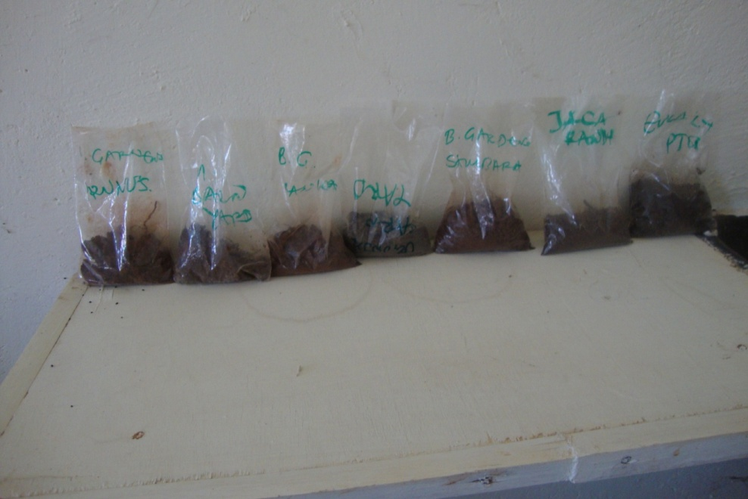
Plate 1.1: These are the soil samples from the field after collection awaiting analysis. From left are samples collected under Prunus spp., Barn yard, Grass land, Crop yard, Syzygium camini, Mimosa folia and Eucalyptus sp

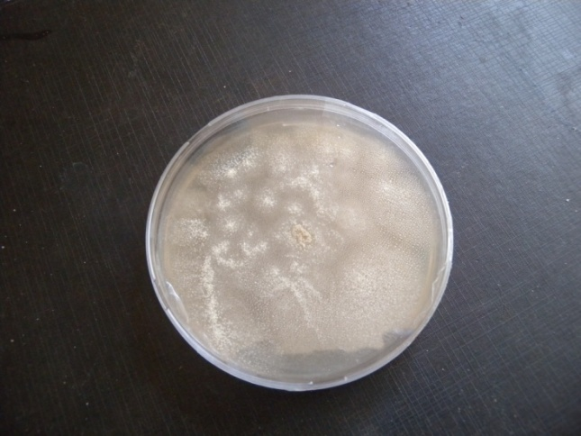
Plate 1.2.: A seven day old AT1 Isolate growing on 1/2 yeast-starch

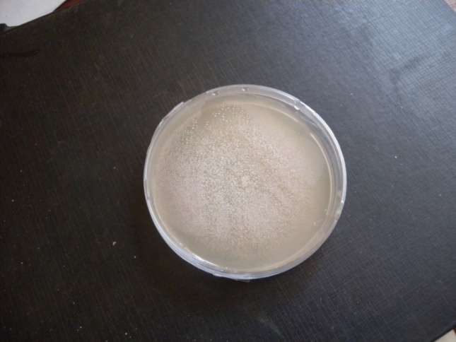
Plate 1.2.: A seven day old culture of AT2 growing on 1/2 yeast-starch medium
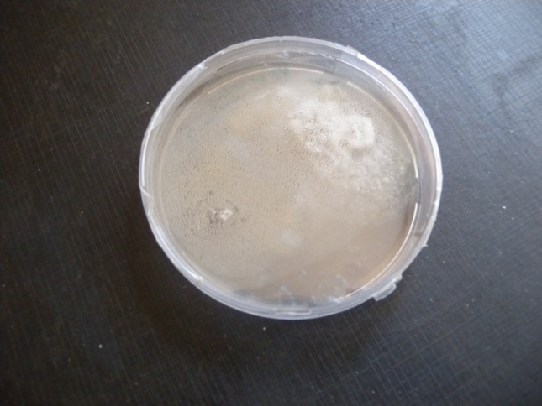
Plate 1.3: A seven day old AT 3 culture growing on 1/2 yeast-starch medium

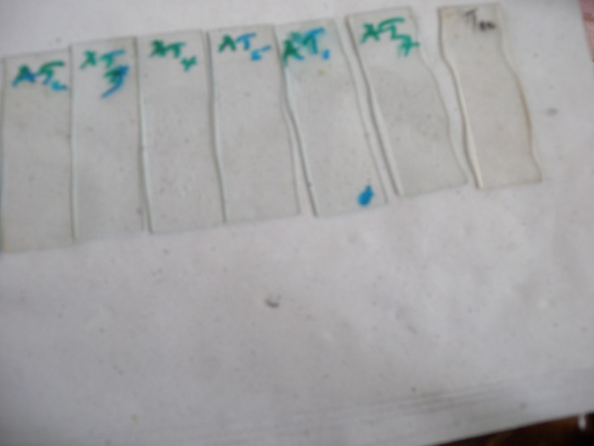
Plate 1.4: Isolates AT1-AT7 on sterile glass slides ready for the microscopic observation to determine the spore morphological characters. A loop full of one week old culture was introduced into the glasses and incubated at 26 ⁰ C - 28 ⁰ C. Periodic observations were made and recorded.

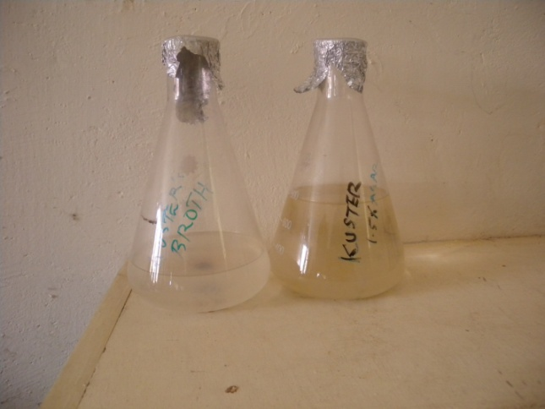
Plate 1.5: Contents of the conical flasks are; Kuster’s broth that was prepared to harvest the actinomycetes metabolites and 1.5% Kuster’s agar used for the morphological studies.

Appendix 2.0 Inhibition tests of isolated actinomycetes against Pyricularia grisea
2.1 Pricularia isolates
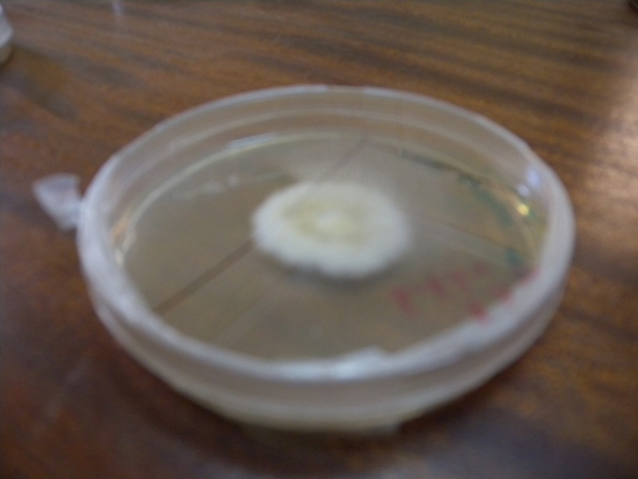
Plate 2.1: A sub-culture of Pyricularia growing on yeast extract medium.

2.2 Inhibitory effects of isolated actinomycetes
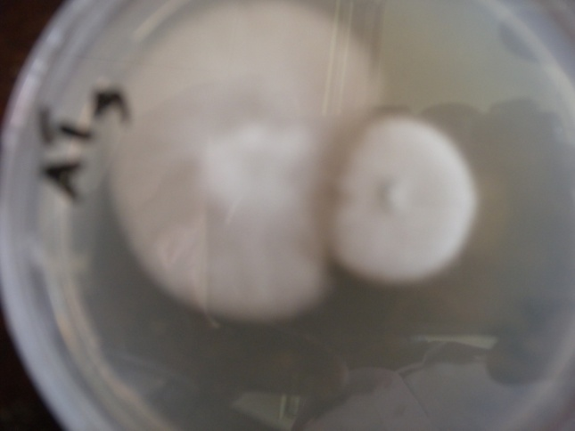
Plate 2.2.1: Invitro tests of AT3 against Pyricularia in kuster’s medium. This was done to confirm the results with the PDA.
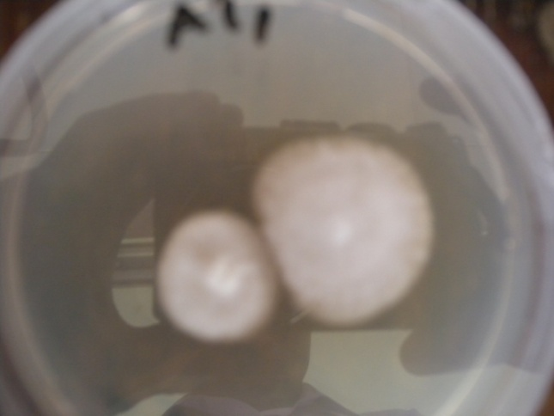
Plate 2.2.2: Invitro tests of AT1 against Pyricularia in Kuster’s medium.
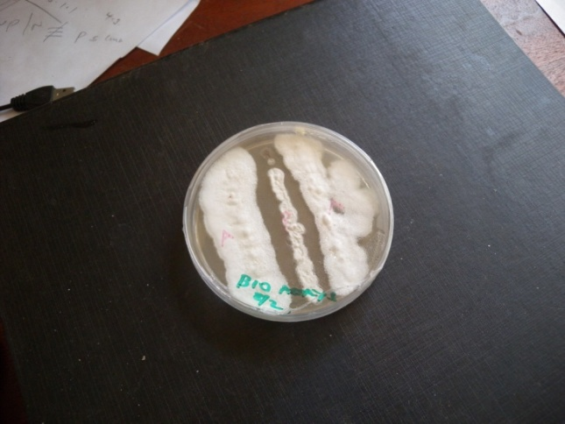
Plate 2.2.3: The test results of AT 2 against Pyricularia on Kuster’s medium. This is a stripe technique. The middle stripe is the Pyricularia and the two outer stripes on each side are the AT strains.

Table 2.1 Inhibition zone in (mm) of Streptomyces isolated against Pyricularia grisea
 |  | Time in hours
 |  | 24 | 48 | 72 | 96 | 120
AT1 | R₁ | 16 | 8 | 6 | 4 | 2
 | R₂ | 18 | 7 | 7 | 4 | 2
 | R₃ | 16 | 6 | 5 | 1 | 1
 | AUDPS |  |  |  |  | 506
AT2 | R₁ | 17 | 14 | 11 | 10 | 10
 | R₂ | 15 | 15 | 12 | 10 | 9
 | R₃ | 16 | 15 | 11 | 11 | 11
 | AUDPS |  |  |  |  | 607
AT3 | R₁ | 18 | 10 | 6 | 3 | 0
 | R₂ | 15 | 6 | 1 | 1 | 1
 | R₃ | 10 | 4 | 0 | 0 | 0
 | AUDPS |  |  |  |  | 424
AT4 | R₁ | 15 | 10 | 8 | 7 | 7
 | R₂ | 9 | 9 | 9 | 9 | 9
 | R₃ | 11 | 11 | 10 | 10 | 10
 | AUDPS |  |  |  |  | 542
AT5 | R₁ | 14 | 5 | 2 | 0 | 0
 | R₂ | 18 | 18 | 5 | 3 | 3
 | R₃ | 8 | 1 | 0 | 0 | 0
 | AUDPS |  |  |  |  | 444
AT6 | R₁ | 9 | 6 | 0 | 0 | 0
 | R₂ | 11 | 7 | 0 | 0 | 0
 | R₃ | 7 | 7 | 0 | 0 | 0
 | AUDPS |  |  |  |  | 408
AT7 | R₁ | 6 | 4 | 3 | 0 | 0
 | R₂ | 5 | 3 | 2 | 1 | 0
 | R₃ | 14 | 11 | 1 | 1 | 0
 | AUDPS |  |  |  |  | 597
AT8 | R₁ | 9 | 9 | 5 | 0 | 0
 | R₂ | 8 | 8 | 7 | 0 | 0
 | R₃ | 13 | 5 | 2 | 1 | 1
 | AUDPS |  |  |  |  | 437
AT9 | R₁ | 17 | 6 | 3 | 1 | 0
 | R₂ | 16 | 7 | 4 | 2 | 1
 | R₃ | 15 | 3 | 3 | 0 | 0
 | AUDPS |  |  |  |  | 467
AT10 | R₁ | 13 | 12 | 3 | 2 | 0
 | R₂ | 12 | 10 | 4 | 2 | 0
 | R₃ | 11 | 9 | 0 | 0 | 0
 | AUDPS |  |  |  |  | 559
AT11 | R₁ | 11 | 10 | 0 | 0 | 0
 | R₂ | 12 | 10 | 1 | 1 | 0
 | R₃ | 9 | 6 | 0 | 0 | 0
 | AUDPS |  |  |  |  | 572

Table 2.2 Efficacy of actinomycetes extracts in well technique
Treatments |  | Time in hours
 |  | 24 | 48 | 72 | 96 | 120
Pyricularia grisea alone | R₁ | 4 | 1 | 1 | 1 | 1
 | R₂ | 4 | 1 | 1 | 1 | 1
 | R₃ | 4 | 1 | 1 | 1 | 1
 | AUDPS |  |  |  |  | 24
AT2 Extracts | R₁ | 4 | 4 | 3 | 2 | 2
 | R₂ | 4 | 4 | 4 | 4 | 4
 | R₃ | 4 | 4 | 3 | 3 | 4
 | AUDPS |  |  |  |  | 53
AT4 Extracts | R₁ | 4 | 3 | 3 | 2 | 1
 | R₂ | 4 | 3 | 3 | 3 | 3
 | R₃ | 4 | 2 | 2 | 2 | 2
 | AUDPS |  |  |  |  | 42
AT6 Extracts | R₁ | 4 | 1 | 1 | 1 | 1
 | R₂ | 4 | 3 | 2 | 2 | 1
 | R₃ | 4 | 3 | 3 | 1 | 1
 | AUDPS |  |  |  |  | 32
Probenazole | R₁ | 4 | 4 | 4 | 4 | 4
 | R₂ | 4 | 4 | 4 | 4 | 4
 | R₃ | 4 | 4 | 4 | 4 | 4
 | AUDPS |  |  |  |  | 60

Appendix3: Efficacy of actinomycetes extracts on Pyricularia grisea
3.1 Plates of various stages
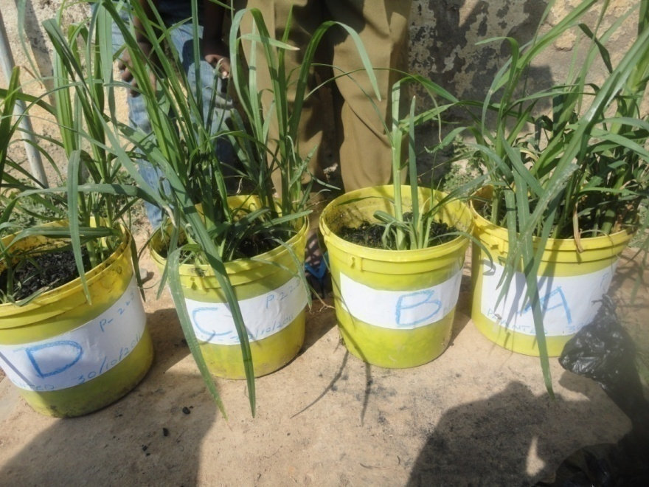
Plate 3.1.1 Pots of finger millet (P224) varieties at 40 days after sowing. These pots were later treated and the symptoms observed

Table 3.1 Disease severity score in host plants
Treatments |  | Time in hours
 |  | 24 | 48 | 72 | 96 | 120
Pyricularia grisea alone | R₁ | 1 | 2 | 4 | 4 | 4
 | R₂ | 1 | 3 | 3 | 5 | 5
 | R₃ | 1 | 2 | 4 | 5 | 5
 | AUDPS |  |  |  |  | 49
AT2 Extracts | R₁ | 1 | 1 | 2 | 2 | 2
 | R₂ | 1 | 1 | 1 | 2 | 2
 | R₃ | 1 | 1 | 1 | 1 | 1
 | AUDPS |  |  |  |  | 20
AT4 Extracts | R₁ | 1 | 1 | 1 | 1 | 2
 | R₂ | 1 | 2 | 2 | 3 | 3
 | R₃ | 1 | 2 | 2 | 2 | 2
 | AUDPS |  |  |  |  | 26
AT6 Extracts | R₁ | 1 | 4 | 5 | 5 | 4
 | R₂ | 1 | 3 | 3 | 4 | 4
 | R₃ | 1 | 2 | 3 | 3 | 3
 | AUDPS |  |  |  |  | 46
Probenazole | R₁ | 1 | 1 | 1 | 1 | 2
 | R₂ | 1 | 1 | 1 | 1 | 1
 | R₃ | 1 | 1 | 1 | 1 | 1
 | AUDPS |  |  |  |  | 17

